BOOTSTRAP INDEPTH

Note : to get all html entites link:

<https://unicode-table.com/en/html-entities/>

1. When ever we are going to start using bootstrap the html layout we use will be :

<!doctype html>

<html lang="en">

  <head>

    <meta charset="utf-8">

    <meta name="viewport" content="width=device-width, initial-scale=1">

    <title>Bootstrap demo</title>

    <link href="https://cdn.jsdelivr.net/npm/bootstrap@5.2.0-beta1/dist/css/bootstrap.min.css" rel="stylesheet" integrity="sha384-0evHe/X+R7YkIZDRvuzKMRqM+OrBnVFBL6DOitfPri4tjfHxaWutUpFmBp4vmVor" crossorigin="anonymous">

  </head>

  <body>

    <h1>Hello, world!</h1>

    <script src="https://cdn.jsdelivr.net/npm/bootstrap@5.2.0-beta1/dist/js/bootstrap.bundle.min.js" integrity="sha384-pprn3073KE6tl6bjs2QrFaJGz5/SUsLqktiwsUTF55Jfv3qYSDhgCecCxMW52nD2" crossorigin="anonymous"></script>

  </body>

</html>

Note : if we are using external css . in html we are going to put the link of it below css link of bootstrap.

2. Forming a layout through bootstrap :

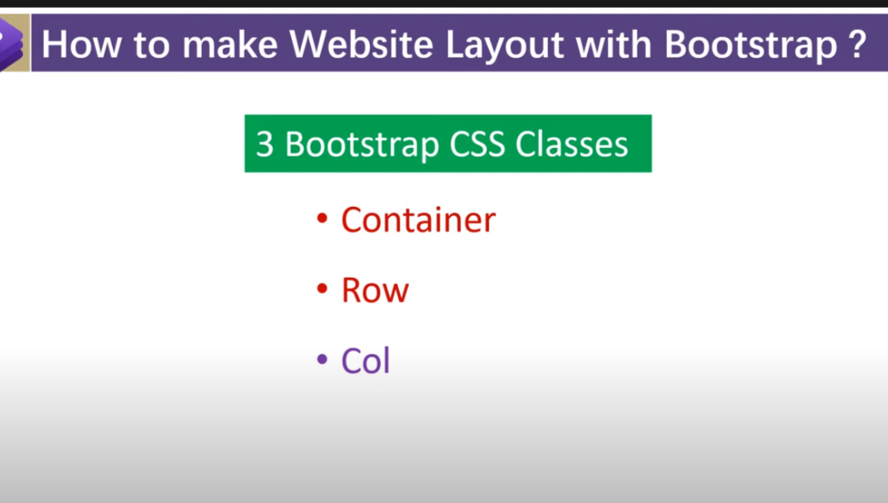

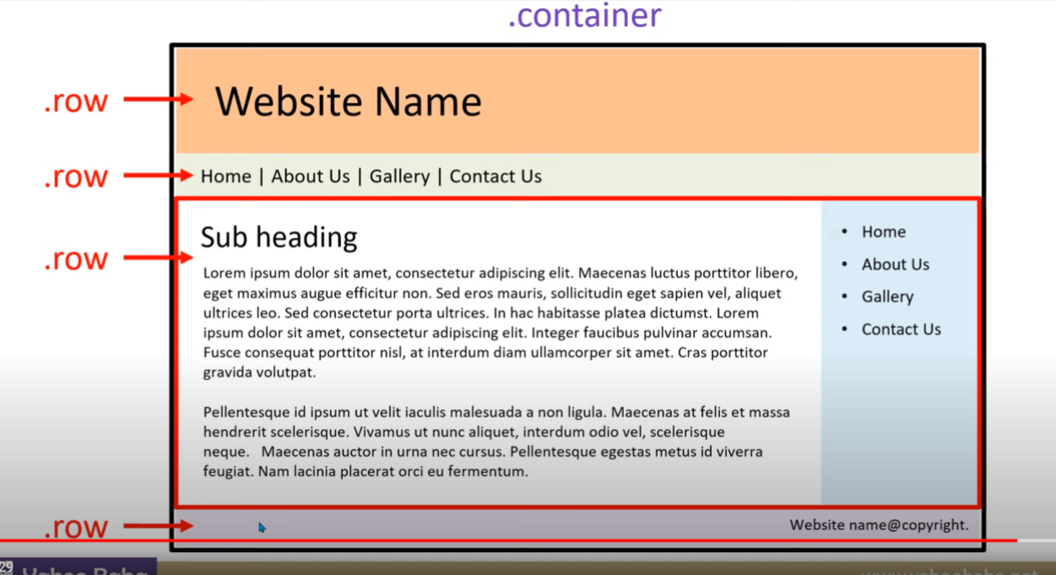

Note : we use container for only once for setting the width and height of box.

ii) under container we are going to play with row

iii)under row we are going to paly with col .

example of layout :

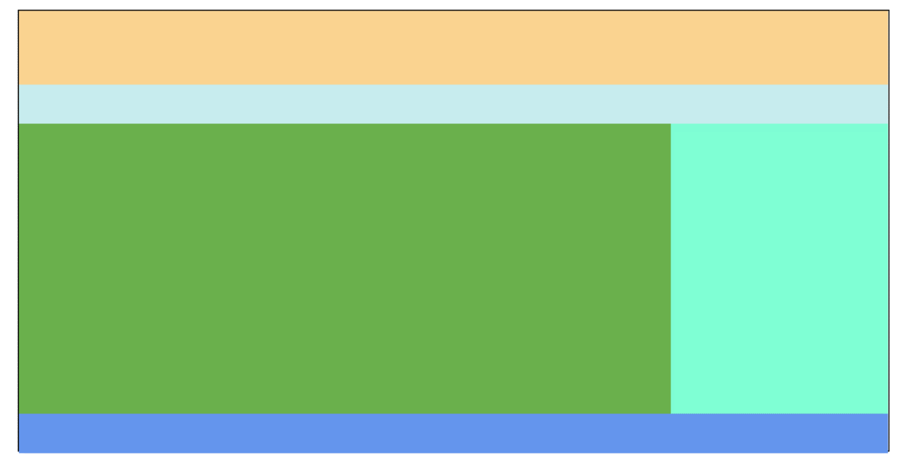

Here we palay with container , row height and col:

<!doctype html>

<html lang="en">

  <head>

    <meta charset="utf-8">

    <meta name="viewport" content="width=device-width, initial-scale=1">

    <title>Bootstrap demo</title>

    <link href="https://cdn.jsdelivr.net/npm/bootstrap@5.2.0-beta1/dist/css/bootstrap.min.css" rel="stylesheet" integrity="sha384-0evHe/X+R7YkIZDRvuzKMRqM+OrBnVFBL6DOitfPri4tjfHxaWutUpFmBp4vmVor" crossorigin="anonymous">

    <link rel="stylesheet" href="external.css">

  </head>

  <body>

    <div class="container">

        <div class="row row1"></div>

        <div class="row row2"></div>

        <div class="row row3">

            <div class="col-9 col1"></div>

            <div class="col col2"></div>

        </div>

        <div class="row row4"></div>

    </div>

    <script src="https://cdn.jsdelivr.net/npm/bootstrap@5.2.0-beta1/dist/js/bootstrap.bundle.min.js" integrity="sha384-pprn3073KE6tl6bjs2QrFaJGz5/SUsLqktiwsUTF55Jfv3qYSDhgCecCxMW52nD2" crossorigin="anonymous"></script>

  </body>

</html>

External css :

.container{

*height*: 90vh;

*border*: 2px solid black;

*margin-top*: 50px;

*margin-bottom*: 50px;

}

.row1{

*height*: 15vh;

*background-color*: #fad390;

}

.row2{

*height*: 8vh;

*background-color*: #c7ecee;

}

.row3{

*height*: 59vh;

}

.col1{

*background-color*: #6ab04c;

}

.col2{

*background-color*: aquamarine;

}

.row4{

*height*: 8vh;

*background-color*: cornflowerblue;

}

2.2 class=”row row-cols-3” use of it

2.3 class=”col-break-point-n” use of it

2.4 . class=”offset-col_brak-n” use of it

2.5 class=”order-break_ponit-n” use of it

We have : order-first or order-last

3. Bootstrap nesting

4. Margin :

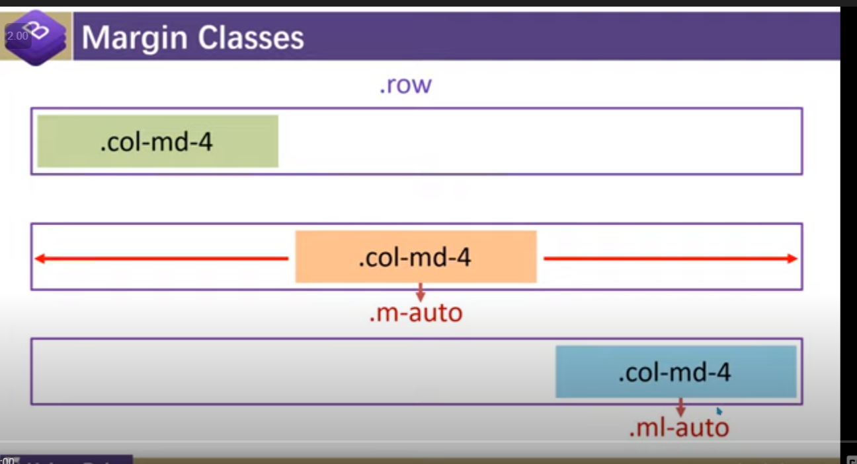

it will going to give margin from top right bottom left

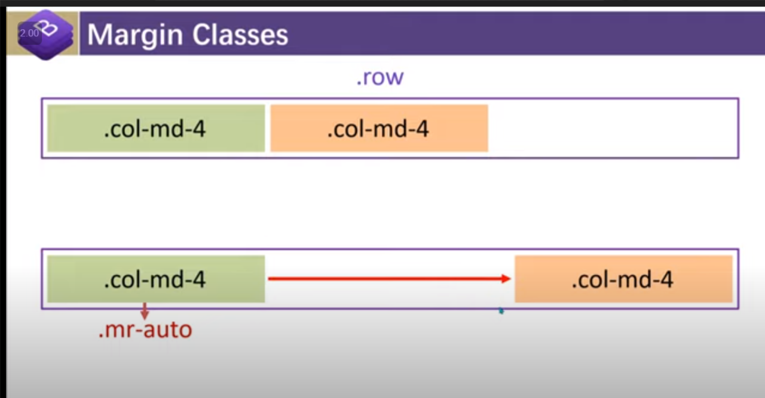

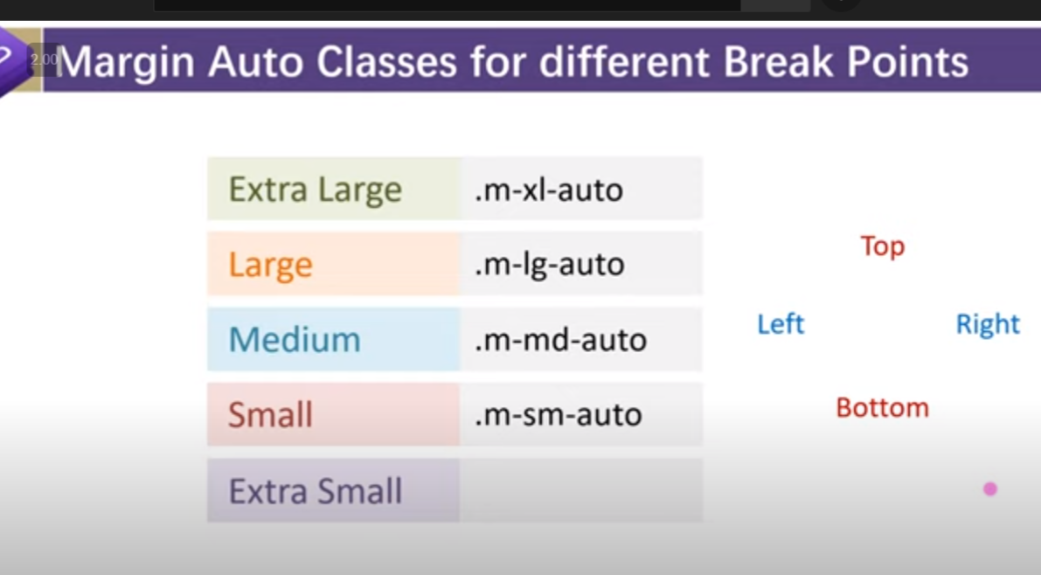

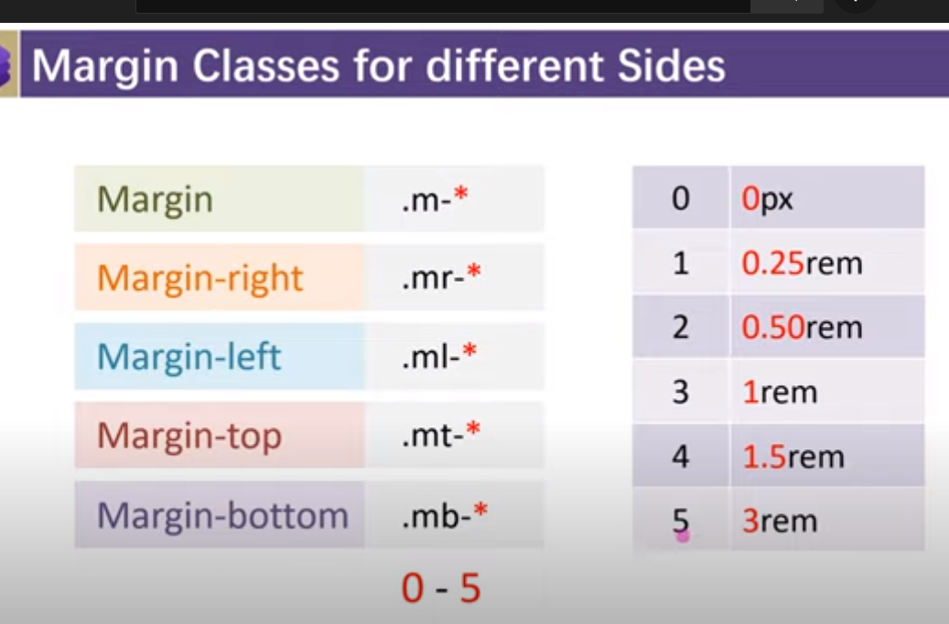

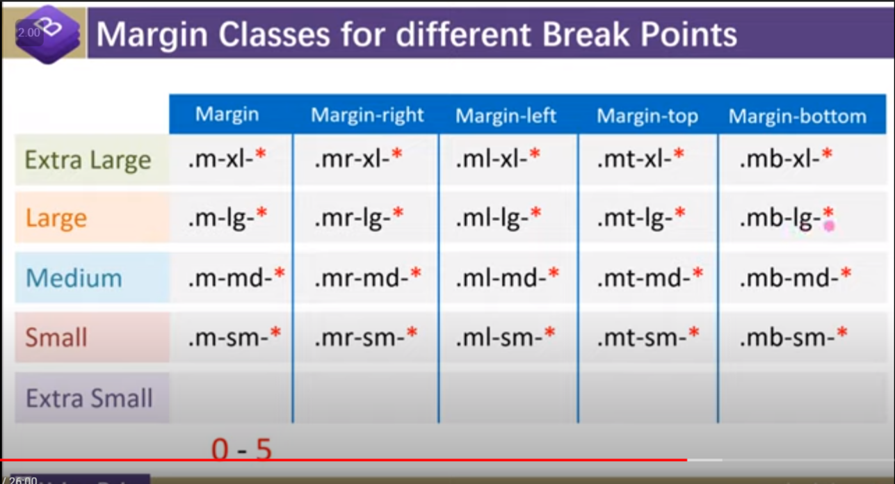

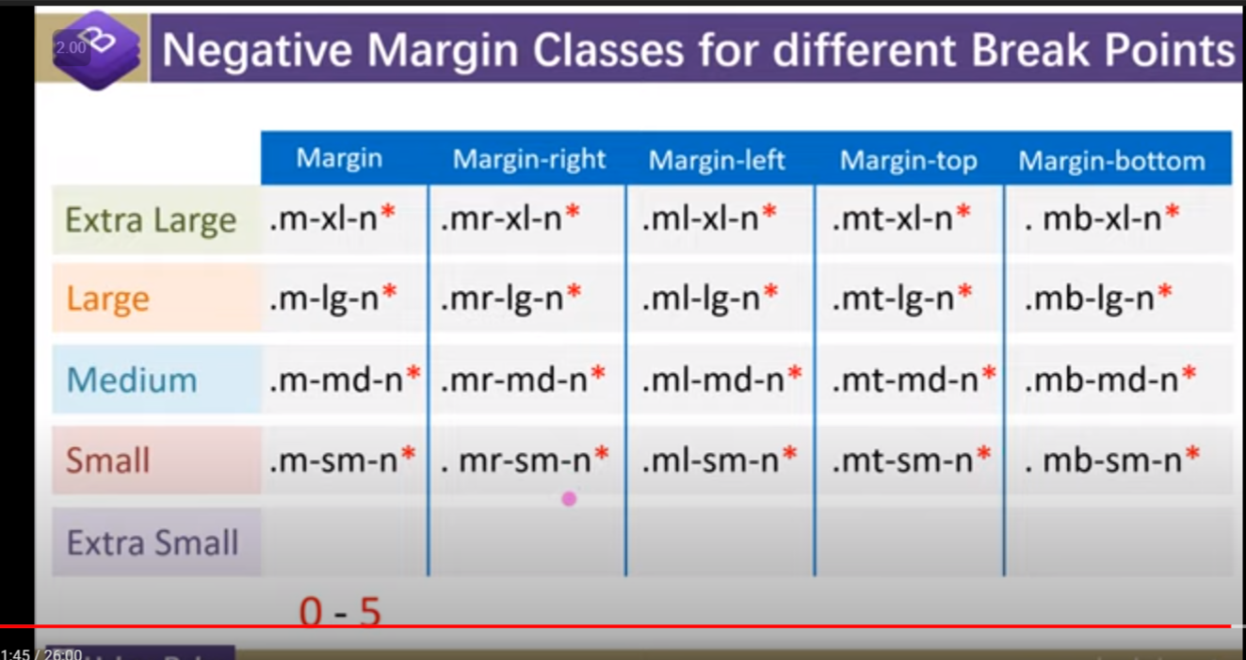

5.Padding : by default we have padding-left/-right:15px;

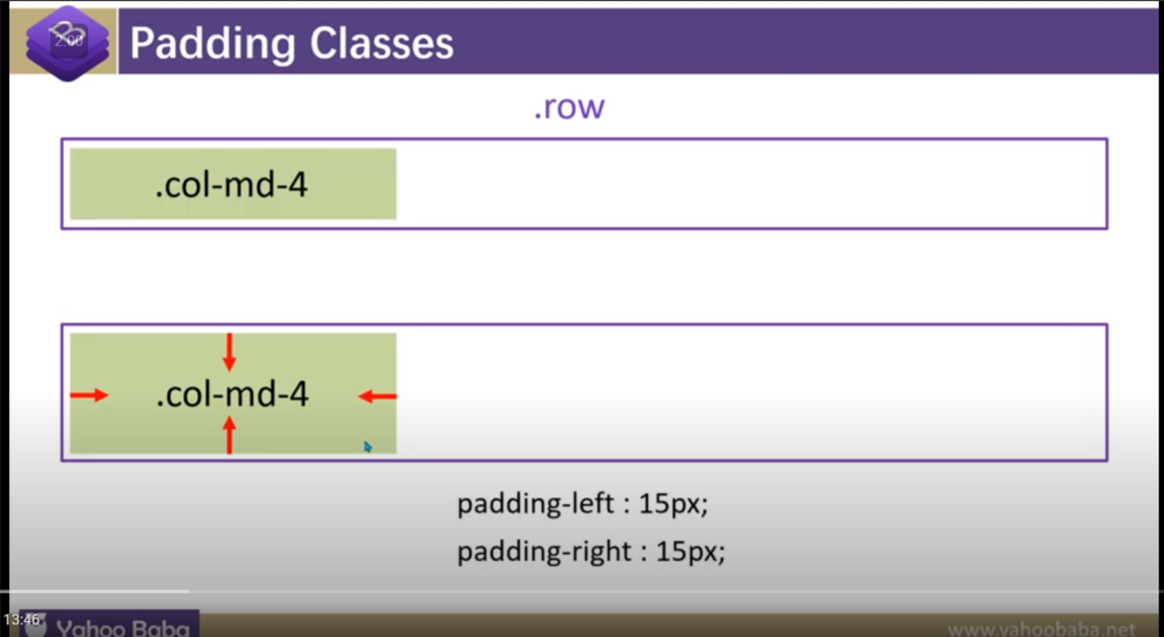

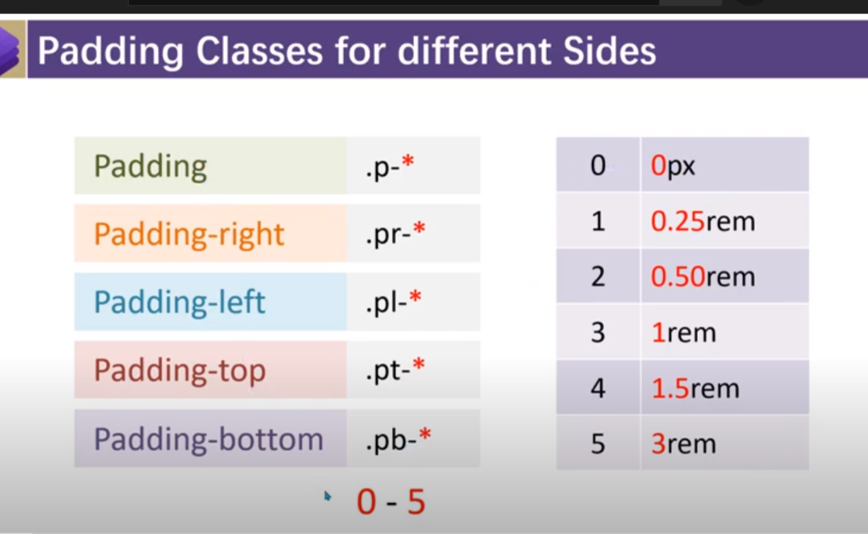

5.1. For padding y-axis or margin x-axis :

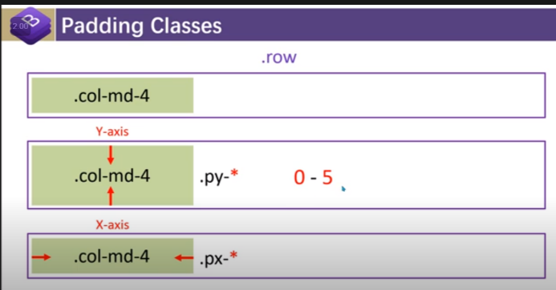 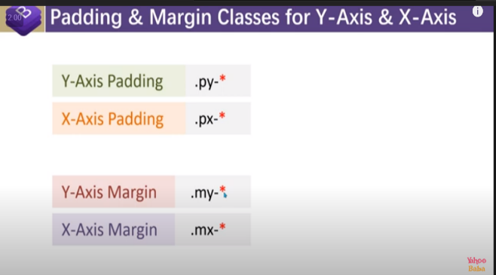

Note:By default we have :

i)container padding-left/right:15px;

ii) col padding-left/right:15px;

iii)row margin-left/right:-15px;

5.2if I want no by default padding in col :

so we need to put class in row : no-gutters

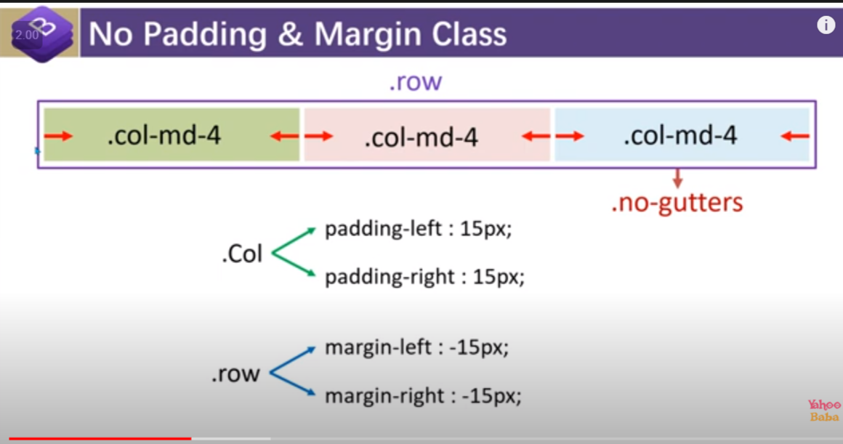

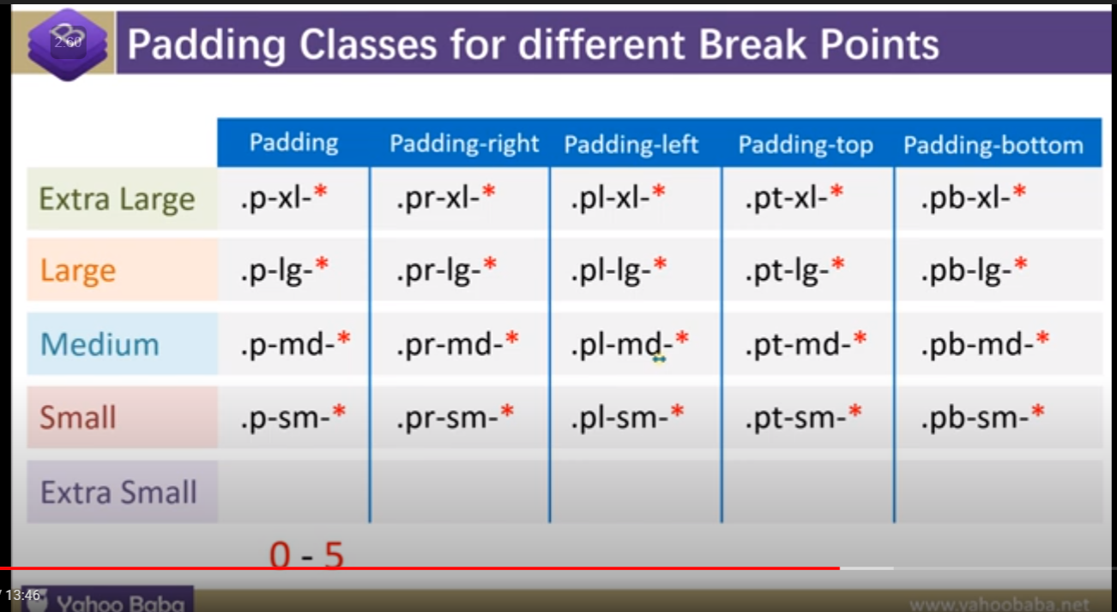

6.HORIZONTAL ALIGMENT :

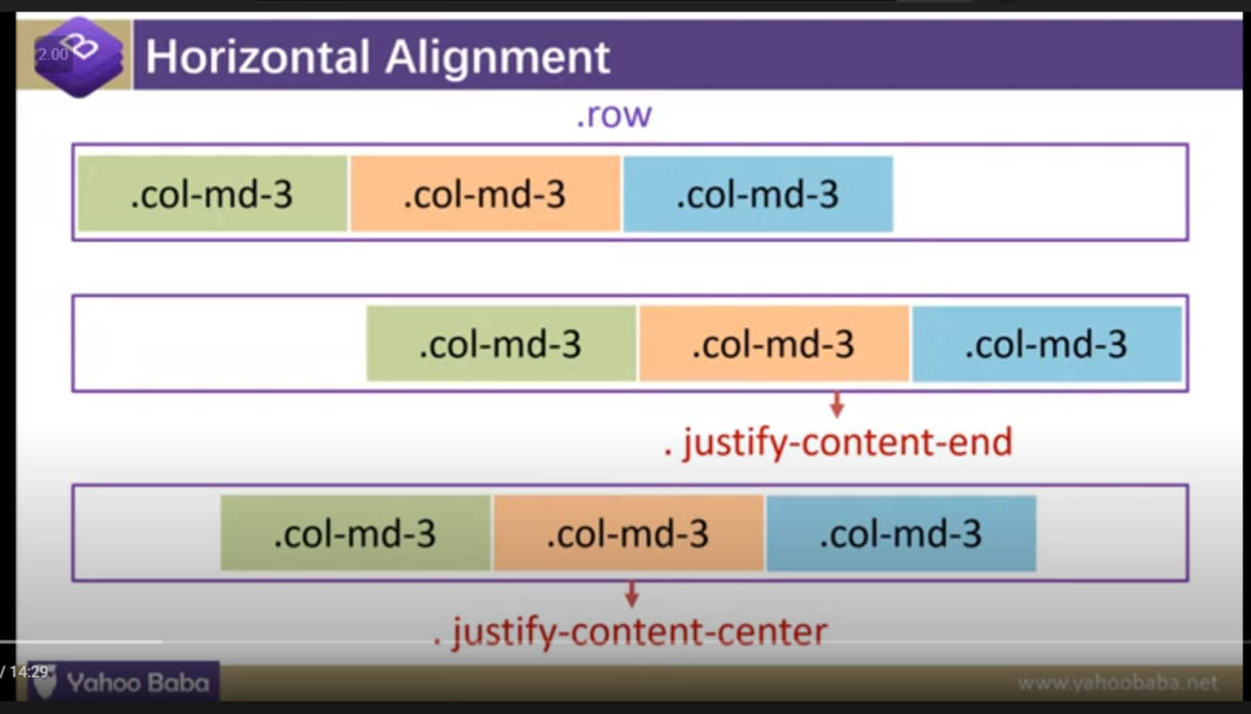

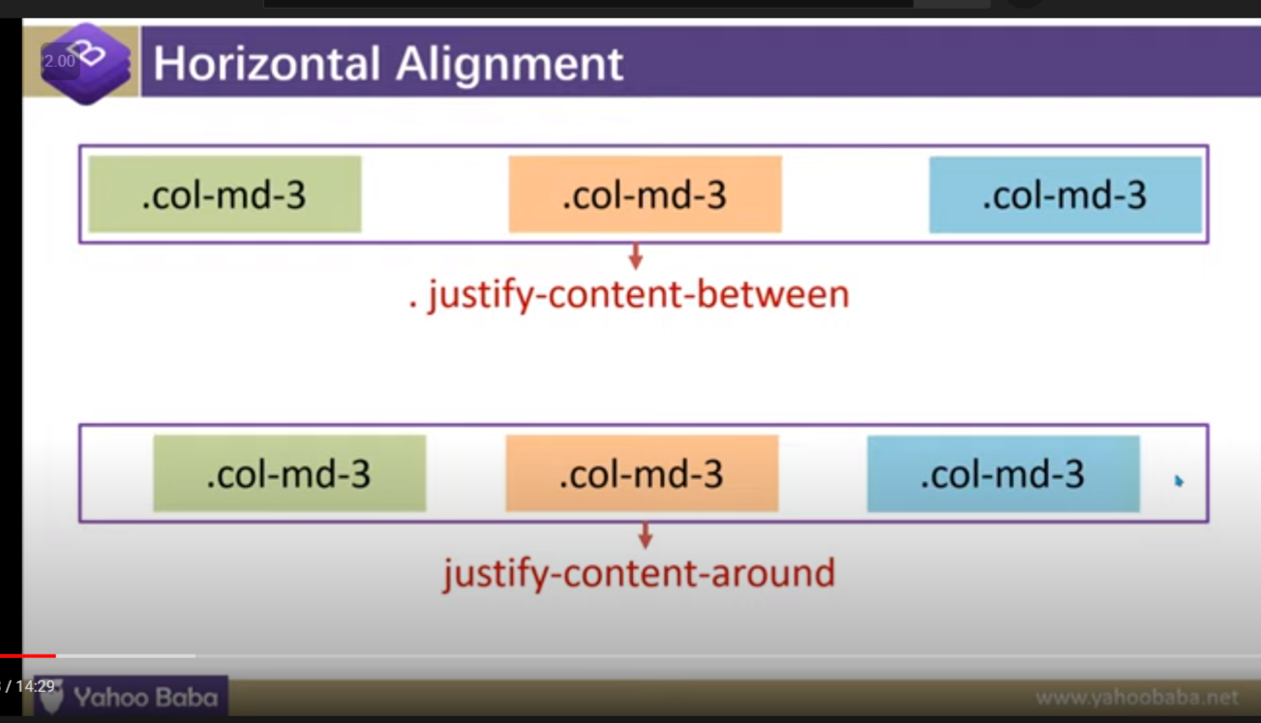

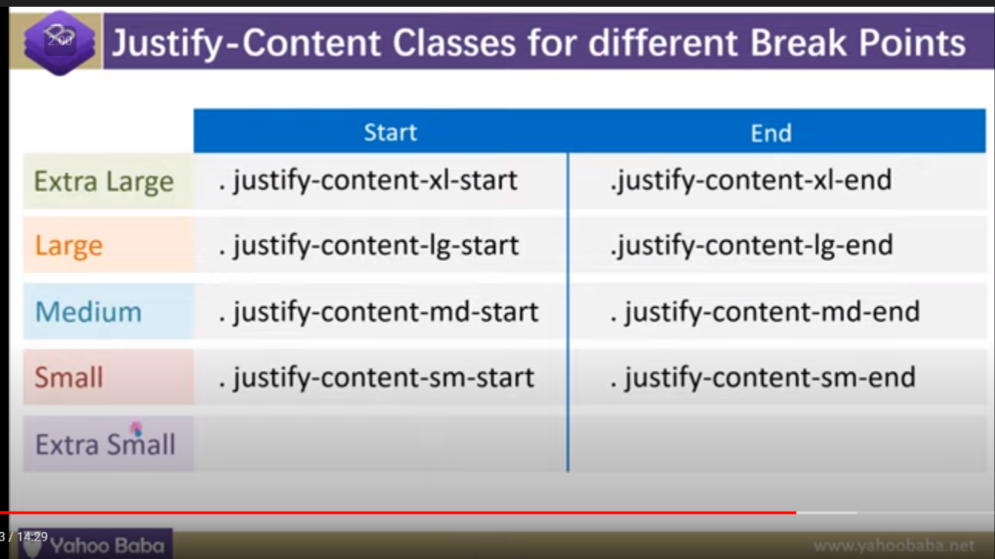

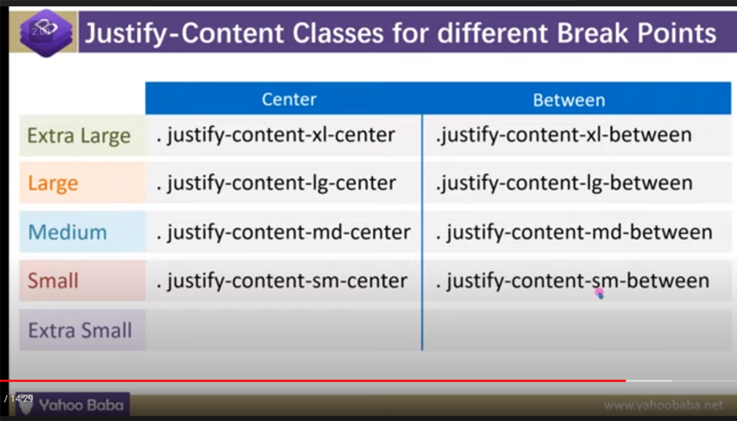

7. vertical alignment :

7.1 . align-items:

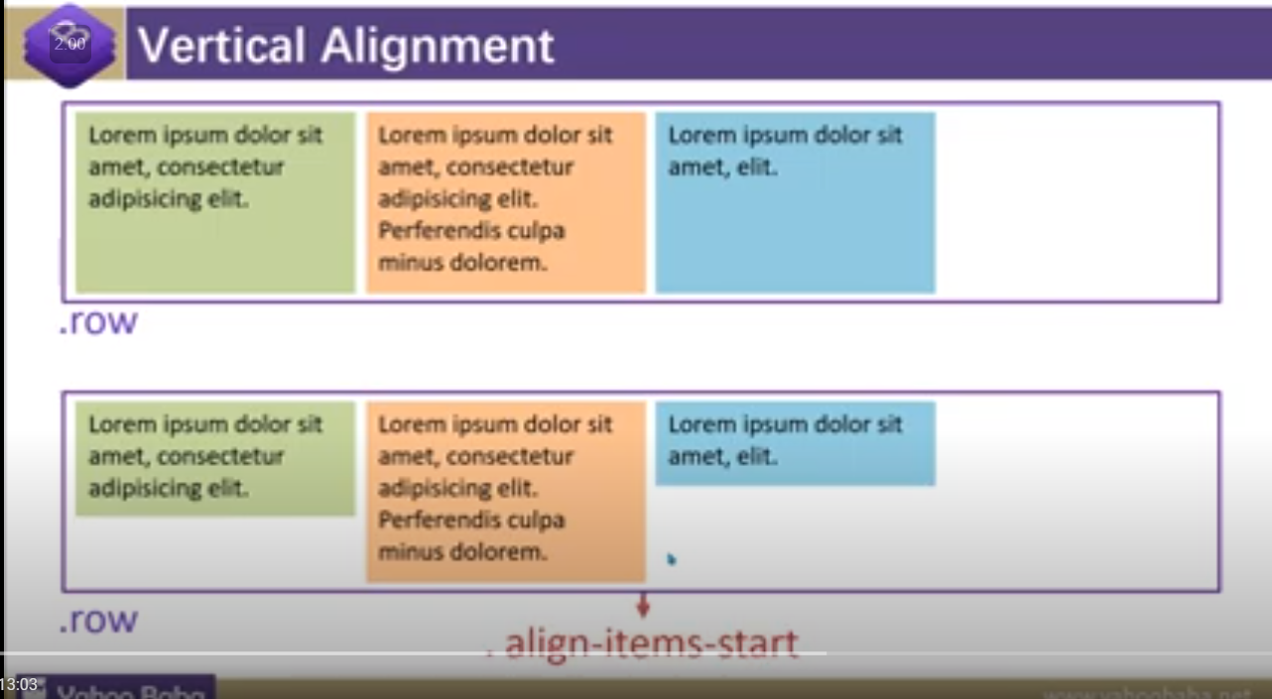

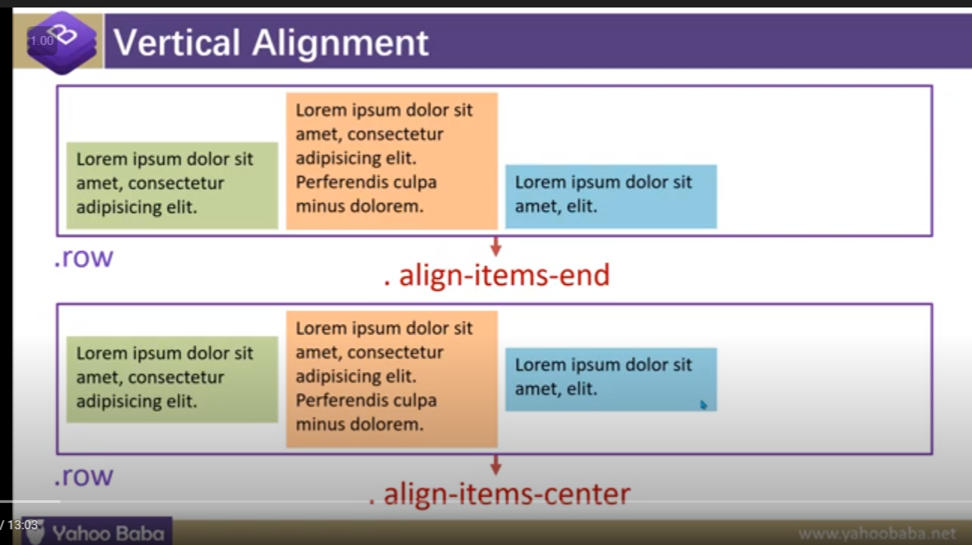

7.2.Align content : it works only when we have given height

1.red arrow indicating that we have give height

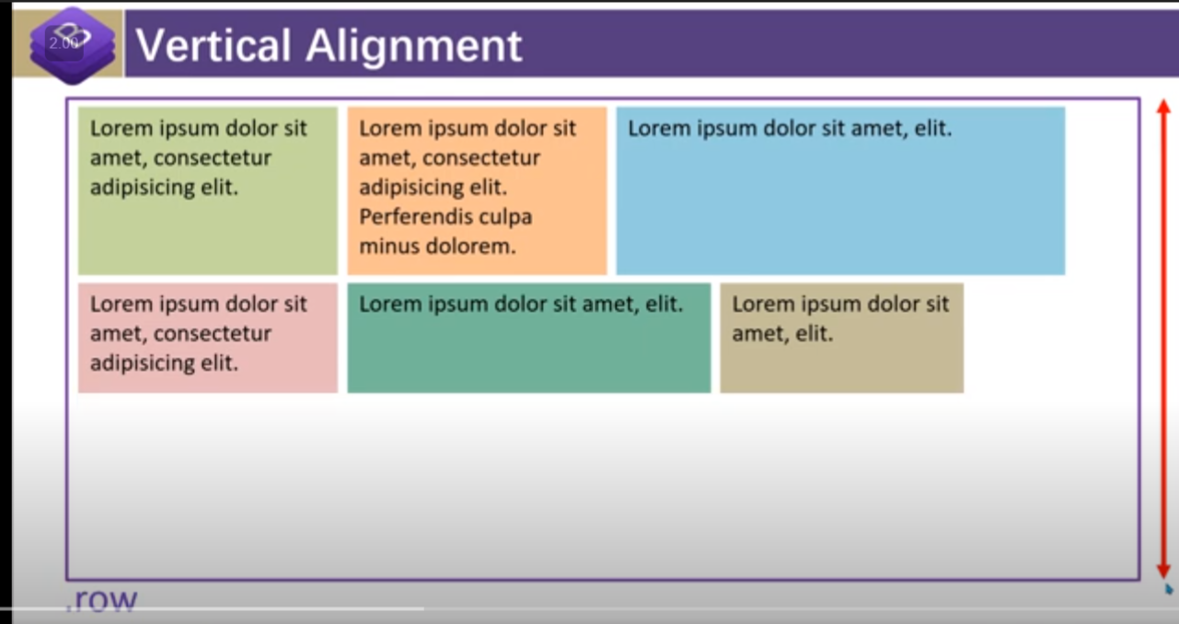

In boot strap : after giving height it will be going to look like this

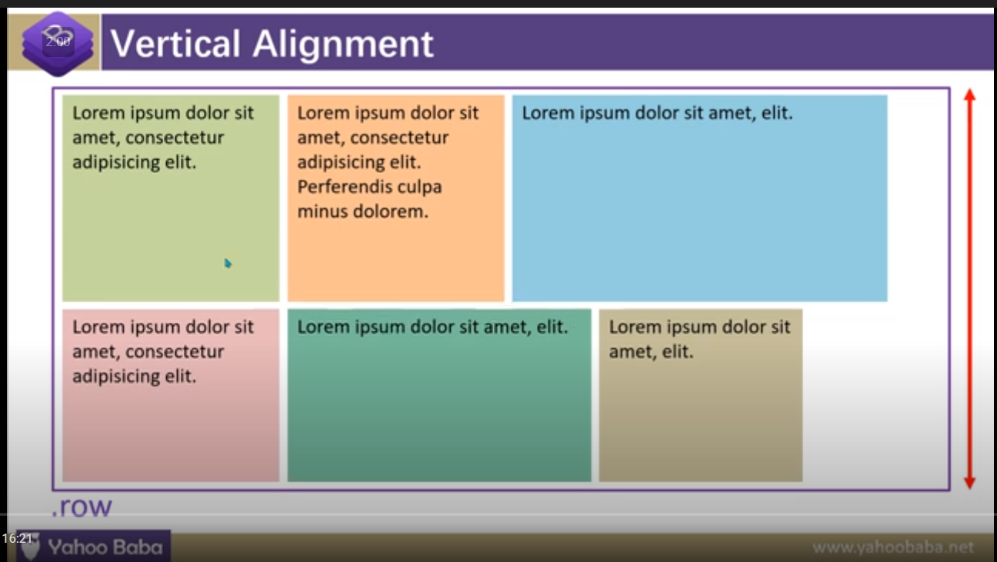

But if we do not want it like this .

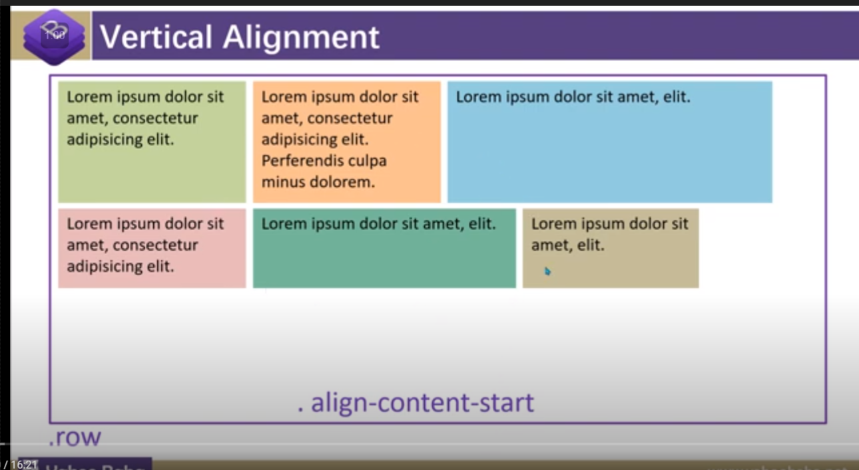

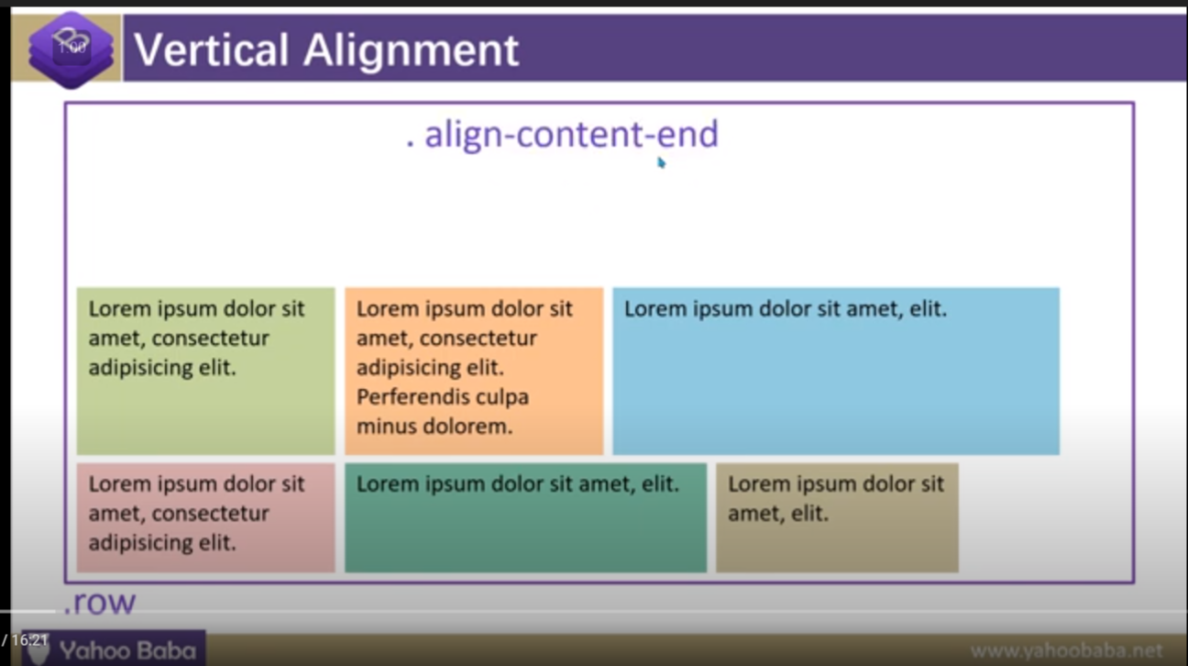

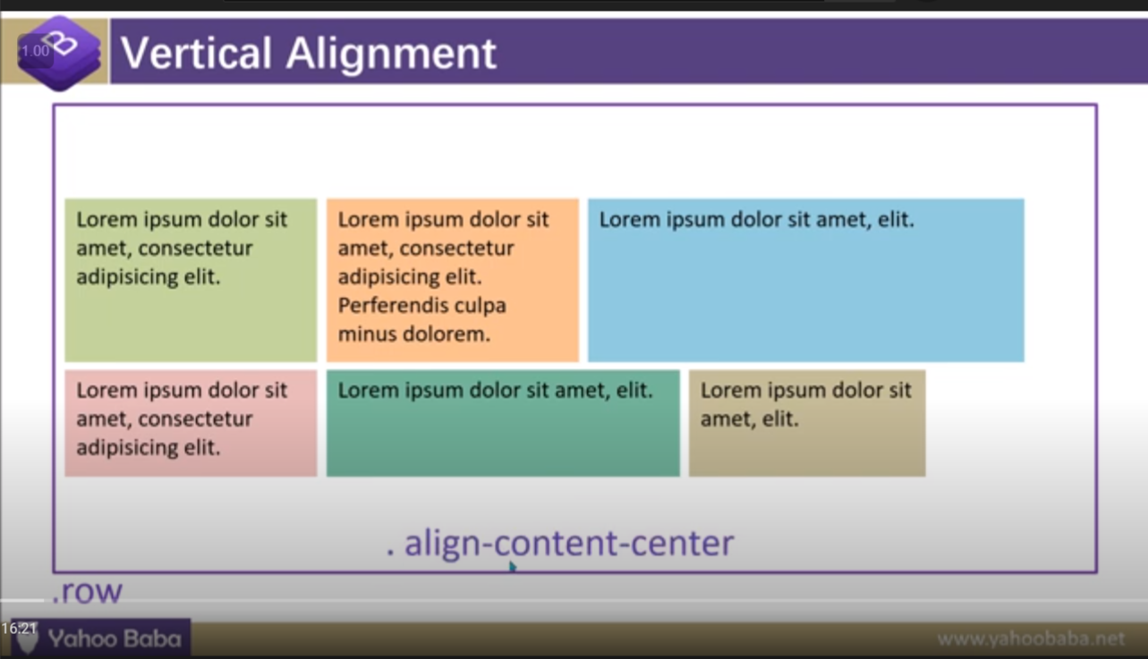

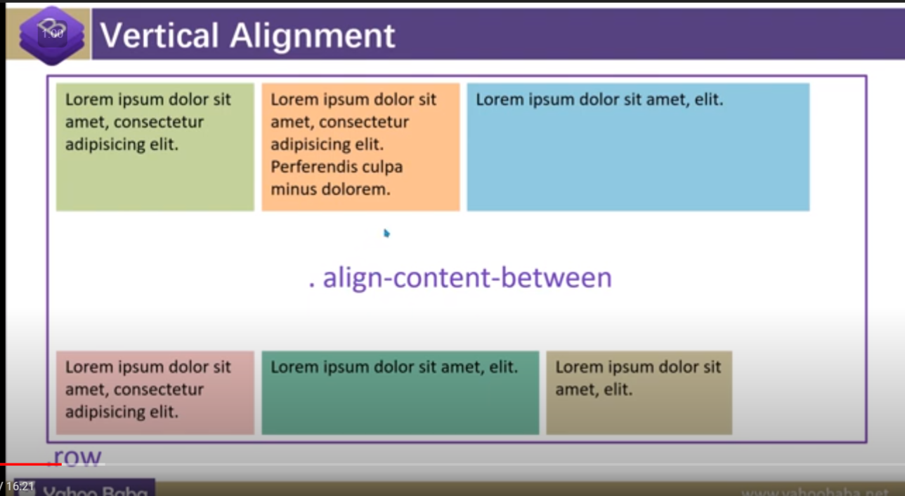

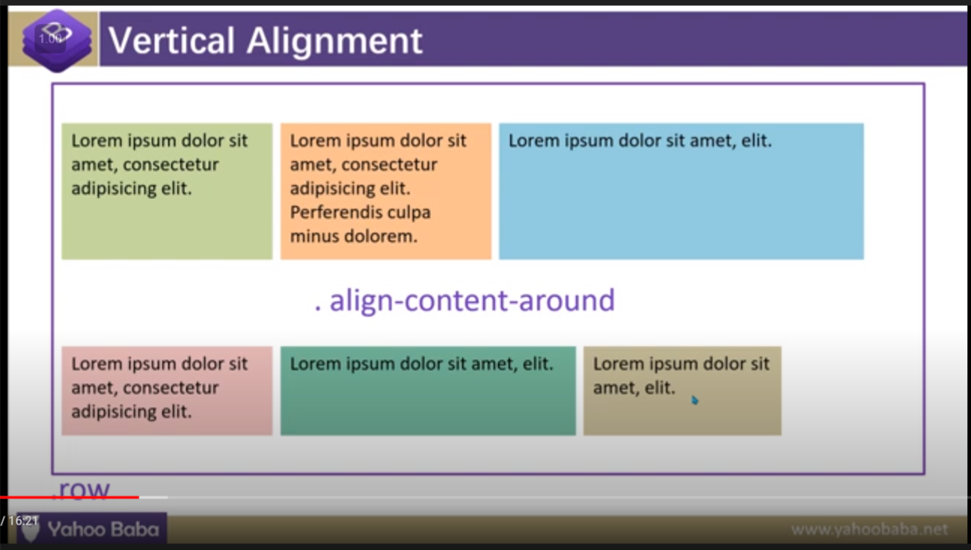

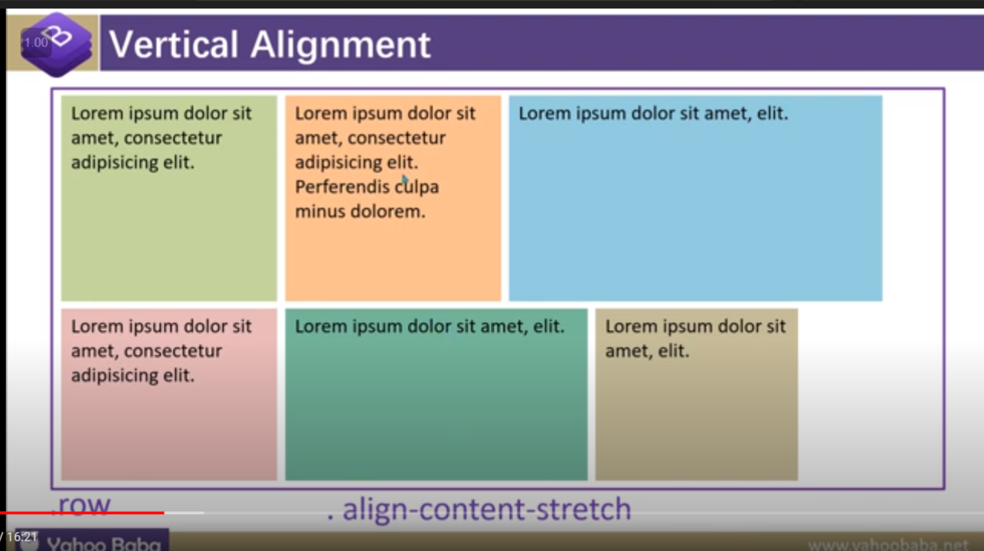

7.3 . algin-self:

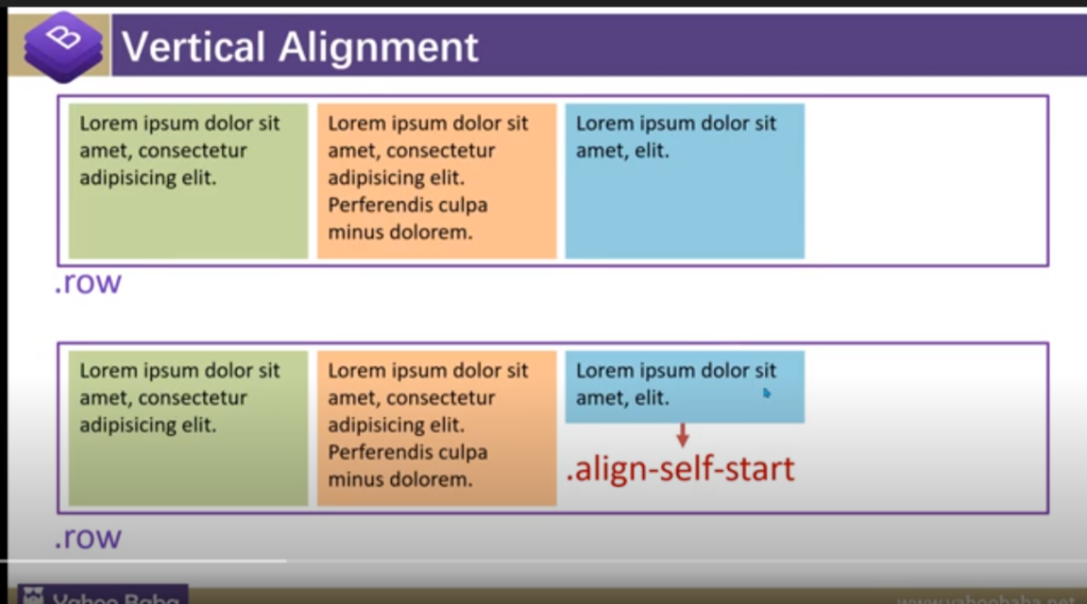

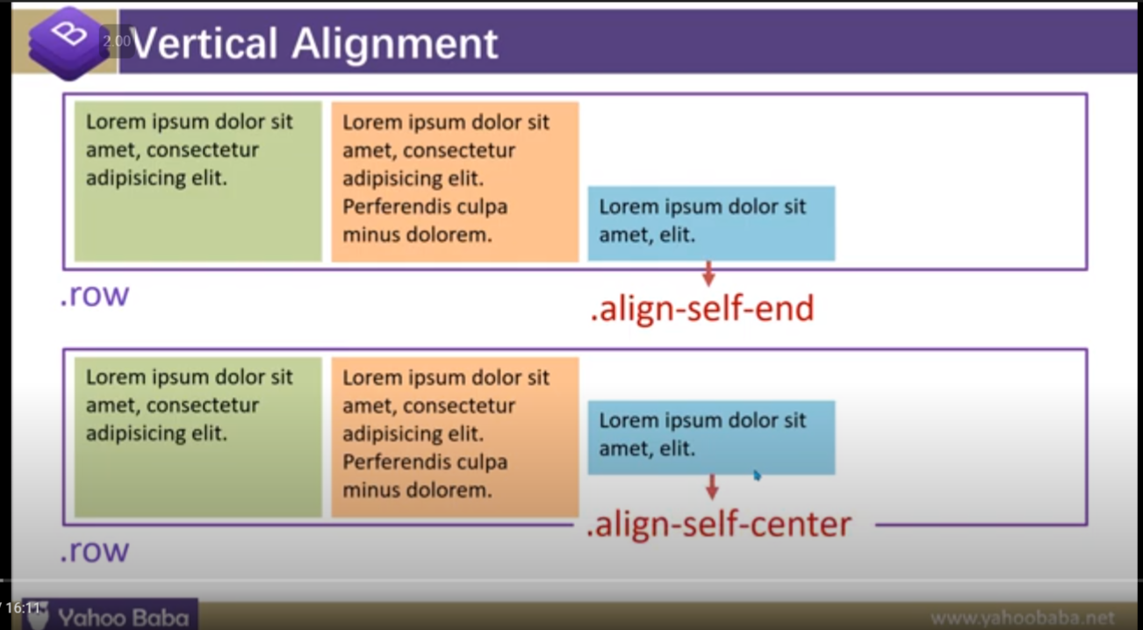

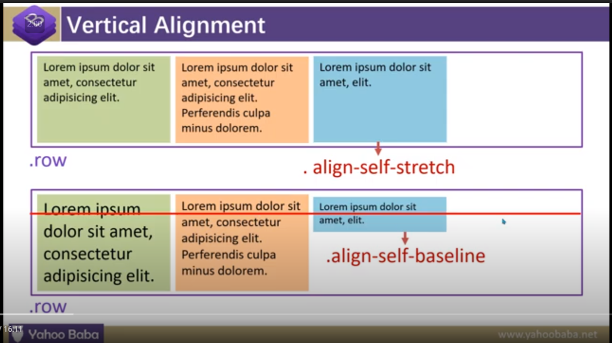

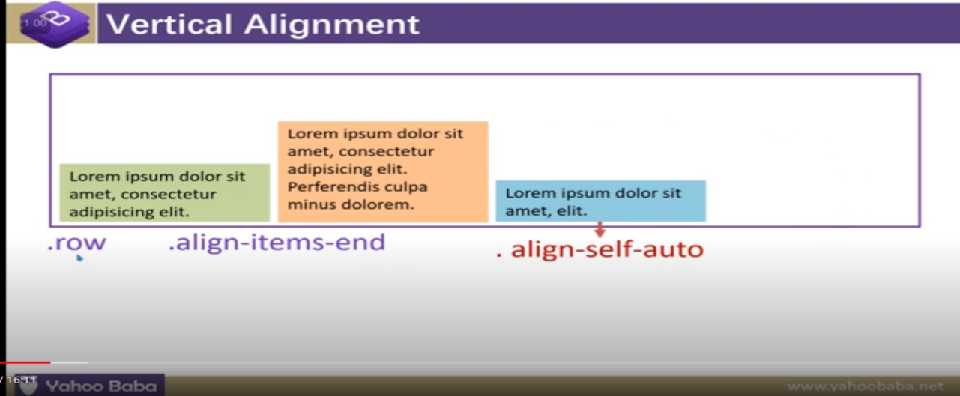

8.Flex direction :

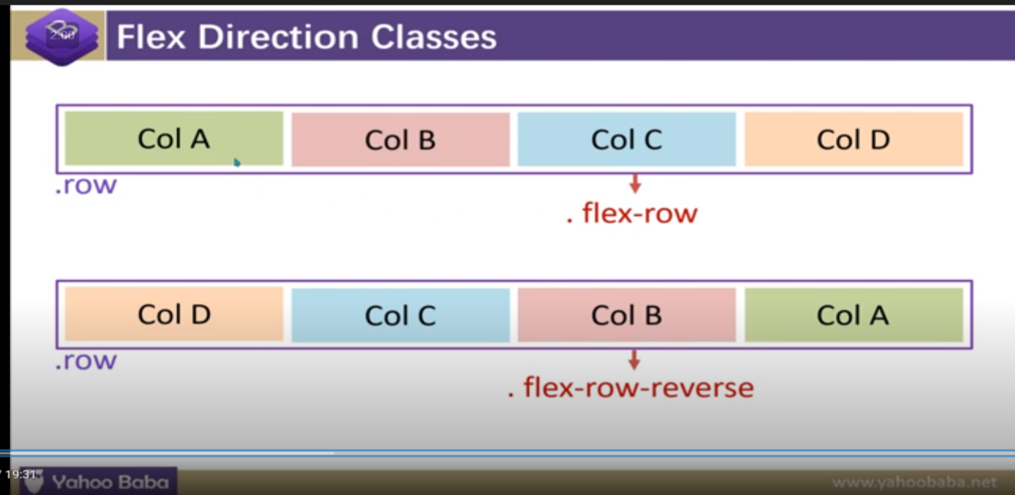

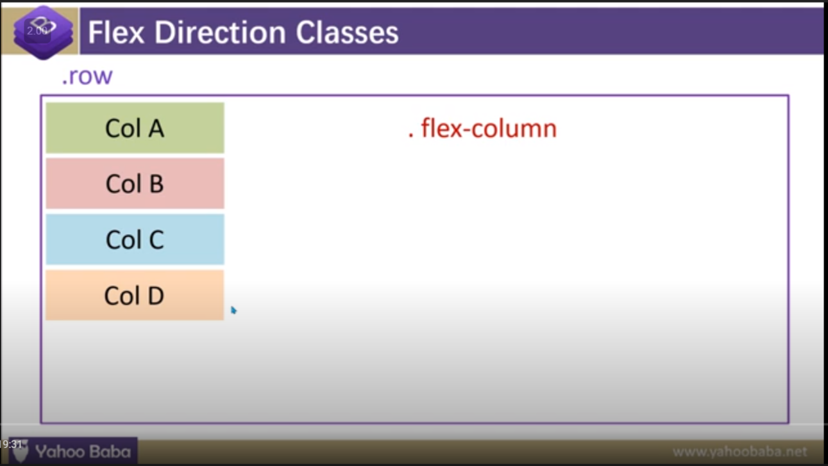

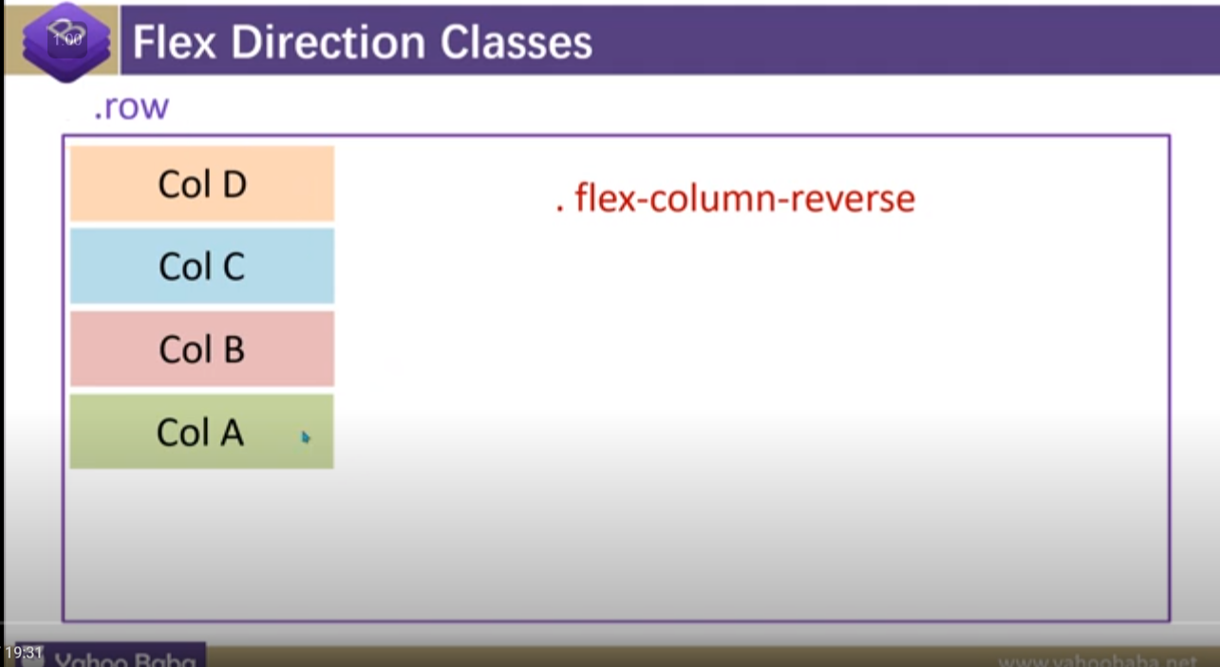

9:Flex wrap:

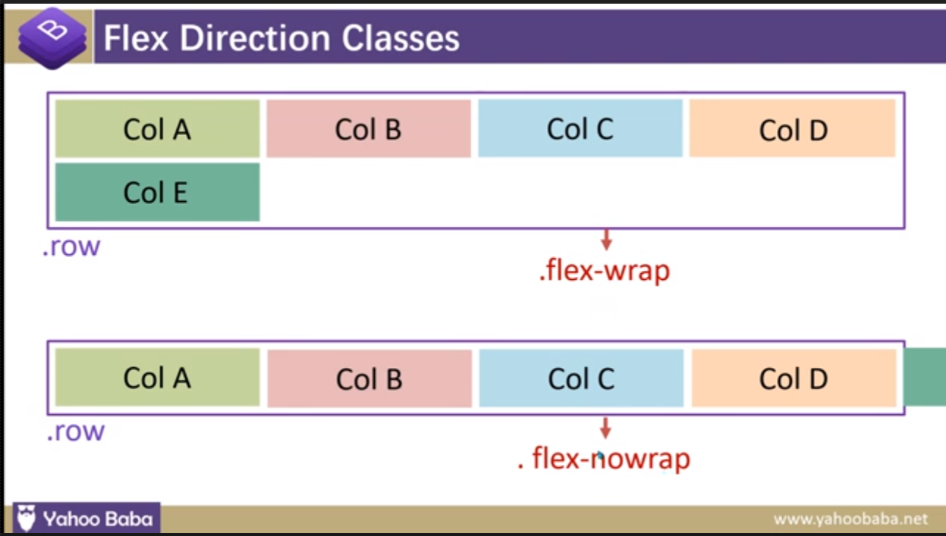

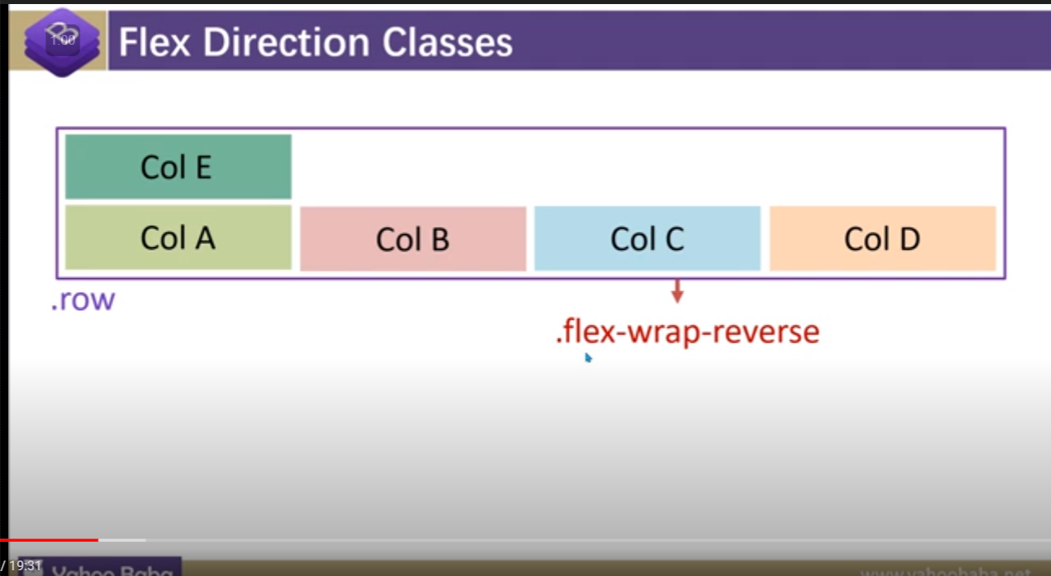

10. Display : it generally used when we are not using row or we want to change the display aperture .

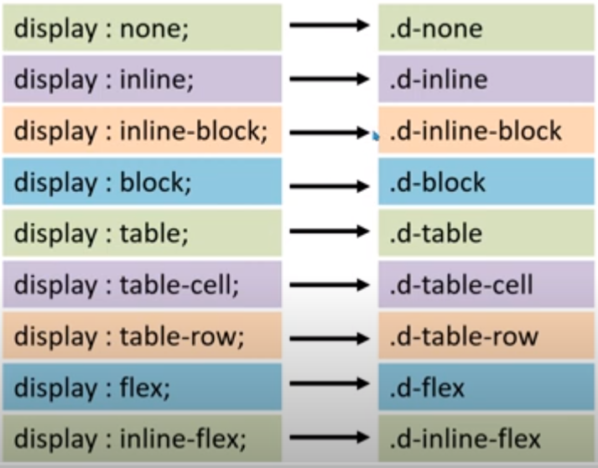

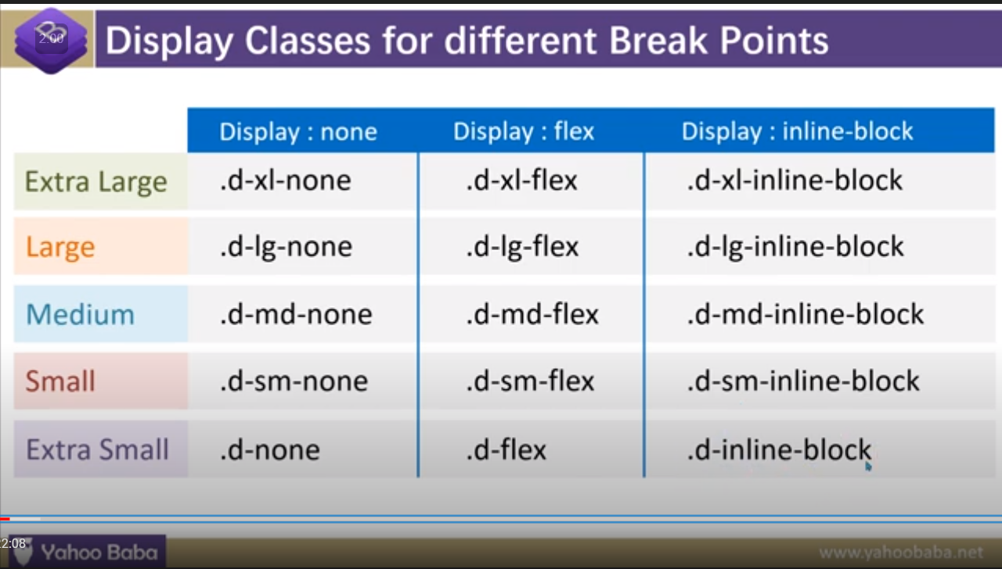

10.1. d-print- :

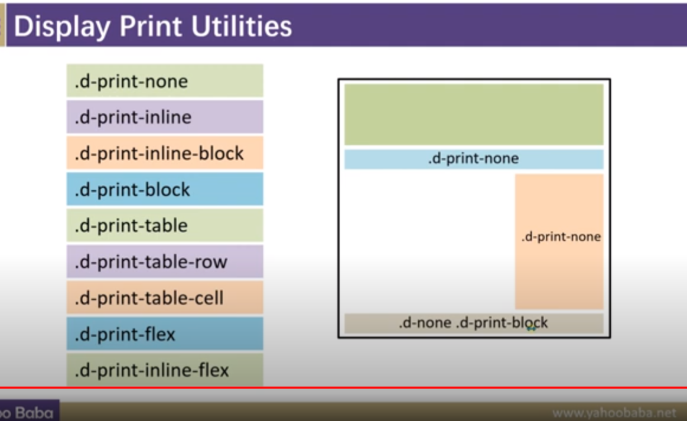

11. Float and clearfix :

Note : clearfix will be used on container

12.width or height :

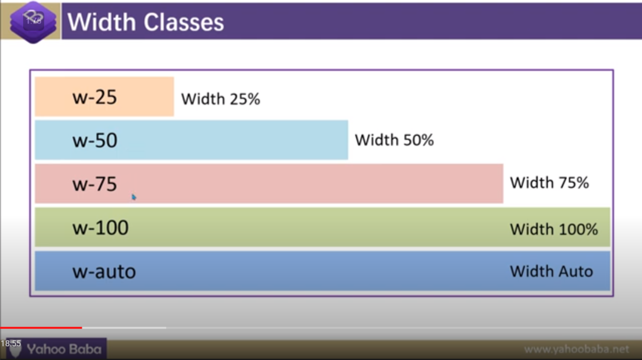

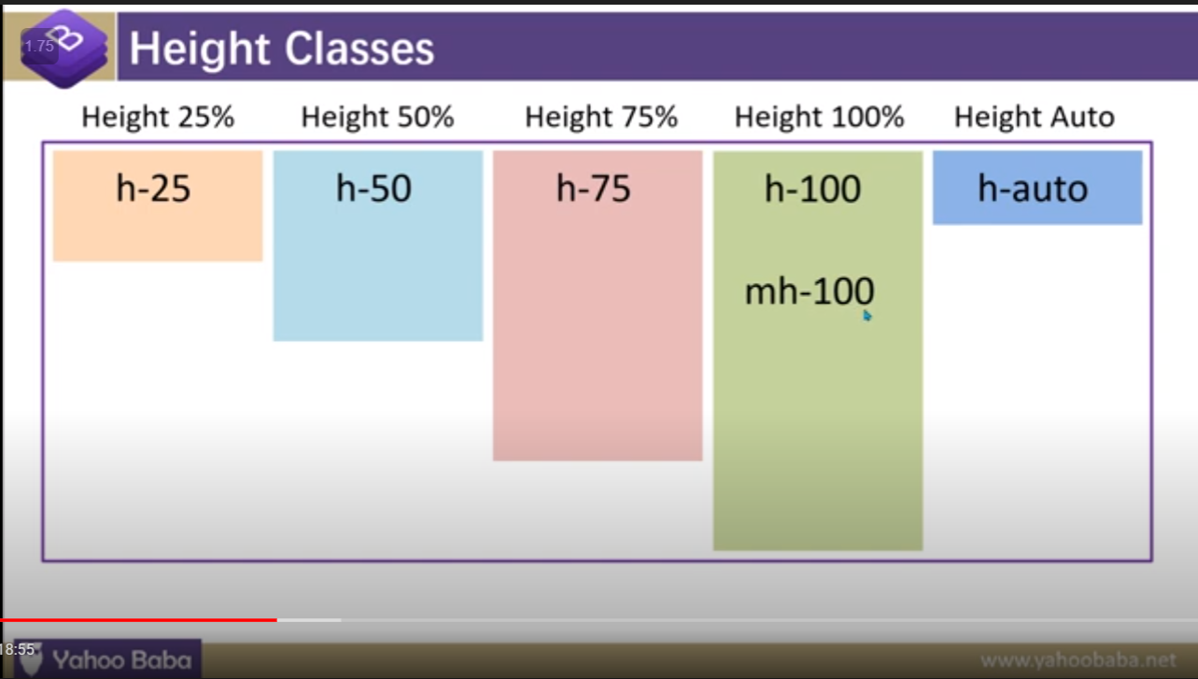

For: max-width or min-width or same for height

We will going to use .mw or .mh as a class for max

For min : we will going to use min-

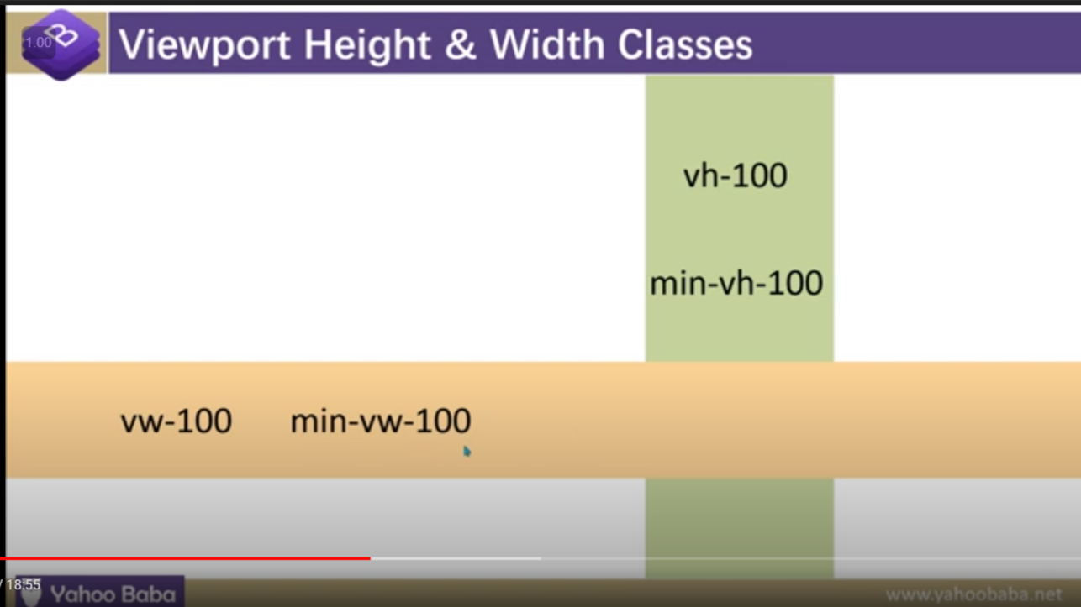

13. Position :

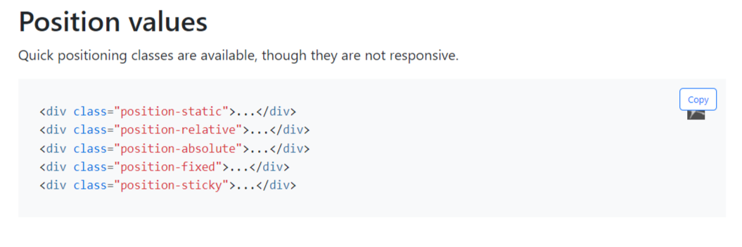

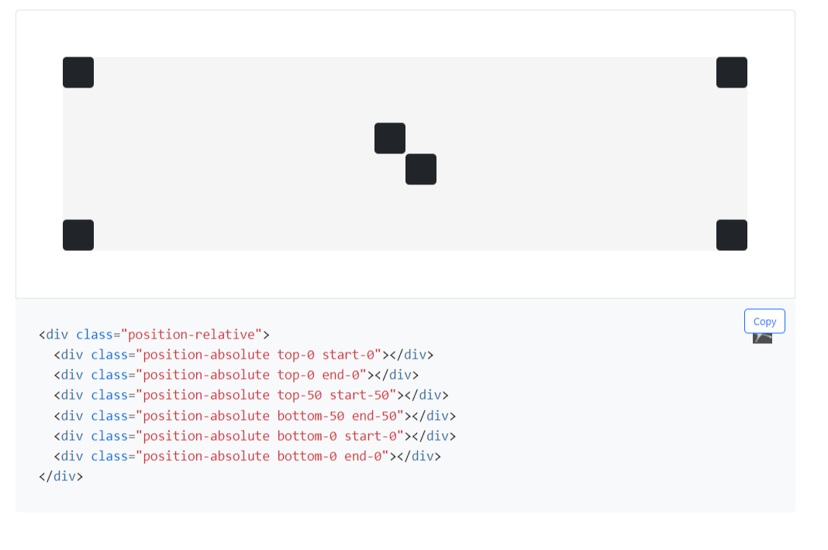

Here fixed-top or sticky-top :here left =:0;

14.OVERFLOW

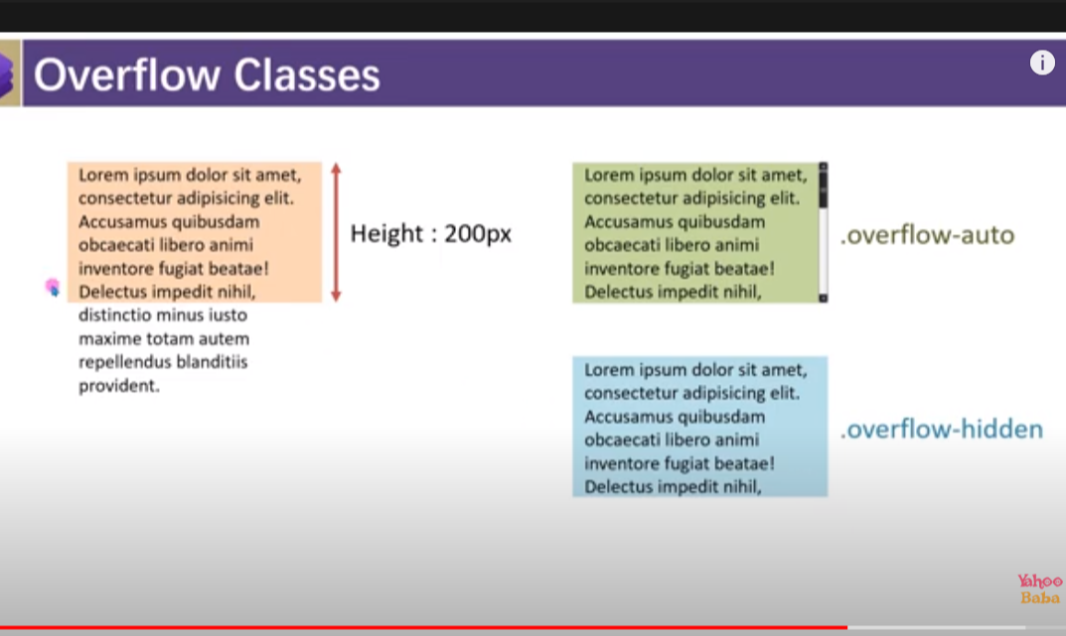

15.background and colour :

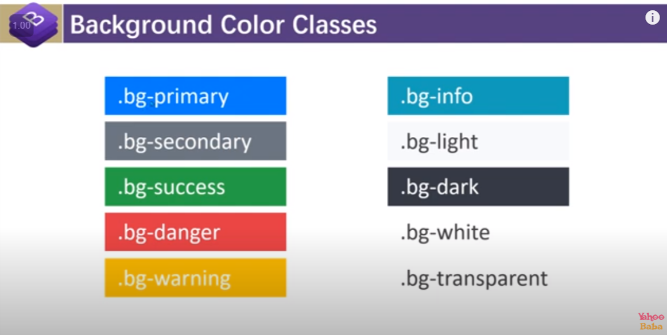

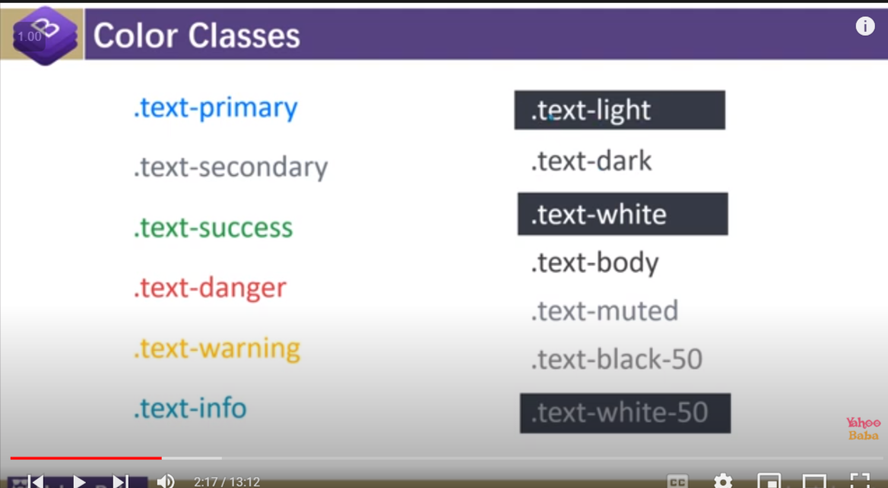

Class=”bg-primary bg-gradiant” it will going to add light colour

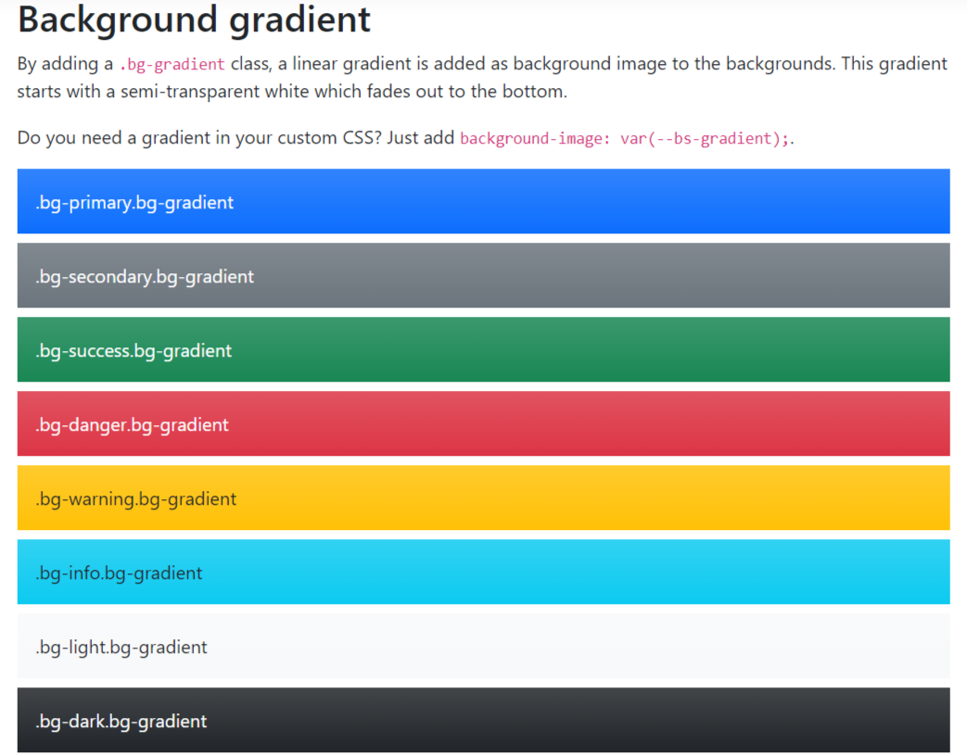

For colour use : text-primary

15.1 text -align

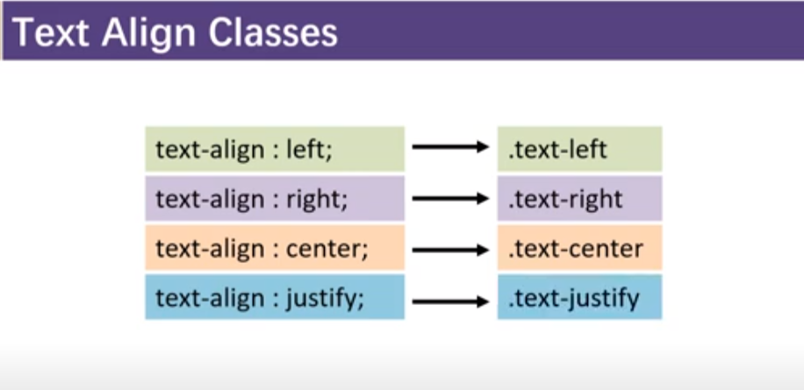

16.border

<span class="border border-primary"></span>

<span class="border border-secondary"></span>

<span class="border border-success"></span>

<span class="border border-danger"></span>

<span class="border border-warning"></span>

<span class="border border-info"></span>

<span class="border border-light"></span>

<span class="border border-dark"></span>

<span class="border border-white"></span>

<span class="border-0"></span>

<span class="border-top-0"></span>

<span class="border-right-0"></span>

<span class="border-bottom-0"></span>

<span class="border-left-0"></span>

16.1 border-radius:

Border-radius

Add classes to an element to easily round its corners.

<img src="..." alt="..." class="rounded">

<img src="..." alt="..." class="rounded-top">

<img src="..." alt="..." class="rounded-right">

<img src="..." alt="..." class="rounded-bottom">

<img src="..." alt="..." class="rounded-left">

<img src="..." alt="..." class="rounded-circle">

<img src="..." alt="..." class="rounded-0">

1ggh

17.gutter padding(in x and y) it applies on the row

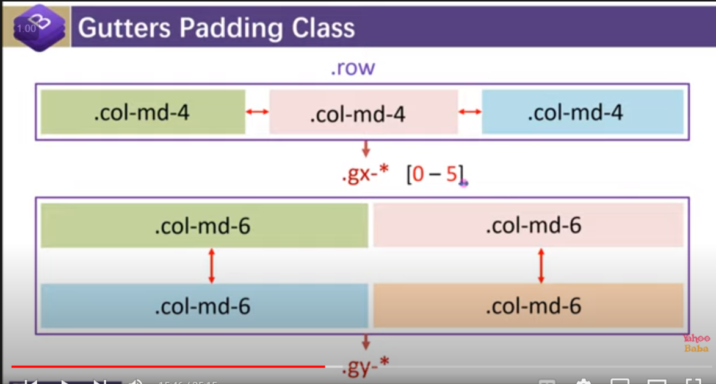

17.2gutter g

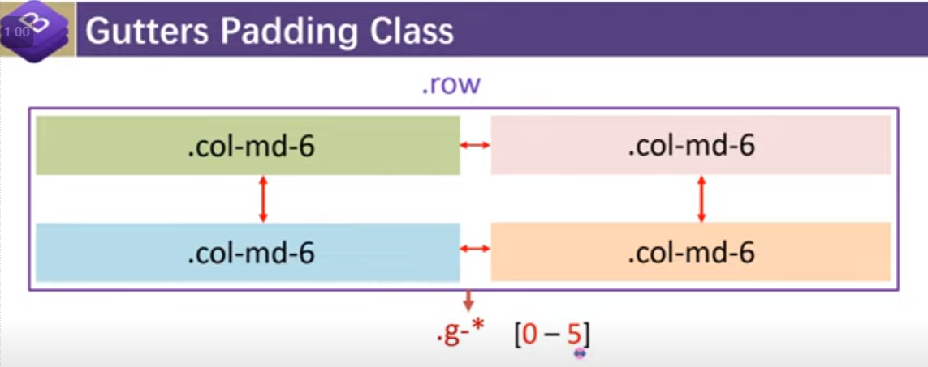

17.3gutter at different break-point

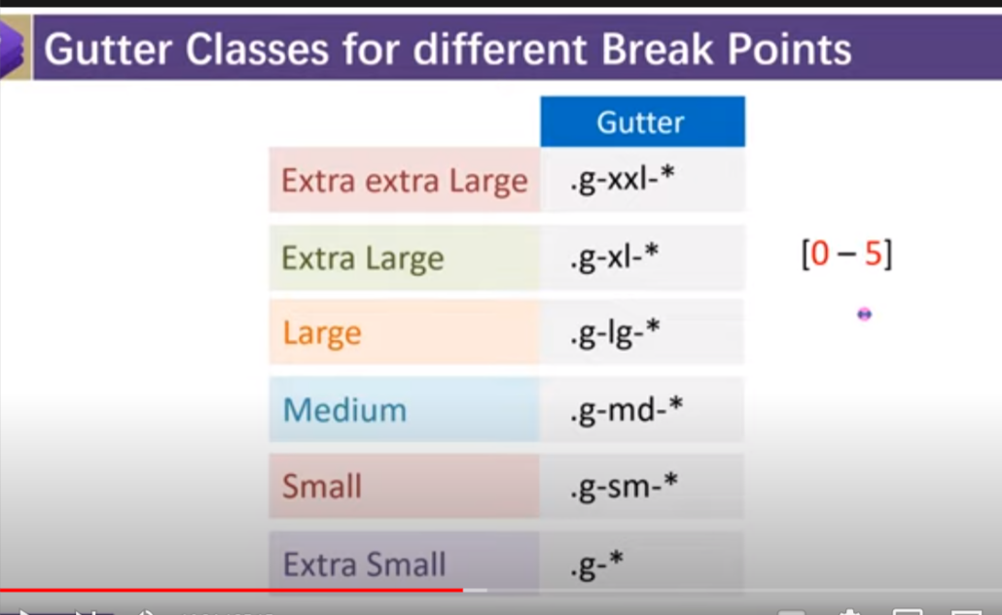

18.line-height

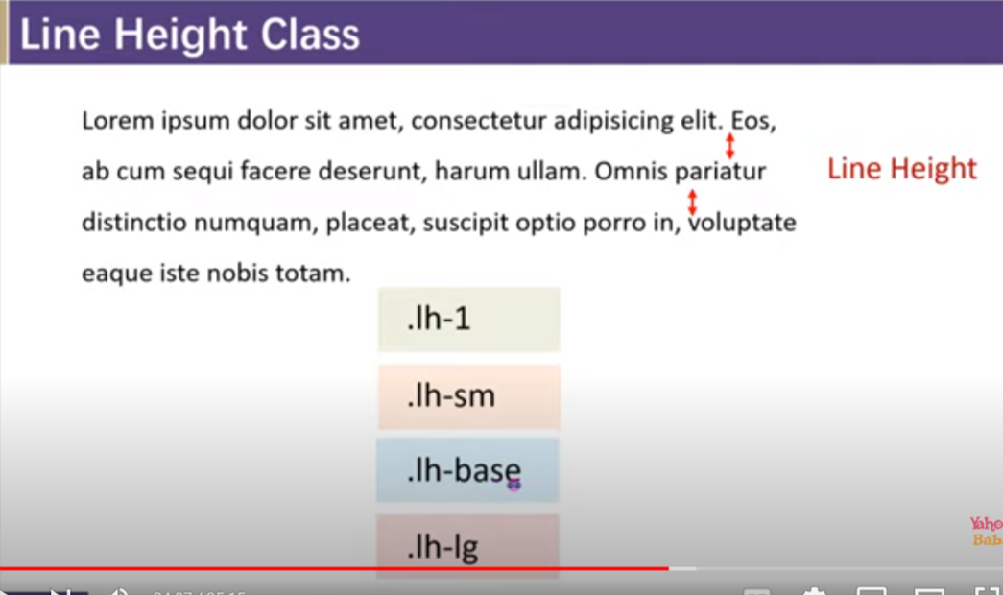

19.visiblity

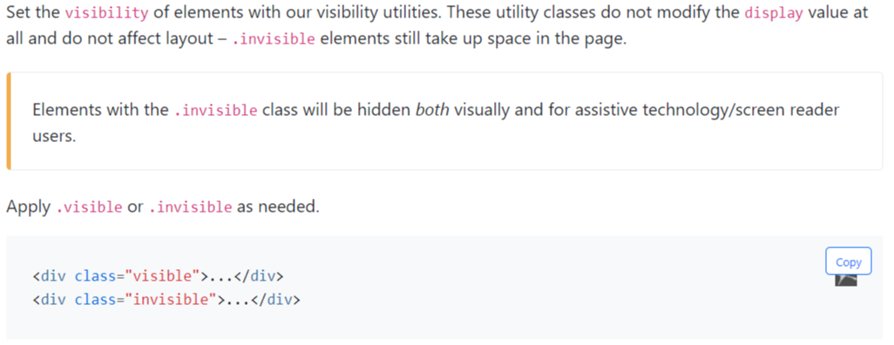

********Bootstrap property*************

1.button :

1.1

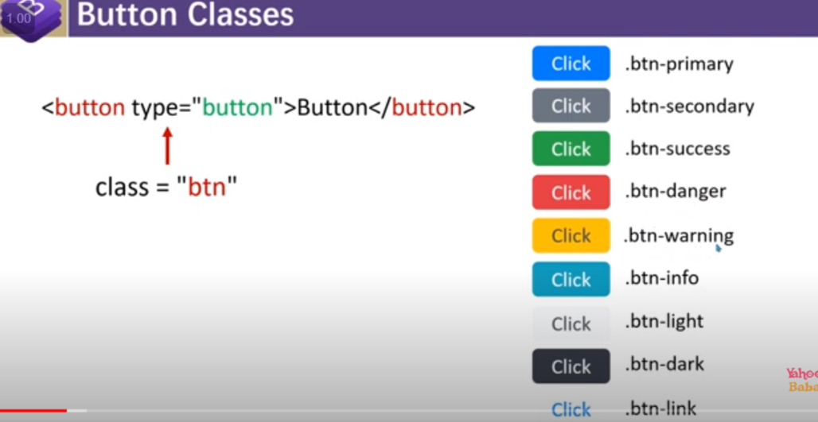

1.2 btn with different color

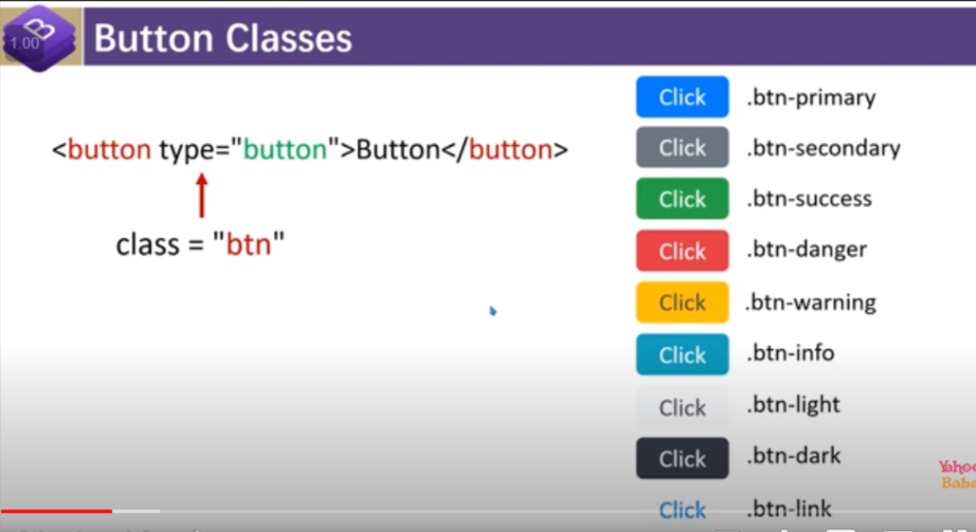

1.3 btn with the outline property

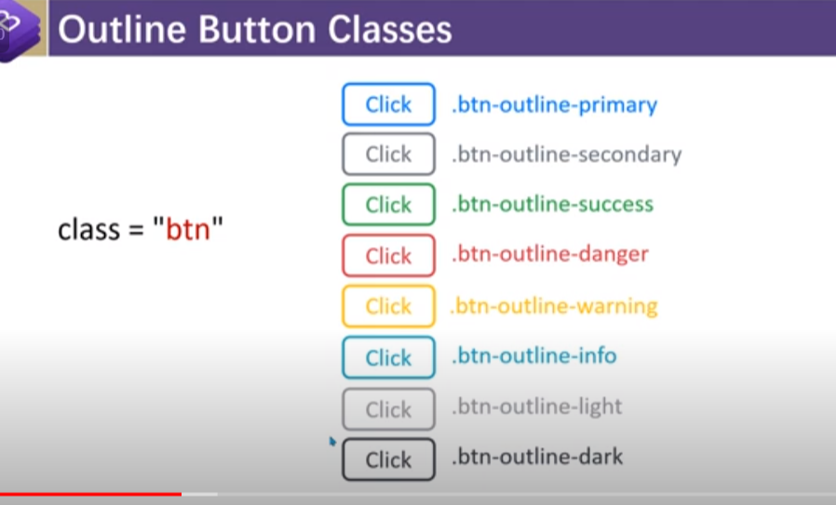

1.4 different btn size

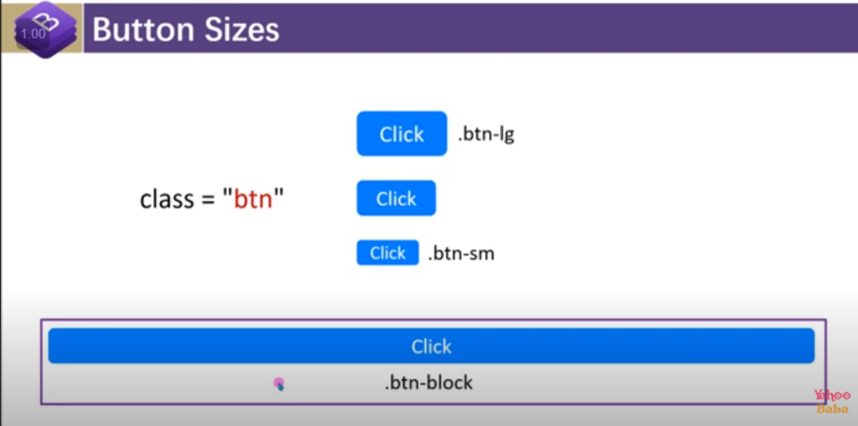

1.5 btn active or disabled

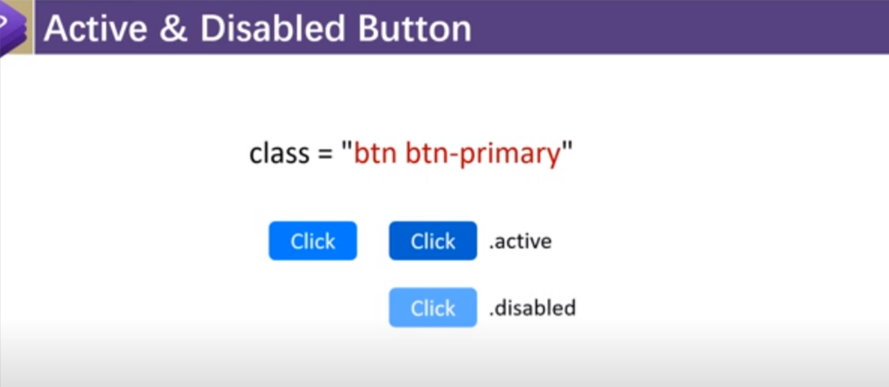

1.6 converting btn into links

By using class=”btn btn-link”

1.7.btn plugins :

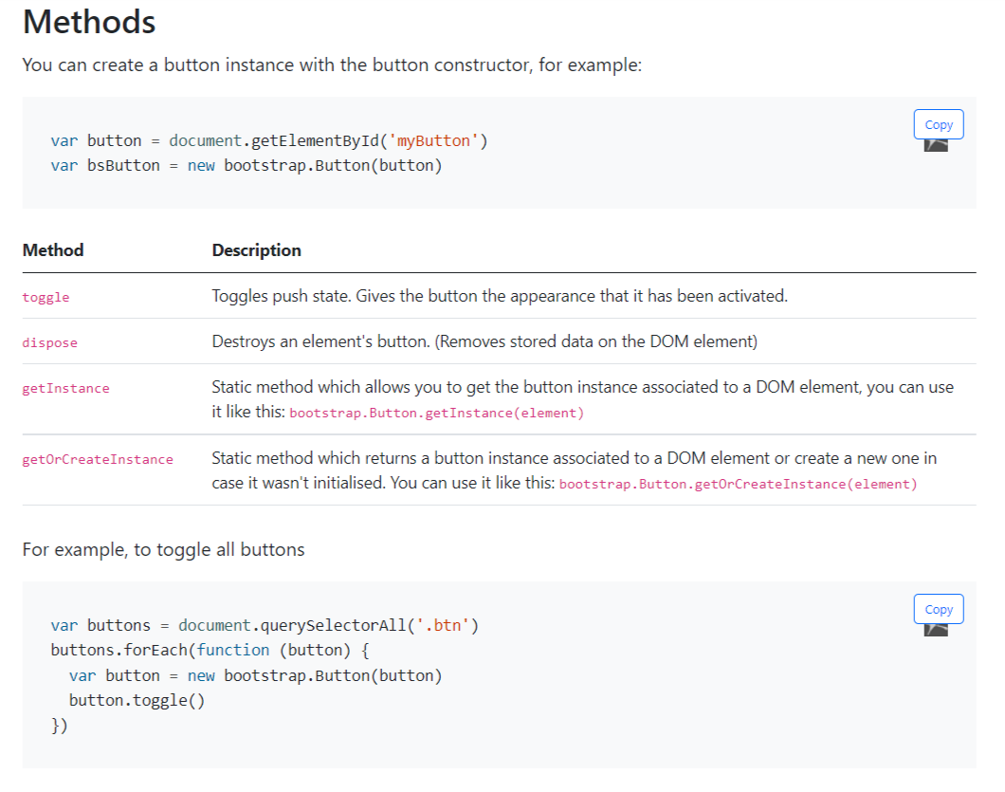

2.btn group

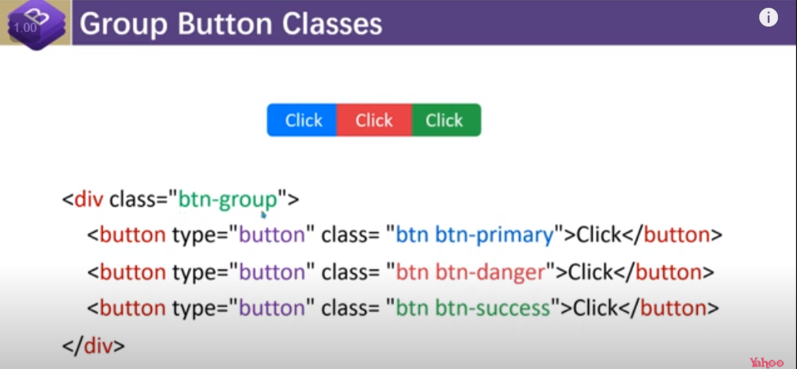

2.2 btn group size

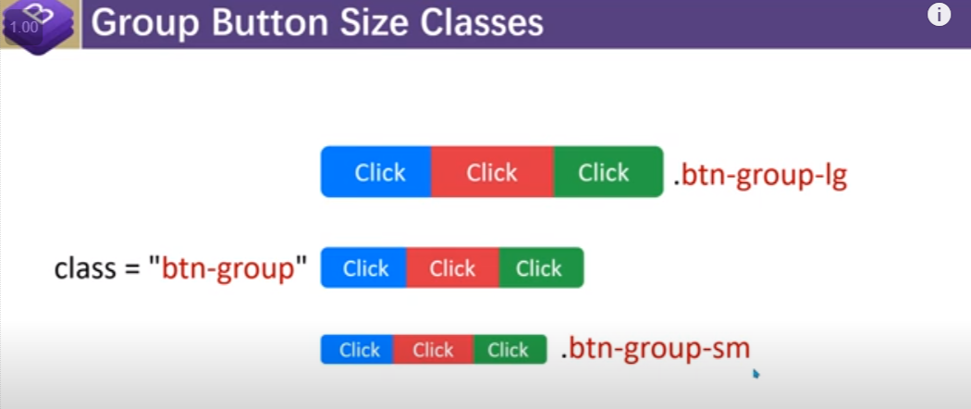

2.3 btn toolbar

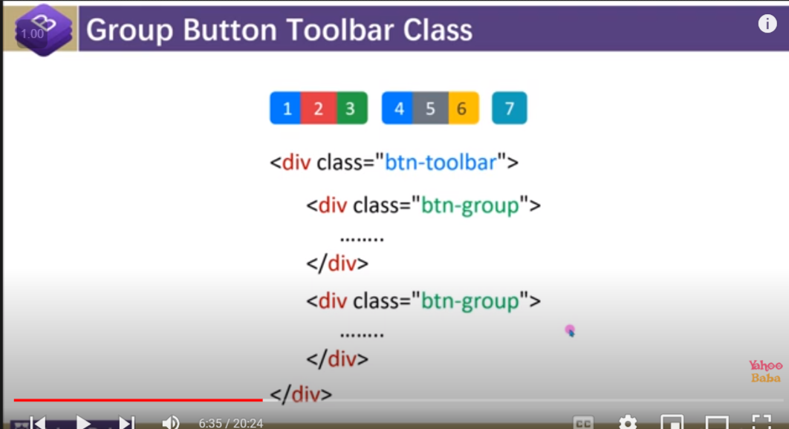

2.4 Btn-vertical

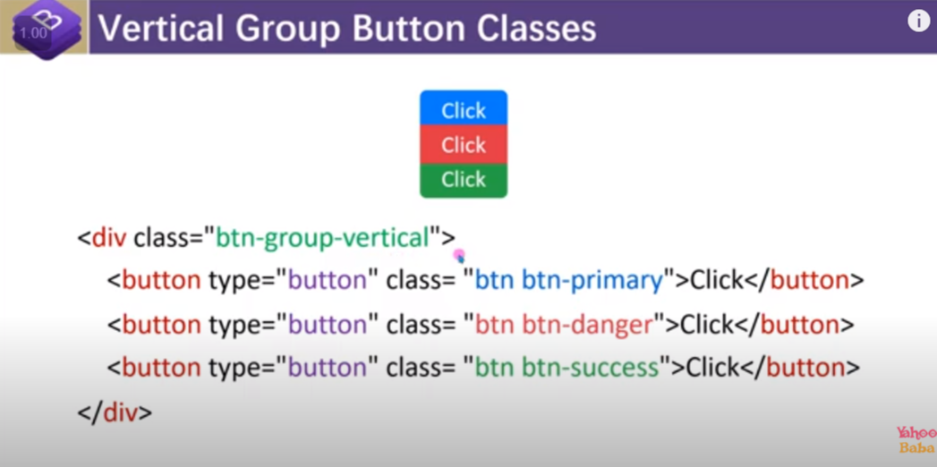

3.btn drop-down

Link :

<https://getbootstrap.com/docs/5.0/components/dropdowns/>

4. List group

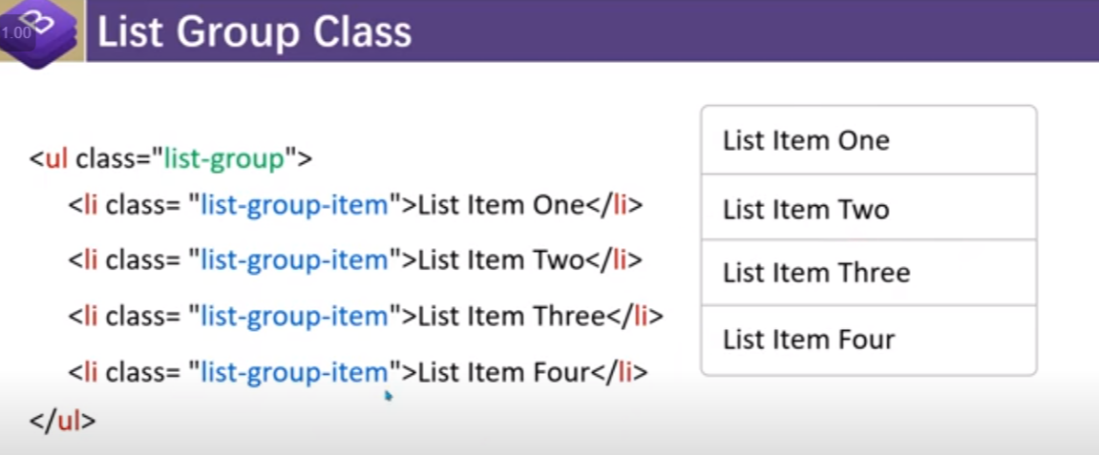

4.2 list without outer border

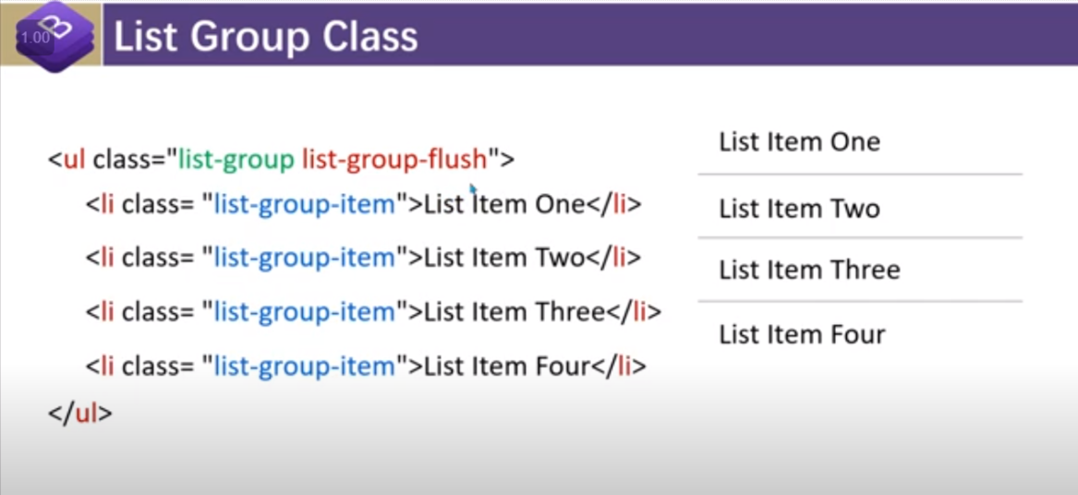

4.3 list group with active and disabled

4.4 list group with the different colour

Note : class=”list-group-item list-group-item-primary”

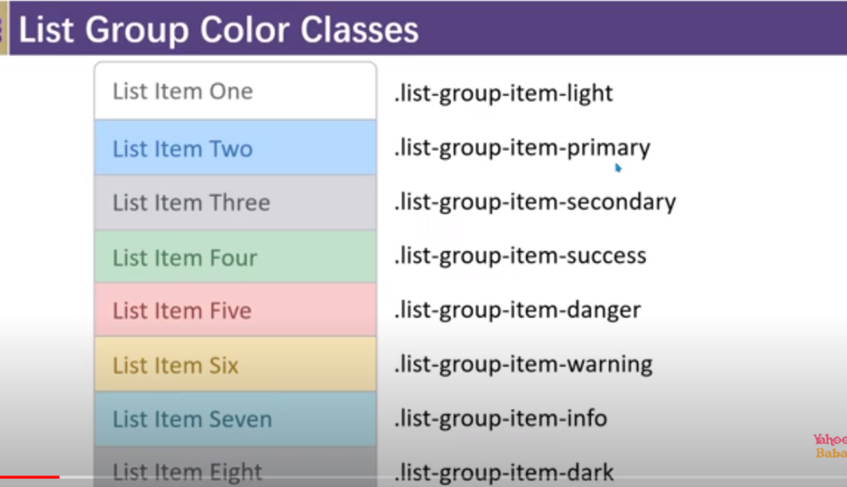

4.5 list group hrozintal

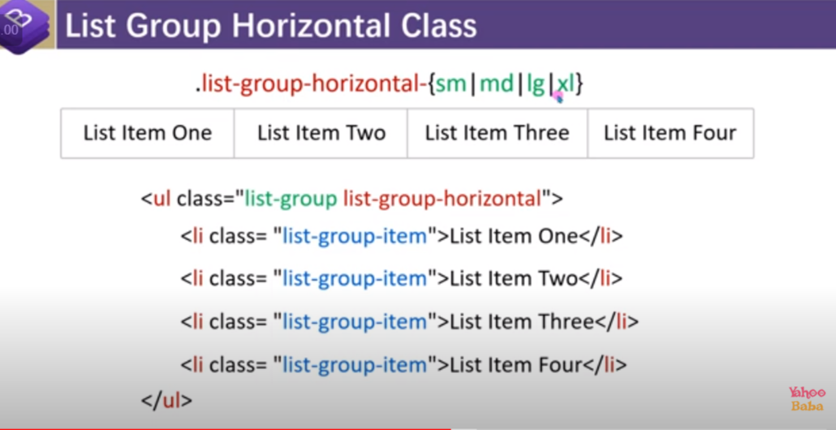

4.6 list group with the link

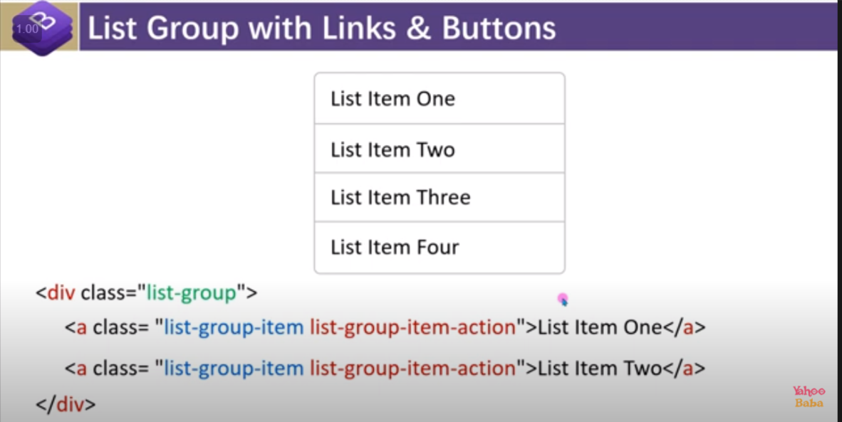

5.Table

5.1.normal table

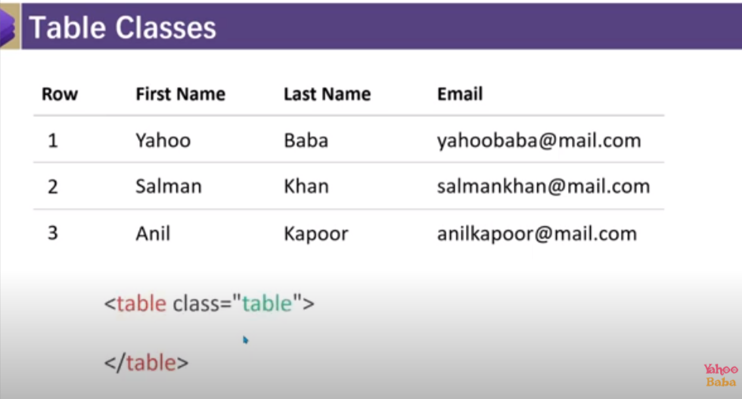

5.2 coloured table

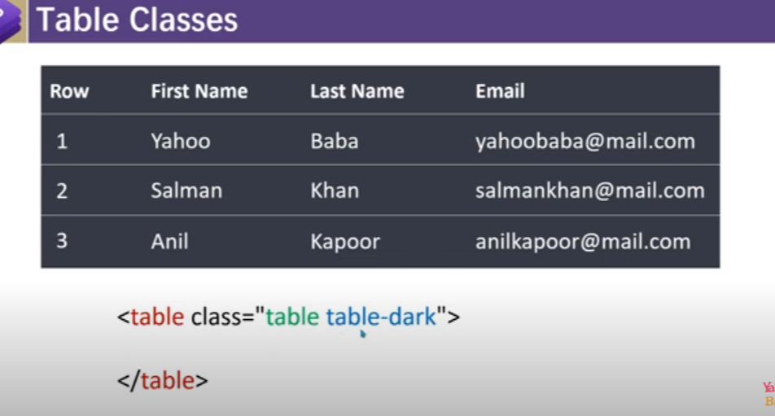

5.3 border less table

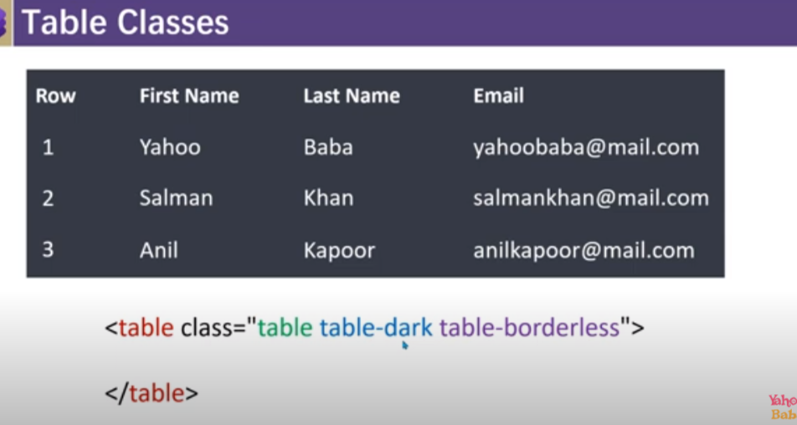

5.4 Table striped

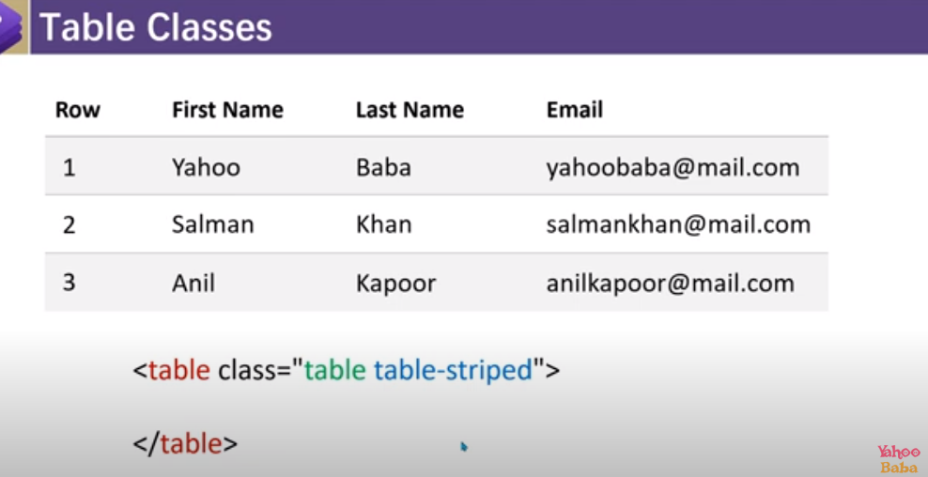

5.5 tabel-borederd :going to give vertical border

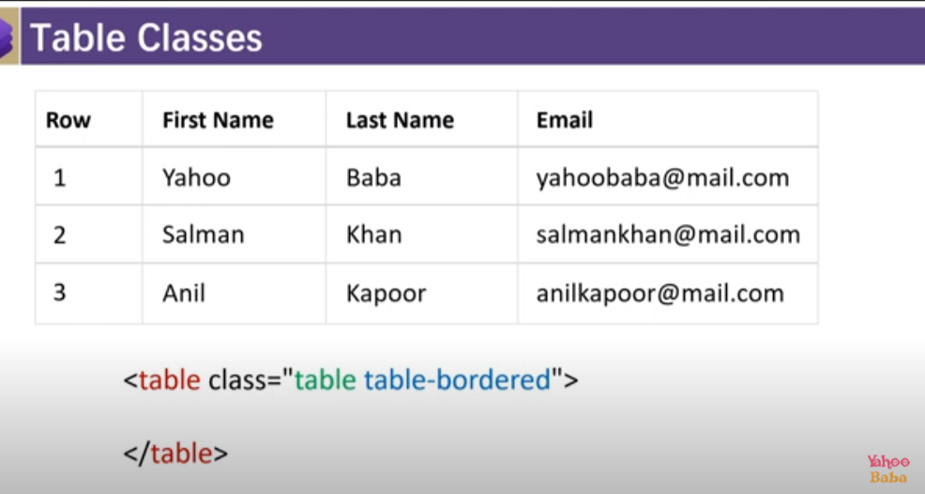

5.6 table-hover

5.7 table size : table-sm

5.8Table responsive

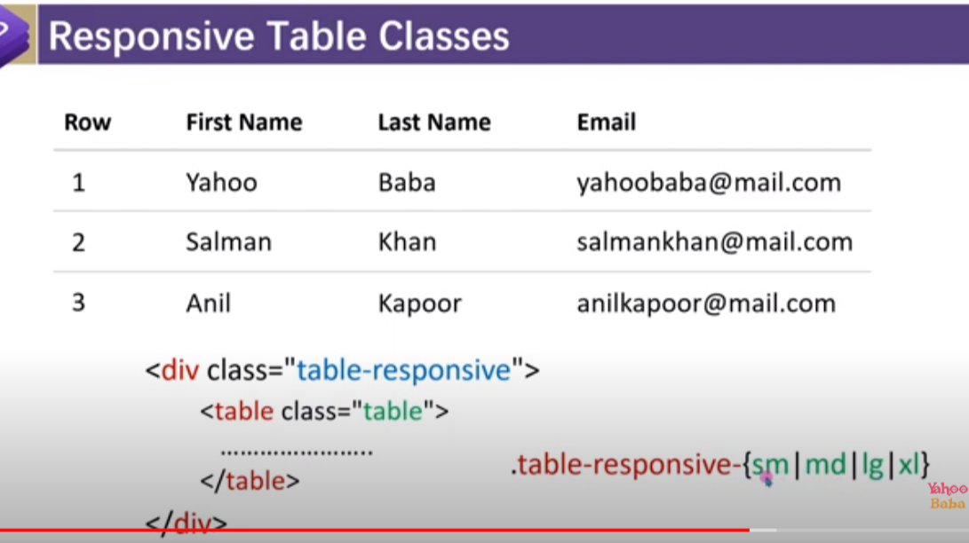

5.9 Table border color :

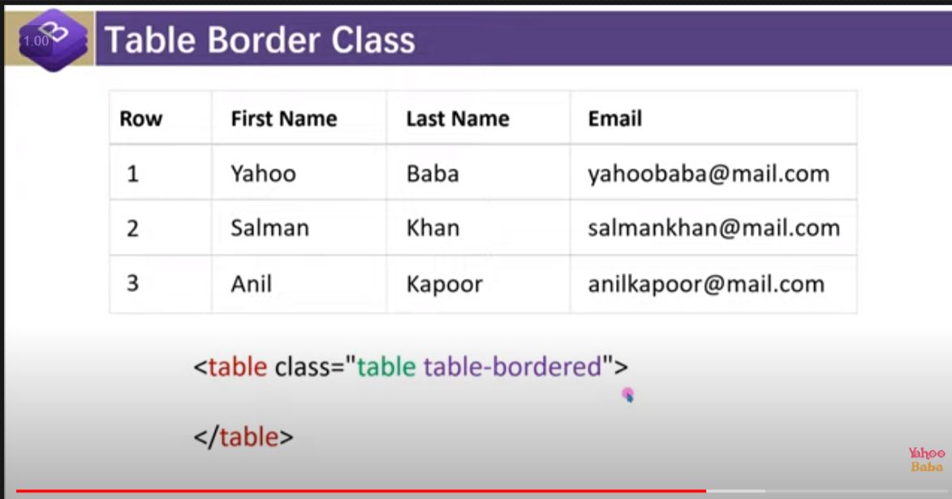

5.10 Table item aligment :

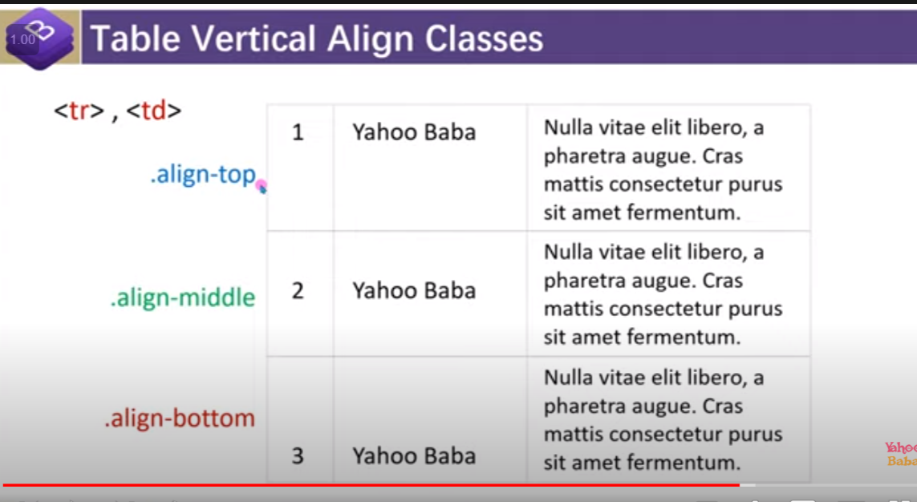

Align-baseline : aligment is wrt to largest text base line .

5.11 class=”table-active”

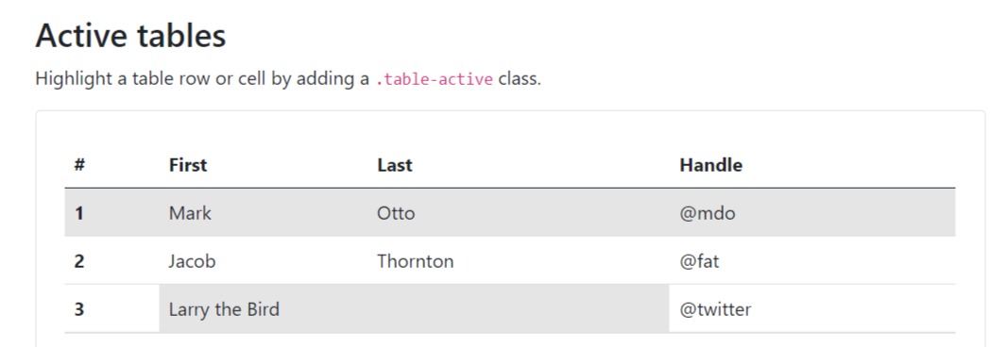

Table property for row and col :

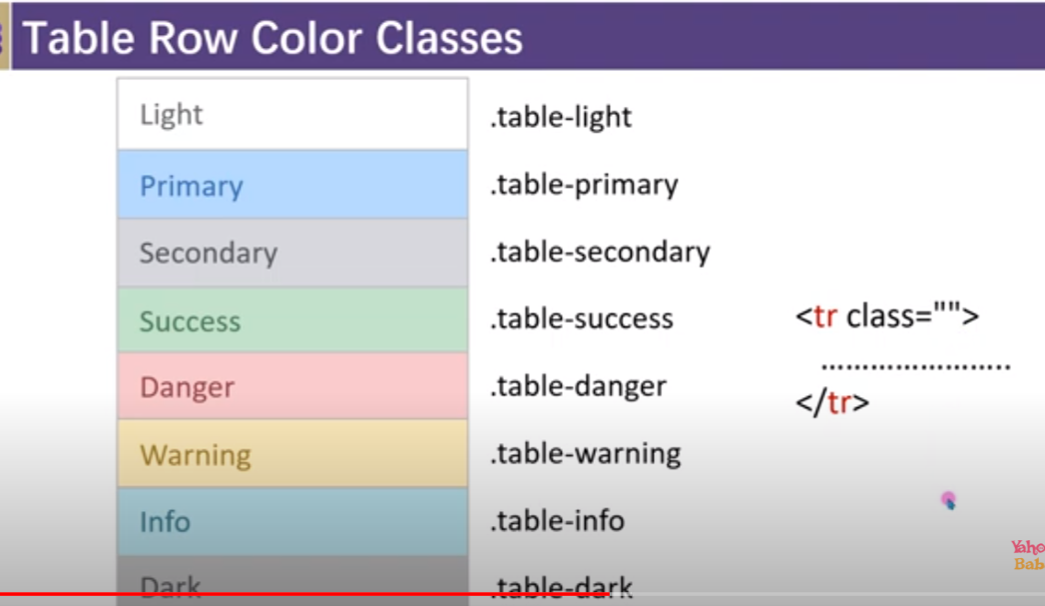

6.Pagination

6.1 normal pagination

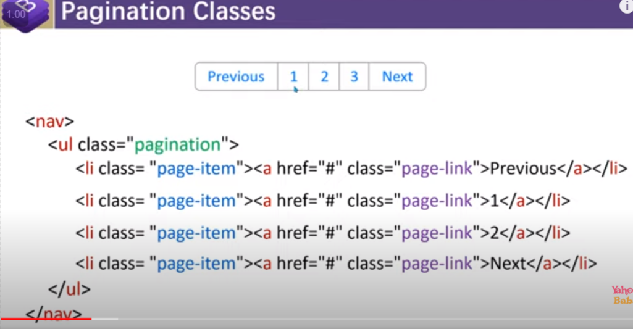

6.2 pagination active and disabled

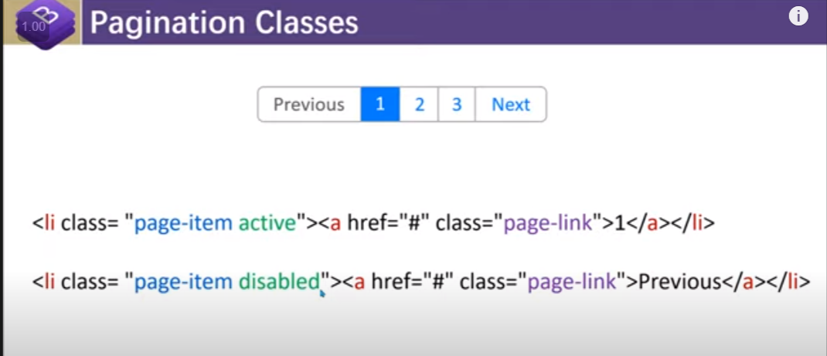

6.3 pagination size

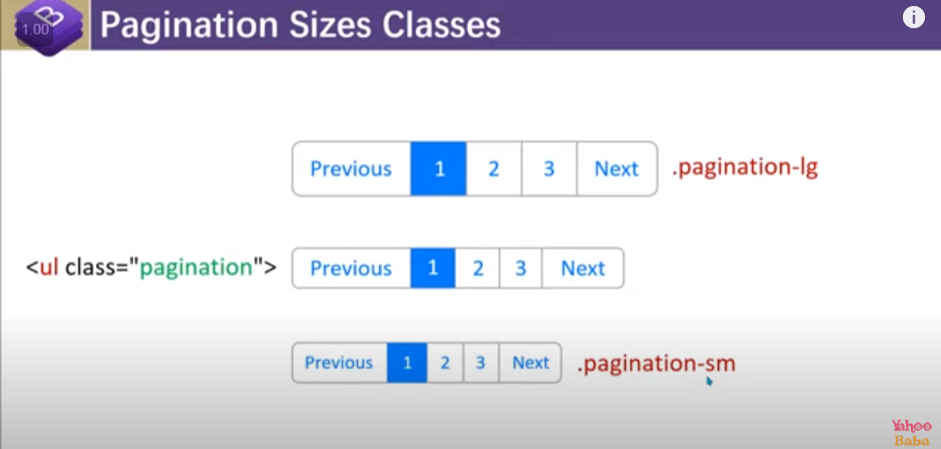

7.Breadcum and active

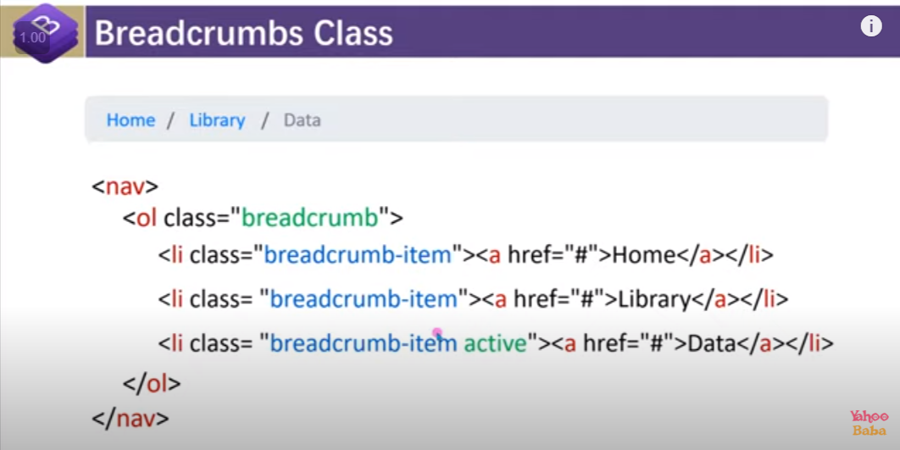

8.form

8.1 form basic

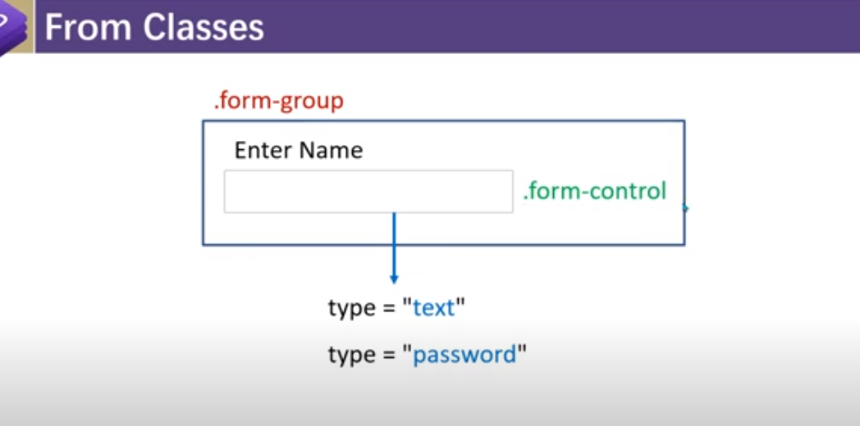

Special class for form label :



8.2 Form input size :

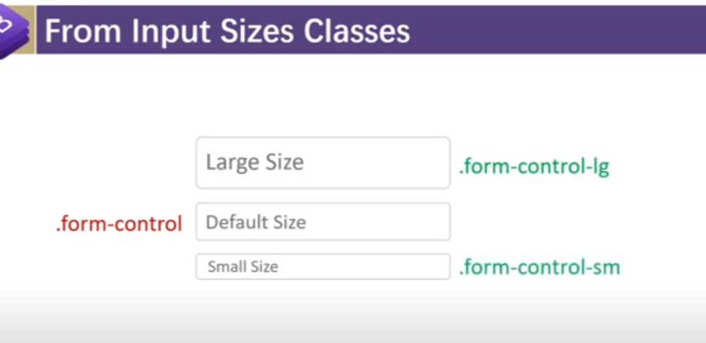

Note : it is only applicable on the form input and select not applicable on the text area

8.12. Special class for select :

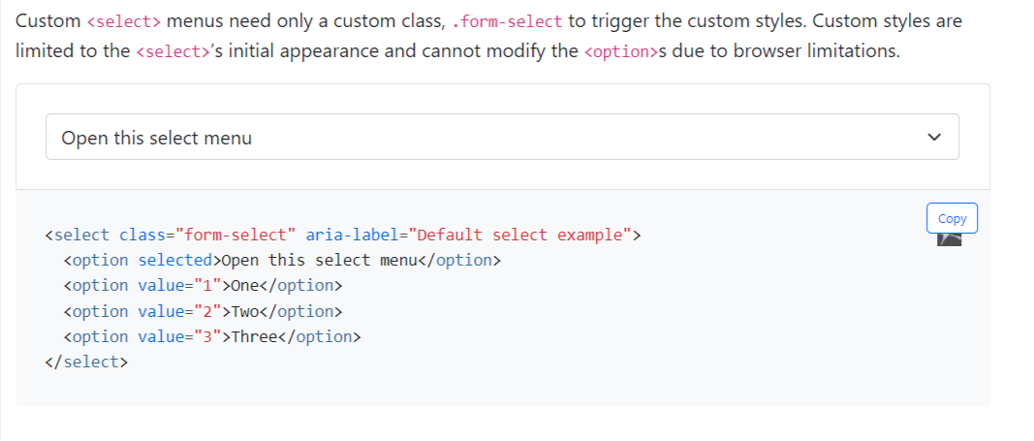

8.3 file form

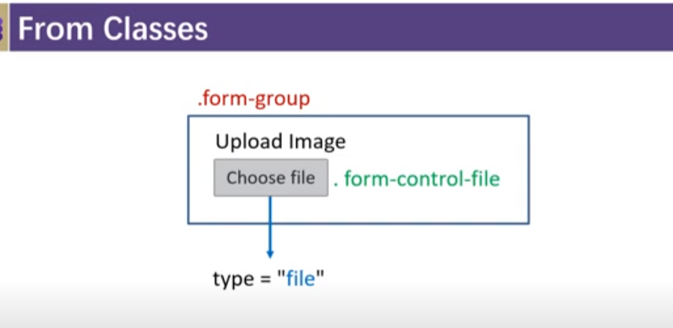

8.4 form-control-plaintext for readonly type

8.5 form -control for range

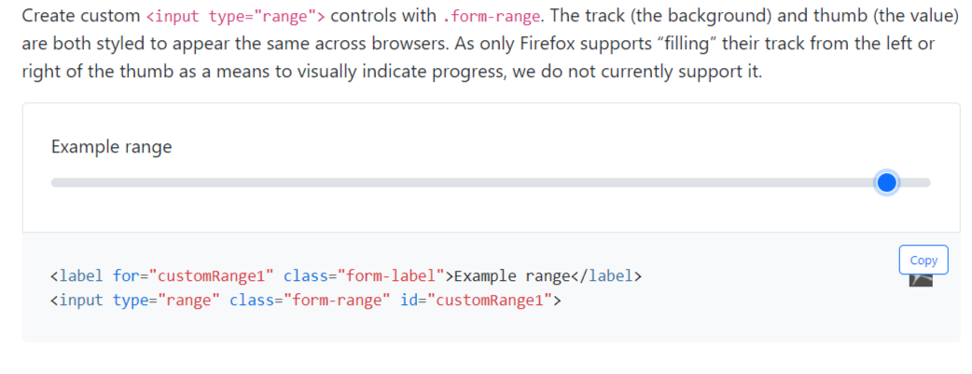

8.6 chekbox

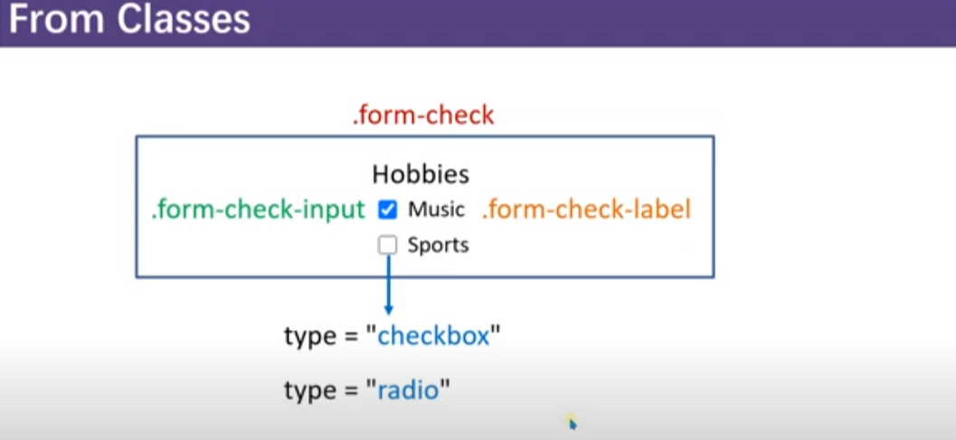

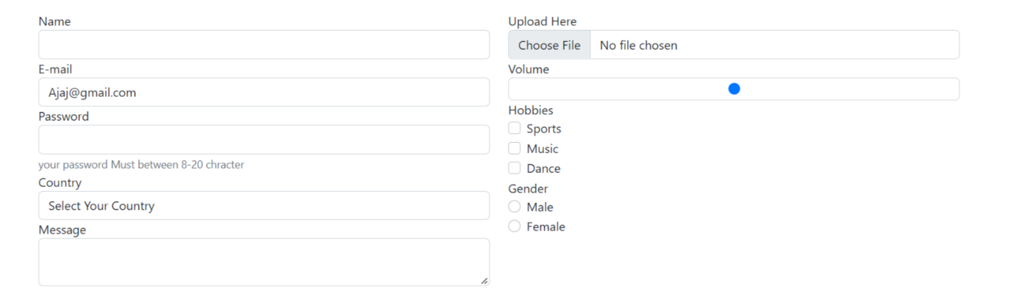

<!doctype html>

<html lang="en">

<head>

  <meta charset="utf-8">

  <meta name="viewport" content="width=device-width, initial-scale=1">

  <title>Bootstrap demo</title>

  <link href="https://cdn.jsdelivr.net/npm/bootstrap@5.2.0/dist/css/bootstrap.min.css" rel="stylesheet">

  <script src="https://code.jquery.com/jquery-3.4.1.slim.min.js"></script>

  <script src="https://cdn.jsdelivr.net/npm/popper.js@1.16.0/dist/umd/popper.min.js"></script>

  <script src="https://cdn.jsdelivr.net/npm/bootstrap@4.4.1/dist/js/bootstrap.min.js"></script>

  <style>

  </style>

</head>

<div class="container">

  <div class="row p-5">

    <div class="col-lg-6">

      <div class="form-group">

        <label>Name</label>

        <input type="text" class="form-control">

      </div>

      <div class="form-group">

        <label for="">E-mail</label>

        <input type="text" class="form-control" value="Ajaj@gmail.com" readonly>

      </div>

      <div class="form-group">

        <label for="">Password</label>

        <input type="password" class="form-control">

        <small class="form-text text-muted">your password Must between 8-20 chracter</small>

      </div>

      <div class="form-group">

        <label for="">Country</label>

        <select name="" id="" class="form-control">

          <option value="" disabled selected>Select Your Country</option>

          <option class="form-control" value="">India</option>

          <option class="form-control" value="">Nepal</option>

          <option class="form-control" value="">bangldesh</option>

          <option class="form-control" value="">pakistan</option>

        </select>

      </div>

      <div class="form-group">

        <label for="">Message</label>

        <textarea name="" class="form-control"></textarea>

      </div>

    </div>

    <div class="col-lg-6">

      <div class="form-group">

        <label for="">Upload Here</label>

        <input type="file" class="form-control">

      </div>

      <div class="form-group">

        <label for="">Volume</label>

        <input type="range" class="form-control" maxlength="10" step="1">

      </div>

      <div class="form-group">

        <label for="">Hobbies</label>

        <div class="form-check">

          <label for="" class="form-check-label">Sports</label>

          <input type="checkbox" class="form-check-input">

        </div>

        <div class="form-check">

          <label for="" class="form-check-label">Music</label>

          <input type="checkbox" class="form-check-input">

        </div>

        <div class="form-check">

          <label for="" class="form-check-label">Dance</label>

          <input type="checkbox" class="form-check-input">

        </div>

      </div>

      <div class="form-group">

        <label for="">Gender</label>

        <div class="form-check">

          <label for="" class="form-check-label">Male</label>

          <input type="radio" class="form-check-input" name="Gender">

        </div>

        <div class="form-check">

          <label for="" class="form-check-label">Female</label>

          <input type="radio" class="form-check-input" name="Gender">

        </div>

      </div>

    </div>

  </div>

</div>

<body>

</body>

</html>

8.7 inline form

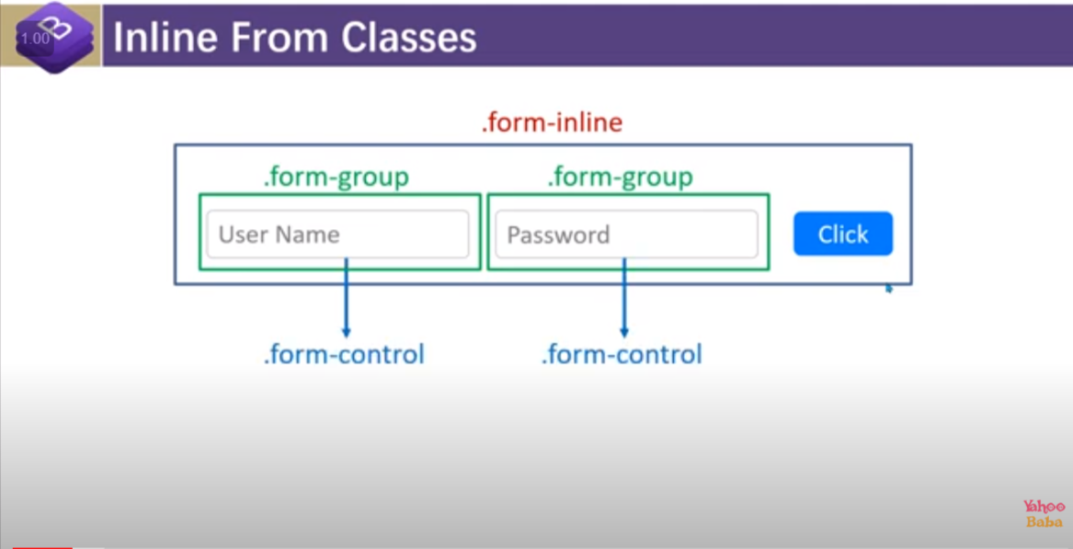

<form class="row g-3">

    <div class="col-md-5">

      <label for="staticEmail2" class="visually-hidden">Email</label>

      <input type="text" readonly class="form-control-plaintext" id="staticEmail2" value="email@example.com">

    </div>

    <div class="col-md-5">

      <label for="inputPassword2" class="visually-hidden">Password</label>

      <input type="password" class="form-control" id="inputPassword2" placeholder="Password">

    </div>

    <div class="col-md-2">

      <button type="submit" class="btn btn-primary mb-3">Confirm identity</button>

    </div>

  </form>



8.8 checkbox and radio inline :

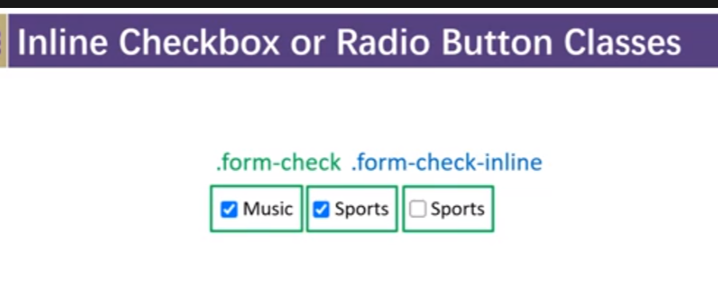

8.9 . Horizontal form class

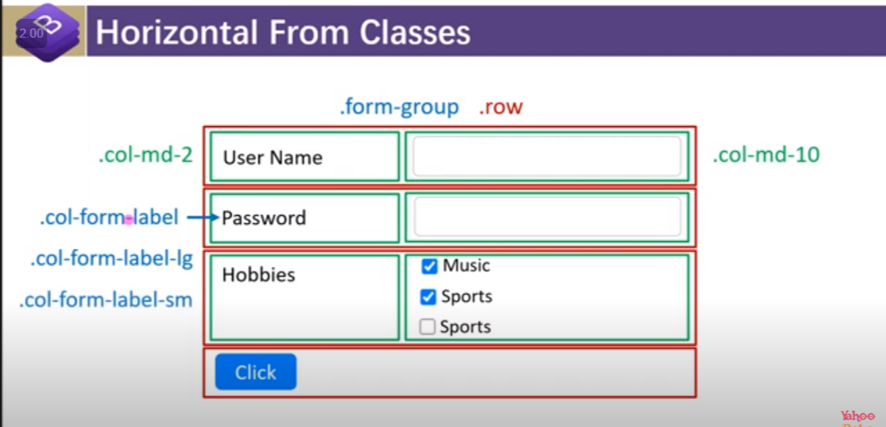

<div class="container p-3">

    <div class="row ">

      <div class="col">

        <div class="form-group row mb-3">

          <label for="" class="col-md-2 col-form-label-lg">User Name</label>

          <div class="col-md-10">

            <input type="text" class="form-control">

          </div>

        </div>

        <div class="form-group row mb-3">

          <label for="" class="col-md-2 col-form-label-lg">Password</label>

          <div class="col-md-10">

            <input type="password" class="form-control">

          </div>

        </div>

        <div class="row">

          <div class="col">

            <button type="submit" class="btn btn-success">submit</button>

          </div>

        </div>

      </div>

    </div>

  </div>

8.10.Form validate

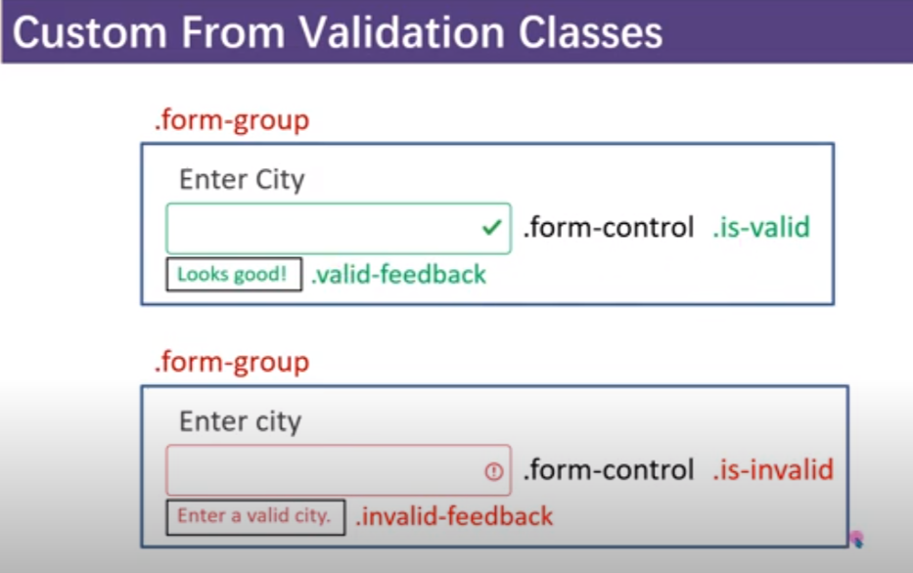

8.11.input group

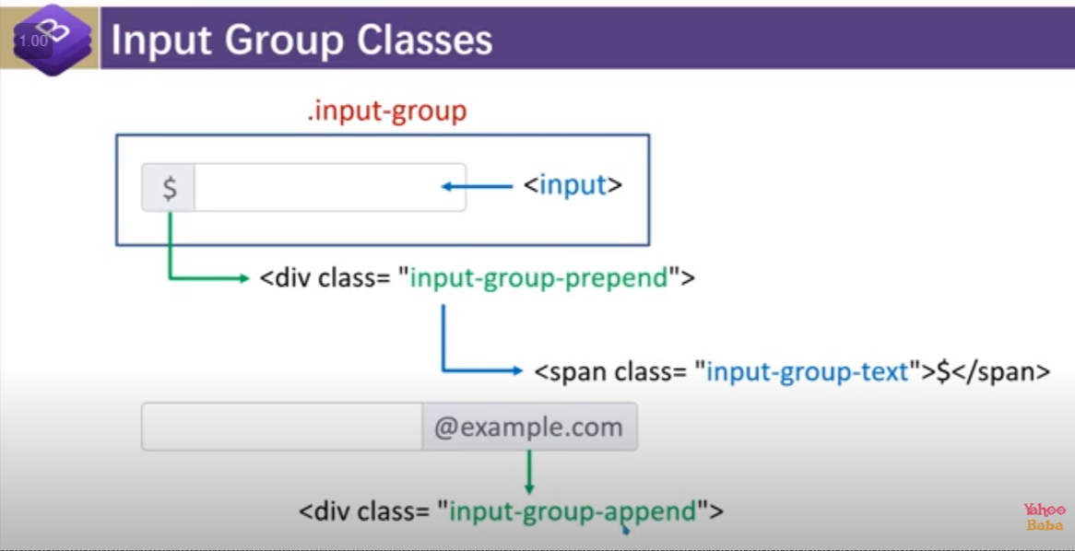

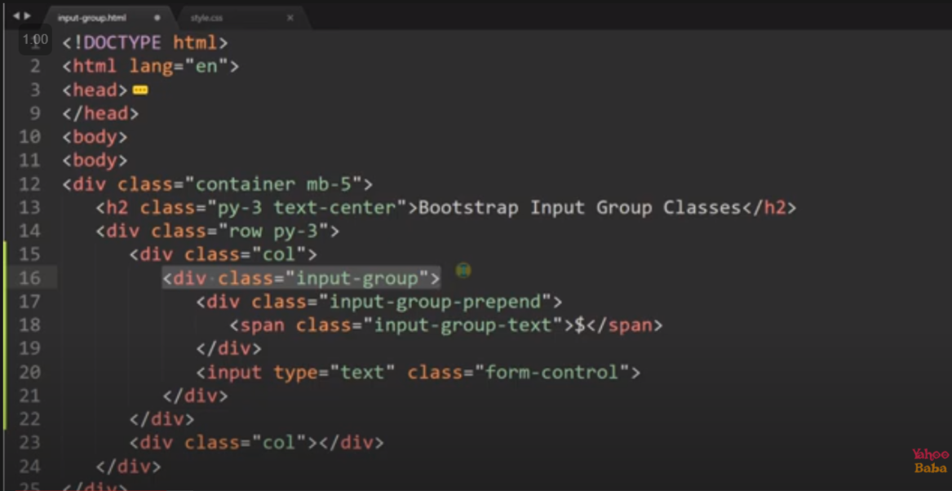

11.input group with append and prepend both :



      <div class="input-group">

        <div class="input-group-prepend">

          <div class="input-group-text">$</div>

        </div>

        <input type="text" placeholder="enter $...." class="form-control">

        <div class="input-append">

          <div class="input-group-text">&#x20B9</div>

        </div>

     </div>

11.input group with the multiple input

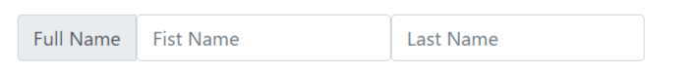

<div class="input-group">

        <div class="input-group-prepend">

          <div class="input-group-text">Full Name</div>

          <input type="text" class="form-control" placeholder="Fist Name">

          <input type="text" class="form-control" placeholder="Last Name">

        </div>

11.3 input group with the check box and radio :

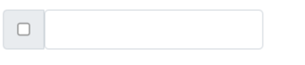

<div class="input-group">

        <div class="input-group-prepend">

          <div class="input-group-text">

            <input type="checkbox">

          </div>

          <input type="text" class="form-control">

        </div>

11.4 input-group size :

Class : on the top of div : input-group input-group-lg/sm

11.5 input-group with button



<div class="col-6">

      <div class="input-group">

        <input type="text" class="form-control" placeholder="User Name">

        <input type="password" class="form-control" placeholder="password">

        <div class="input-group-apppend">

            <button class="btn btn-success ">Sign in</button>

        </div>

      </div>

8.13 . fom switch

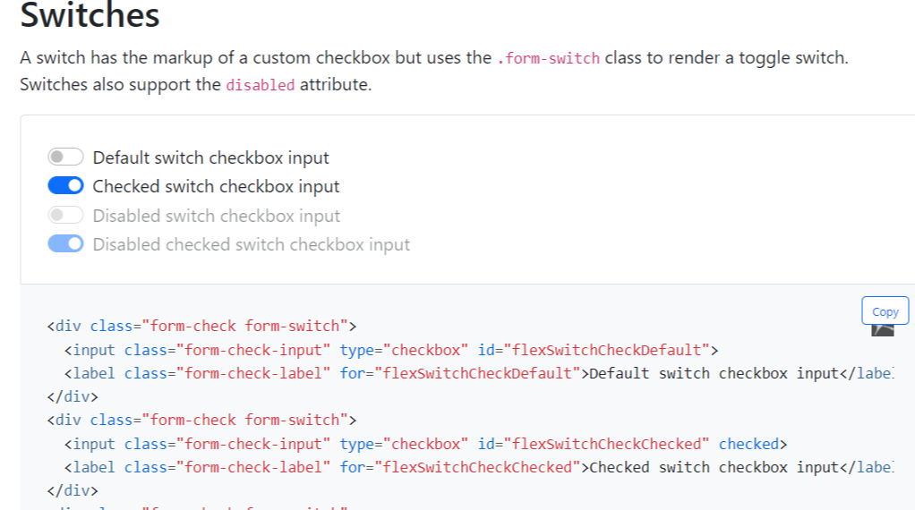

8.14 form-floating

Link:

<https://getbootstrap.com/docs/5.0/forms/floating-labels/>

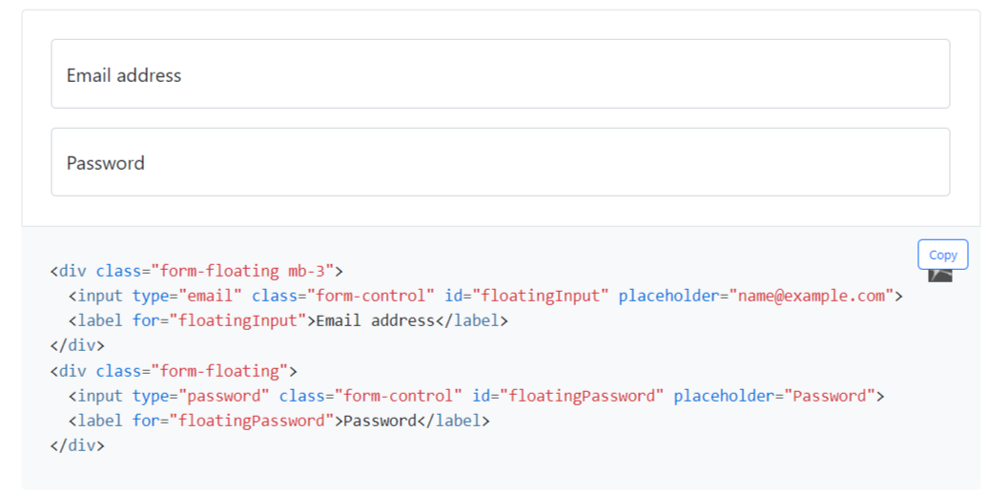

9. NAV class :

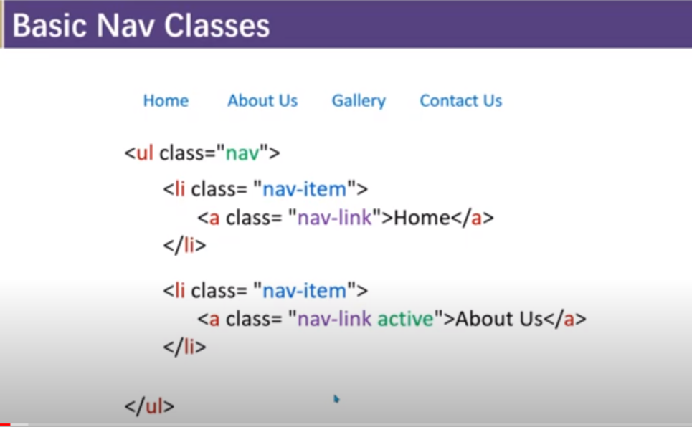



<!doctype html>

<html lang="en">

<head>

  <meta charset="utf-8">

  <meta name="viewport" content="width=device-width, initial-scale=1">

  <title>Bootstrap demo</title>

  <link rel="stylesheet" href="bootstrap.css">

  <style>

    .nav{

*background-color*: aquamarine;

    }

    .nav-link{

*background-color*: lawngreen;

*color*: #fff;

*border-radius*: 4px;

*transition*: 0.3s ease;

    }

    .nav-link:hover{

*background-color*: #fff;

*color*: lawngreen;

    }

  </style>

</head>

<body>

  <ul class="nav justify-content-center px-5 py-3">

    <li class="nav-item">

      <a href="#" class="nav-link mr-2 active ">Home</a>

    </li>

    <li class="nav-item">

      <a href="#" class="nav-link mr-2 ">Menu</a>

    </li>

    <li class="nav-item">

      <a href="#" class="nav-link mr-2  ">Contact</a>

    </li>

    <li class="nav-item">

      <a href="#" class="nav-link mr-2 ">Services</a>

    </li>

    <li class="nav-item">

      <a href="#" class="nav-link disabled">Help</a>

    </li>

  </ul>

</body>

</html>

9.1. use of active and disabled

Note : here we have to create our own active

9.2.other way of creating nav :

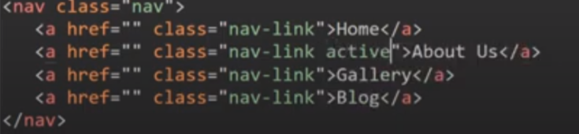

9.3 to make the nav vertical

We use : flex-column with the nav

12.4 class=”nav-pills” // to give background we need to give background by our self by using css

<ul class="nav    nav-pills">

9.5 class=”nav-fill” // it will going to fill the remaining space but the space will be uneven for each element depending on the basis of their text length .

 <ul class="nav    nav-pills nav-fill">

9.6 class=”nav-justified” it will going to fill the remaining space but will going to give every element of nav equall padding .

<ul class="nav    nav-pills nav-justified">

9.7



By using class=”nav nav-tabs”

 <ul class="nav nav-tabs">

                    <li class="nav-item "><a href="#home" class="nav-link active" data-toggle="tab">Home</a></li>

                    <li class="nav-item"><a href="#about" class="nav-link" data-toggle="tab">About</a></li>

                    <li class="nav-item"><a href="#services" class="nav-link" data-toggle="tab">Services</a></li>

                    <li class="nav-item"><a href="#contact" class="nav-link" data-toggle="tab">Contact</a></li>

                </ul>

10.Nav bar

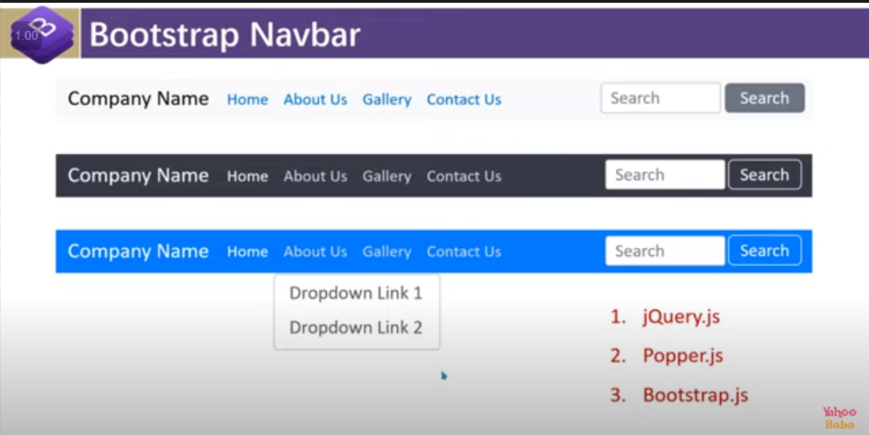

10.1. Navbar syntax

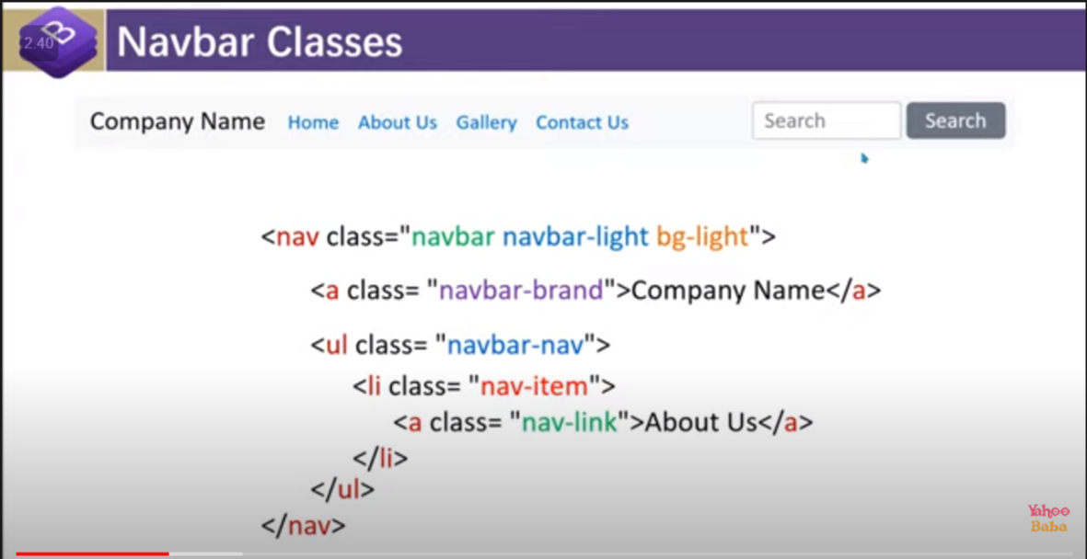

Note : use of

1. Navbar-light : iska MATLAB background light hai text ko dark Karna Hai
2. Navbar-dark : iska matlab background dark hai text ko light karna hai
3. 9.3 to make the navbar – inline : put use class=”navbar-expand-breakpoint(sm/md/lg/xl/xxl)

<header class="navbar navbar-light bg-light navbar-expand-lg ">

10.4 to make a drop down in navbar :

 <li class="nav-item dropdown">

              <a href="#" class="nav-link dropdown-toggle" data-toggle="dropdown">About Us</a>

              <div class="dropdown-menu">

                <a href="#" class="dropdown-item">Link one</a>

                <a href="#" class="dropdown-item">Link Two</a>

                <a href="#" class="dropdown-item">Link Three</a>

              </div>

            </li>

10.5 to make navbar responsive :

<!doctype html>

<html lang="en">

<head>

  <meta charset="utf-8">

  <meta name="viewport" content="width=device-width, initial-scale=1">

  <title>Bootstrap demo</title>

  <link rel="stylesheet" href="bootstrap.css">

  <script src="https://code.jquery.com/jquery-3.4.1.slim.min.js"></script>

  <script src="https://cdn.jsdelivr.net/npm/popper.js@1.16.0/dist/umd/popper.min.js"></script>

  <script src="https://cdn.jsdelivr.net/npm/bootstrap@4.4.1/dist/js/bootstrap.min.js"></script>

</head>

<body>

  <div class="container-fluid">

    <div class="row">

      <div class="col">

        <header class="navbar navbar-light bg-light navbar-expand-lg ">

          <a href="#" class="navbar-brand">AJAJ</a>

          <button class="navbar-toggler" data-toggle="collapse" data-target="#mynavbar">

            <span class="navbar-toggler-icon"></span>

          </button>

          <div class="collapse navbar-collapse" id="mynavbar">

            <ul class="navbar-nav mr-auto">

              <li class="nav-item">

                <a href="#" class="nav-link">Home</a>

              </li>

              <li class="nav-item dropdown">

                <a href="#" class="nav-link dropdown-toggle" data-toggle="dropdown">About Us</a>

                <div class="dropdown-menu">

                  <a href="#" class="dropdown-item">Link one</a>

                  <a href="#" class="dropdown-item">Link Two</a>

                  <a href="#" class="dropdown-item">Link Three</a>

                </div>

              </li>

              <li class="nav-item">

                <a href="#" class="nav-link">Gallery</a>

              </li>

              <li class="nav-item">

                <a href="#" class="nav-link">Contact Us</a>

              </li>

            </ul>

            <form action="">

              <div class="form-inline">

                <input type="text" placeholder="Search" class="form-control mr-sm-2">

                <button class="btn btn-outline-success my-2 my-sm-0" type="submit">Search</button>

              </div>

            </form>

          </div>

        </header>

      </div>

    </div>

  </div>

</body>

</html>

10.6 to add text :

Use use class=”navbar-text”

11.image

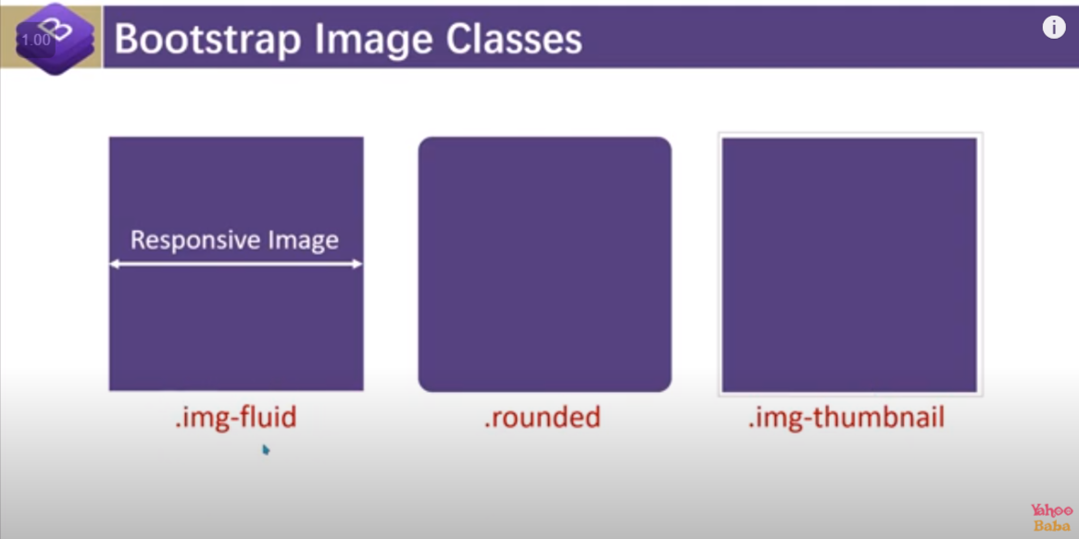

Note : we need to use img-thumbnail when we want t to give border with the img fluid

<div class="ml-5 mt-5" style="width: 350px; ;" >

        <img src="https://images.pexels.com/photos/4308937/pexels-photo-4308937.jpeg" class="img-fluid img-thumbnail rounded" >

    </div>



11.2 imge with some text

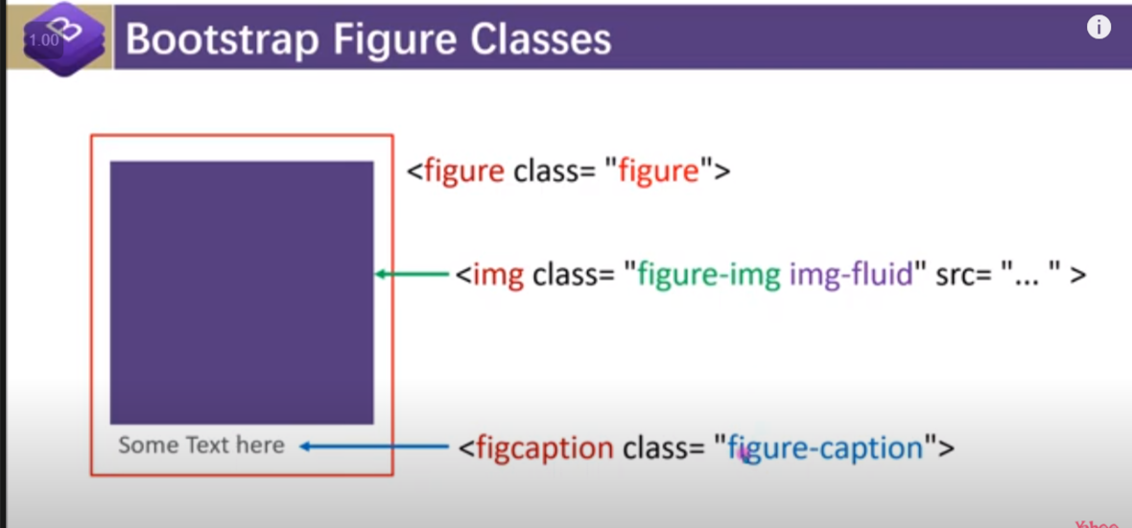

<figure class="figure ml-5 mt-5" style="width: 450px; height : 450px; border: 2px solid grey; ">

        <img src="https://images.pexels.com/photos/4308937/pexels-photo-4308937.jpeg" alt="" class="figure-img img-fluid img-thumbnail" style="height:90%; width:100%">

        <figcaption class="figure-caption  text-center">

            <h5>Word Palace</h5>

        </figcaption>

    </figure>

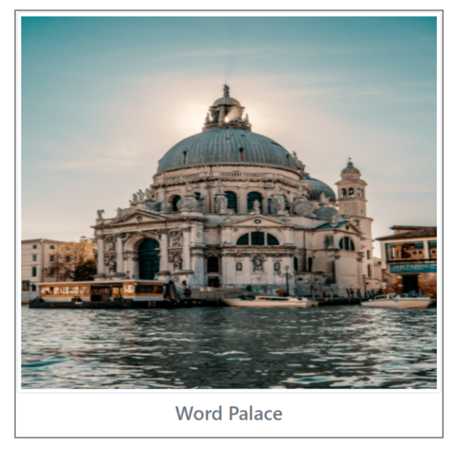

12. video

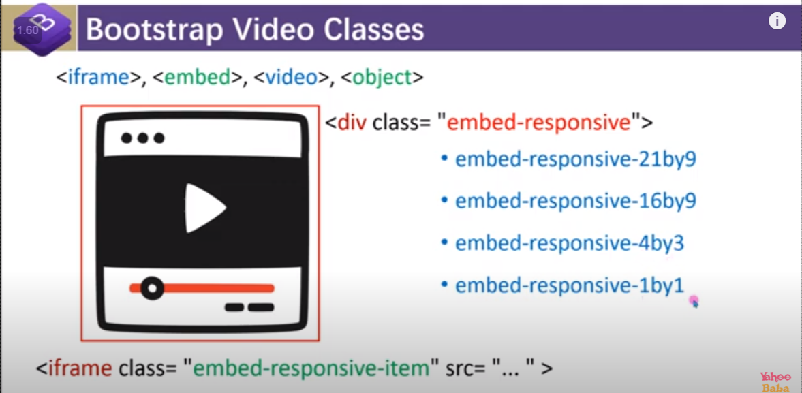

Note : give size is very important :

i)embed-responsive-21by9 and embed-responsive-16by9 will form rectangle

ii)embed-responsive-4by3 and embed-responsive-1by will form square

<div class="row">

        <div class="col-md-4">

            <div class="embed-responsive embed-responsive-16by9">

                <iframe src="https://www.youtube.com/embed/Afxr1bpgDt0" class="embed-responsive-item" frameborder="0"></iframe>

            </div>

        </div>

    </div>

13. border

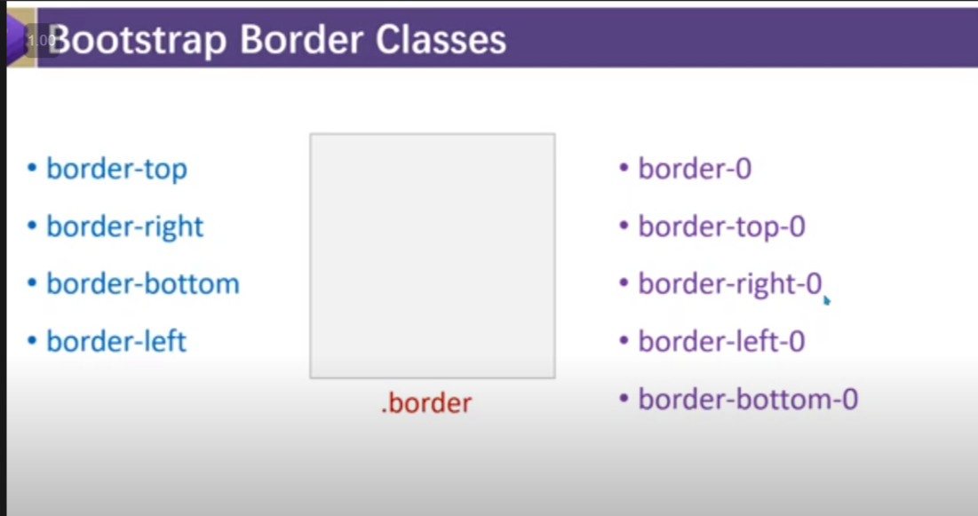

Note: by default, colour of border will be grey

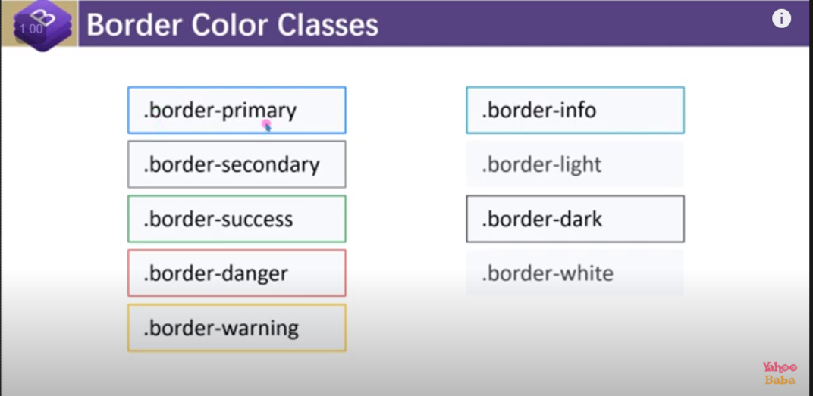

Border-width :

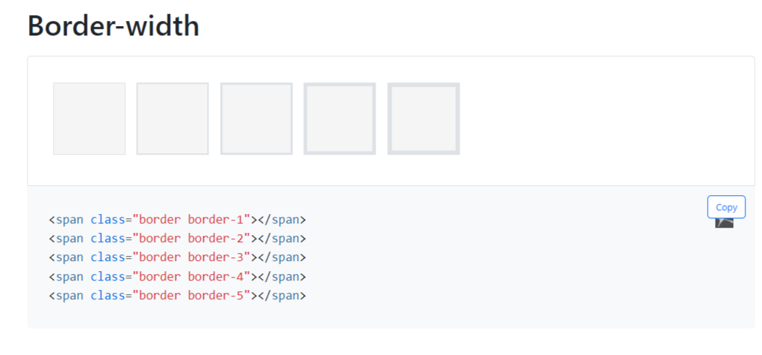

Rounded :

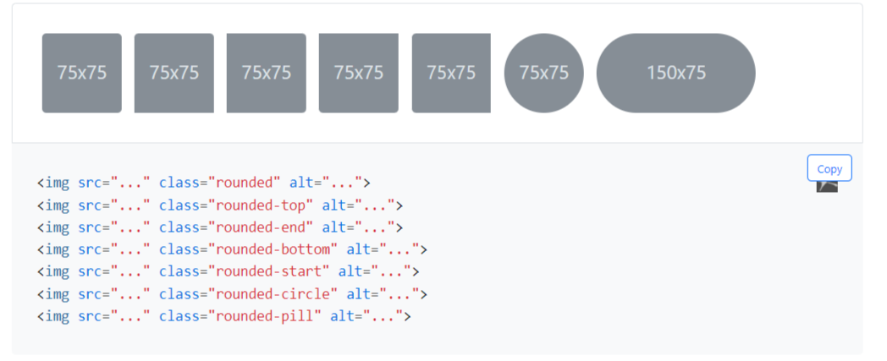

Size of rounded :

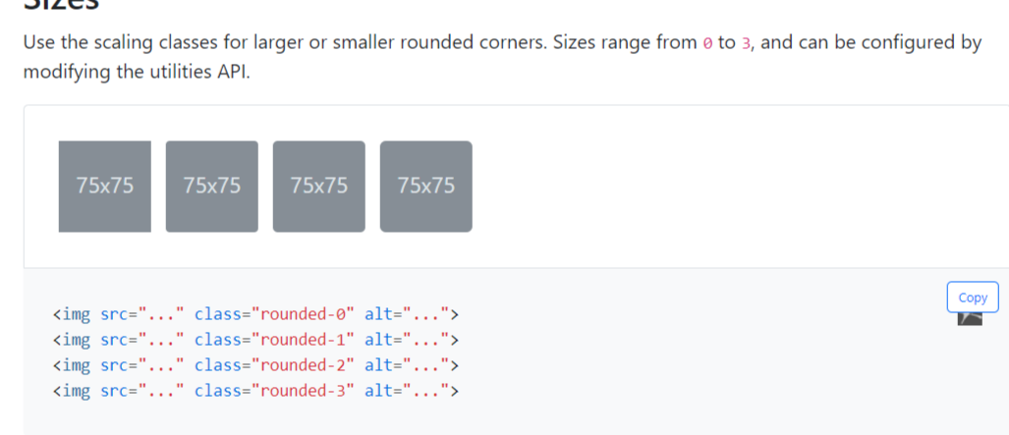

13.2 Shadow

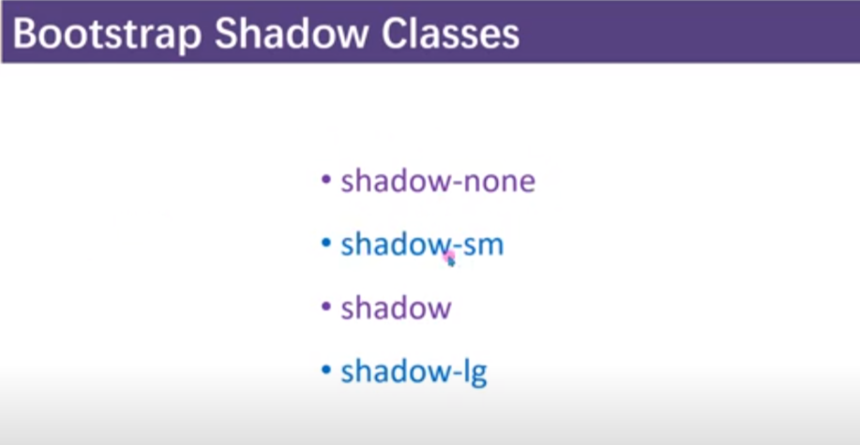note : we can also add button as well .

ii) with the use of class =”card-img” we can make the each corner rounded

14.CARD

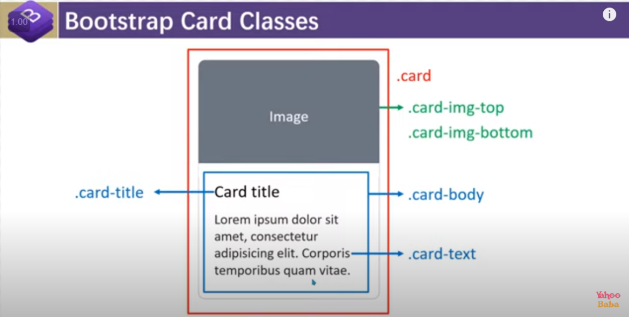

<div class="container">

        <div class="row">

            <div class="col-md-4 mt-5">

                <div class="card">

                    <div  style="height:250px ;">

                        <img src="https://images.pexels.com/photos/12144473/pexels-photo-12144473.jpeg?auto=compress&cs=tinysrgb&w=1260&h=750&dpr=1"

                            class="img-fluid card-img-top" style="height: 100%; width:100%">

                    </div>

                    <div class="card-body">

                        <div class="card-title">

                            <h5>Lorem ipsum dolor sit amet.</h5>

                        </div>

                        <div class="card-text">

                            Lorem ipsum dolor sit amet consectetur adipisicing elit. Aliquam sint quam modi dolore, quis

                            unde.

                        </div>

                        <button class="btn btn-primary">Read More</button>

                    </div>

                </div>

            </div>

            <div class="col-md-4 mt-5">

                <div class="card">

                    <div  style="height:250px ;">

                        <img src="https://images.pexels.com/photos/12144473/pexels-photo-12144473.jpeg?auto=compress&cs=tinysrgb&w=1260&h=750&dpr=1"

                            class="img-fluid card-img" style="height: 100%; width:100%">

                    </div>

                    <div class="card-body">

                        <div class="card-title">

                            <h5>Lorem ipsum dolor sit amet.</h5>

                        </div>

                        <div class="card-text">

                            Lorem ipsum dolor sit amet consectetur adipisicing elit. Aliquam sint quam modi dolore, quis

                            unde.

                        </div>

                        <button class="btn btn-primary">Read More</button>

                    </div>

                </div>

            </div>

            <div class="col-md-4 mt-5">

                <div class="card">

                    <div class="card-body">

                        <div class="card-title">

                            <h5>Lorem ipsum dolor sit amet.</h5>

                        </div>

                        <div class="card-text">

                            Lorem ipsum dolor sit amet consectetur adipisicing elit. Aliquam sint quam modi dolore, quis

                            unde.

                        </div>

                        <button class="btn btn-primary">Read More</button>

                    </div>

                    <div  style="height:250px ;">

                        <img src="https://images.pexels.com/photos/12144473/pexels-photo-12144473.jpeg?auto=compress&cs=tinysrgb&w=1260&h=750&dpr=1"

                            class="img-fluid card-img-bottom" style="height: 100%; width:100%">

                    </div>

                </div>

            </div>

        </div>

    </div>

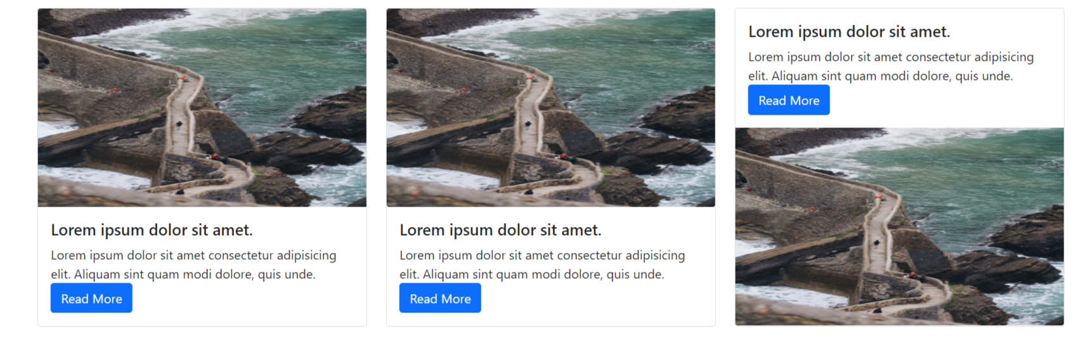

13. 1 adding button in the card .

13.2 we can also form a crad without image

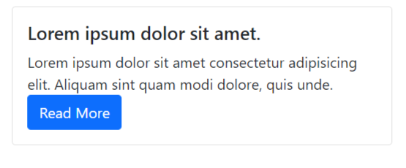

<div class="card">

                    <div class="card-body">

                        <div class="card-title">

                            <h5>Lorem ipsum dolor sit amet.</h5>

                        </div>

                        <div class="card-text">

                            Lorem ipsum dolor sit amet consectetur adipisicing elit. Aliquam sint quam modi dolore, quis

                            unde.

                        </div>

                        <button class="btn btn-primary">Read More</button>

                    </div>

                </div>

13.3 we can also put link also by using class=”card-link”

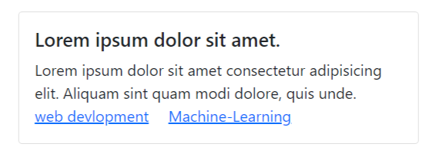

<div class="card">

                    <div class="card-body">

                        <div class="card-title">

                            <h5>Lorem ipsum dolor sit amet.</h5>

                        </div>

                        <div class="card-text">

                            Lorem ipsum dolor sit amet consectetur adipisicing elit. Aliquam sint quam modi dolore, quis

                            unde.

                        </div>

                        <a href="#" class="card-link">web devlopment</a>

                        <a href="#" class="card-link">Machine-Learning</a>

                    </div>

                </div>

13.4

To put text on the body of image : we will going to use class=”card-img-overlay” instead of class=”card-body” .

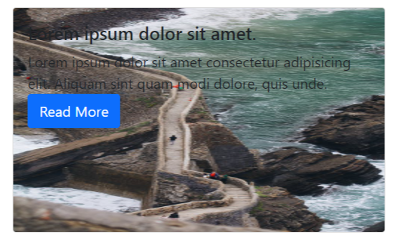

<div class="card">

                    <div style="height:250px ;">

                        <img src="https://images.pexels.com/photos/12144473/pexels-photo-12144473.jpeg?auto=compress&cs=tinysrgb&w=1260&h=750&dpr=1"

                            class="img-fluid card-img" style="height: 100%; width:100%">

                    </div>

                    <div class="card-img-overlay">

                        <div class="card-title">

                            <h5>Lorem ipsum dolor sit amet.</h5>

                        </div>

                        <div class="card-text">

                            Lorem ipsum dolor sit amet consectetur adipisicing elit. Aliquam sint quam modi dolore, quis

                            unde.

                        </div>

                        <button class="btn btn-primary">Read More</button>

                    </div>

                </div>

13.5 use of class=”card-subtitle” it is used inside class=”card-body” it is used to give the subtitle .

Note : colour of card-title and card-subtitle will be same so to diffrencitae we need to give color to different colour to class=”card-subtitle” .

13.6 we can also add list group

For that use need not need to use class=”card-body”

<div class="card">

                    <div style="height:250px ;">

                        <img src="https://images.pexels.com/photos/12144473/pexels-photo-12144473.jpeg?auto=compress&cs=tinysrgb&w=1260&h=750&dpr=1"

                            class="img-fluid card-img" style="height: 100%; width:100%">

                    </div>

                    <ul class="list-group">

                        <li class="list-group-item">Lorem ipsum dolor sit amet.</li>

                        <li class="list-group-item">Lorem ipsum dolor sit amet.</li>

                        <li class="list-group-item">Lorem ipsum dolor sit amet.</li>

                        <li class="list-group-item">Lorem ipsum dolor sit amet.</li>

                        <li class="list-group-item">Lorem ipsum dolor sit amet.</li>

                        <li class="list-group-item">Lorem ipsum dolor sit amet.</li>

                    </ul>

                </div>

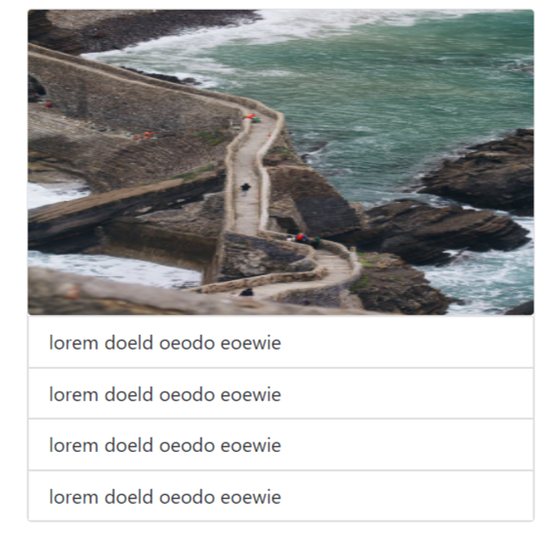

13.7. we can also specify position : by putting class=”text-center” in class=”card “

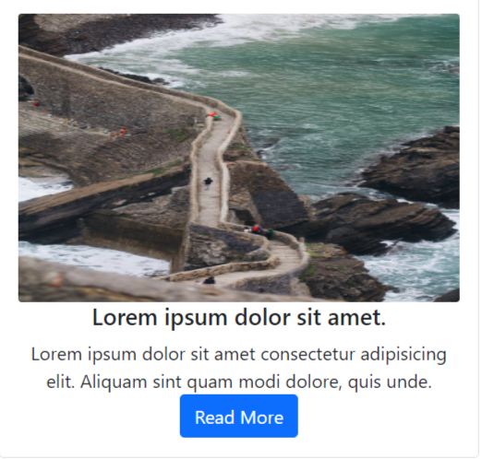

<div class="card text-center">

                    <div class="card-body ">

                        <div style="height:250px ;">

                            <img src="https://images.pexels.com/photos/12144473/pexels-photo-12144473.jpeg?auto=compress&cs=tinysrgb&w=1260&h=750&dpr=1"

                                class="img-fluid card-img" style="height: 100%; width:100%">

                        </div>

                        <div class="card-title">

                            <h5>Lorem ipsum dolor sit amet.</h5>

                        </div>

                        <div class="card-text">

                            Lorem ipsum dolor sit amet consectetur adipisicing elit. Aliquam sint quam modi dolore, quis

                            unde.

                        </div>

                        <button class="btn btn-primary">Read More</button>

                    </div>

                </div>

13.8 we can also specify background colour : by putting class=”br-color_name” inside the class=”card”;

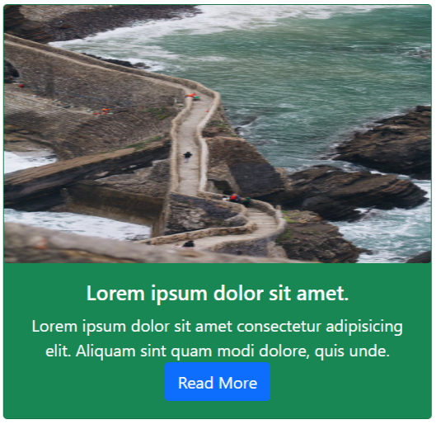

<div class="card text-center bg-success text-white">

                    <div class="card-body ">

                        <div style="height:250px ;">

                            <img src="https://images.pexels.com/photos/12144473/pexels-photo-12144473.jpeg?auto=compress&cs=tinysrgb&w=1260&h=750&dpr=1"

                                class="img-fluid card-img" style="height: 100%; width:100%">

                        </div>

                        <div class="card-title">

                            <h5>Lorem ipsum dolor sit amet.</h5>

                        </div>

                        <div class="card-text">

                            Lorem ipsum dolor sit amet consectetur adipisicing elit. Aliquam sint quam modi dolore, quis

                            unde.

                        </div>

                        <button class="btn btn-primary">Read More</button>

                    </div>

                </div>

13.9 by using class=”card-headder” we can also specify the heading inside the card

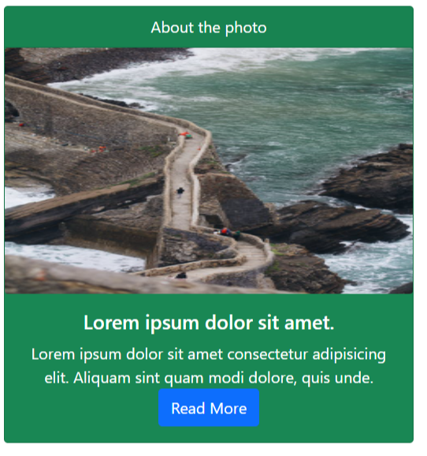

<div class="card text-center bg-success text-white">

                    <div class="card-header">About the photo</div>

                    <div style="height:250px ;">

                        <img src="https://images.pexels.com/photos/12144473/pexels-photo-12144473.jpeg?auto=compress&cs=tinysrgb&w=1260&h=750&dpr=1"

                            class="img-fluid card-img" style="height: 100%; width:100%">

                    </div>

                    <div class="card-body">

                        <div class="card-title">

                            <h5>Lorem ipsum dolor sit amet.</h5>

                        </div>

                        <div class="card-text">

                            Lorem ipsum dolor sit amet consectetur adipisicing elit. Aliquam sint quam modi dolore, quis

                            unde.

                        </div>

                        <button class="btn btn-primary">Read More</button>

                    </div>

                </div>

13.10 . we can also provide footer : by using class=”card-footer”

13.11. To making horizontal card

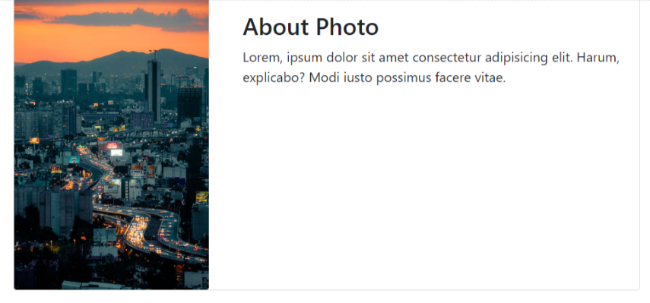

<div class="row gx-4">

            <div class="col-md-7">

                <div class="card">

                    <div class="row">

                        <div class="col-4">

                            <img src="https://images.pexels.com/photos/12491573/pexels-photo-12491573.jpeg?auto=compress&cs=tinysrgb&w=1260&h=750&dpr=1"

                                class="img-fluid card-img">

                        </div>

                        <div class="col-8">

                            <div class="card-body">

                                <h3 class="card-title">About Photo</h3>

                                <div class="card-text">Lorem, ipsum dolor sit amet consectetur adipisicing elit. Harum, explicabo? Modi iusto possimus facere vitae.</div>

                            </div>

                        </div>

                    </div>

                </div>

            </div>

        </div>

15.Card-group , card-deck and card-columns

A) card-group:it is used to put multiple card in group

Img:

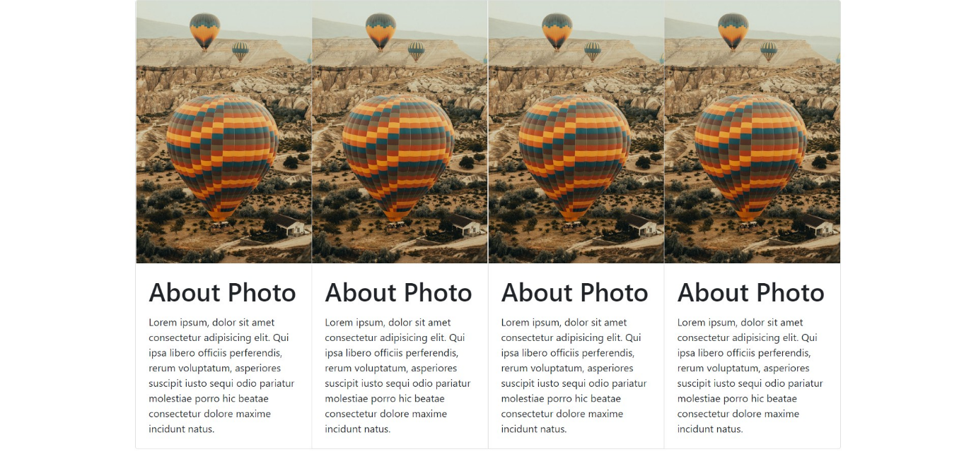

Code :

<body>

    <div class="container">

        <div class="row">

            <div class="col">

                <div class="card-group">

                    <div class="card">

                        <img src="https://images.pexels.com/photos/13010671/pexels-photo-13010671.jpeg?auto=compress&cs=tinysrgb&w=1260&h=750&dpr=1" class="card-img-top img-fluid" height="350px" alt="">

                        <div class="card-body">

                            <h1 class="card-title">About Photo</h1>

                            <p class="card-text">Lorem ipsum, dolor sit amet consectetur adipisicing elit. Qui ipsa libero officiis perferendis, rerum voluptatum, asperiores suscipit iusto sequi odio pariatur molestiae porro hic beatae consectetur dolore maxime incidunt natus.</p>

                        </div>

                    </div>

                    <div class="card">

                        <img src="https://images.pexels.com/photos/13010671/pexels-photo-13010671.jpeg?auto=compress&cs=tinysrgb&w=1260&h=750&dpr=1" class="card-img-top img-fluid" height="350px" alt="">

                        <div class="card-body">

                            <h1 class="card-title">About Photo</h1>

                            <p class="card-text">Lorem ipsum, dolor sit amet consectetur adipisicing elit. Qui ipsa libero officiis perferendis, rerum voluptatum, asperiores suscipit iusto sequi odio pariatur molestiae porro hic beatae consectetur dolore maxime incidunt natus.</p>

                        </div>

                    </div>

                    <div class="card">

                        <img src="https://images.pexels.com/photos/13010671/pexels-photo-13010671.jpeg?auto=compress&cs=tinysrgb&w=1260&h=750&dpr=1" class="card-img-top img-fluid" height="350px" alt="">

                        <div class="card-body">

                            <h1 class="card-title">About Photo</h1>

                            <p class="card-text">Lorem ipsum, dolor sit amet consectetur adipisicing elit. Qui ipsa libero officiis perferendis, rerum voluptatum, asperiores suscipit iusto sequi odio pariatur molestiae porro hic beatae consectetur dolore maxime incidunt natus.</p>

                        </div>

                    </div>

                    <div class="card">

                        <img src="https://images.pexels.com/photos/13010671/pexels-photo-13010671.jpeg?auto=compress&cs=tinysrgb&w=1260&h=750&dpr=1" class="card-img-top img-fluid" height="350px" alt="">

                        <div class="card-body">

                            <h1 class="card-title">About Photo</h1>

                            <p class="card-text">Lorem ipsum, dolor sit amet consectetur adipisicing elit. Qui ipsa libero officiis perferendis, rerum voluptatum, asperiores suscipit iusto sequi odio pariatur molestiae porro hic beatae consectetur dolore maxime incidunt natus.</p>

                        </div>

                    </div>

                </div>

            </div>

        </div>

    </div>

</body>

B) card-deck : it is used to provide gap between the card .

Note : we just need to use card-deck in place of card-group

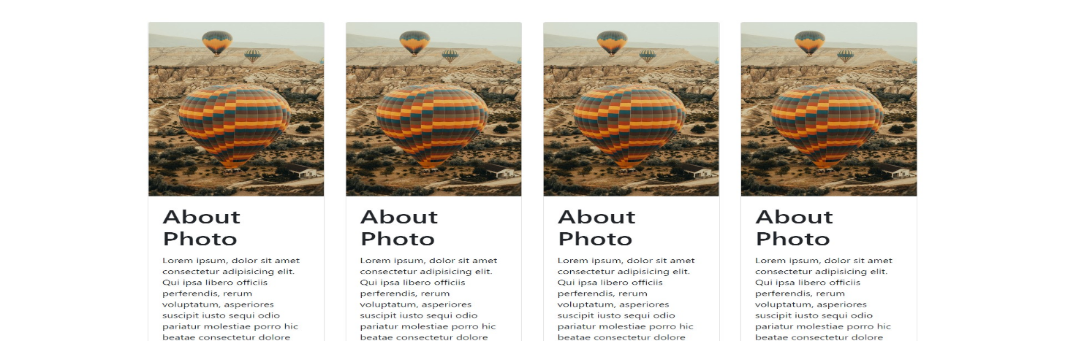

C)card-coloums : it is used to make masonry layout (means card will automatically going to adjust )

Note : we just need to use card-columns instead of card-group calss .

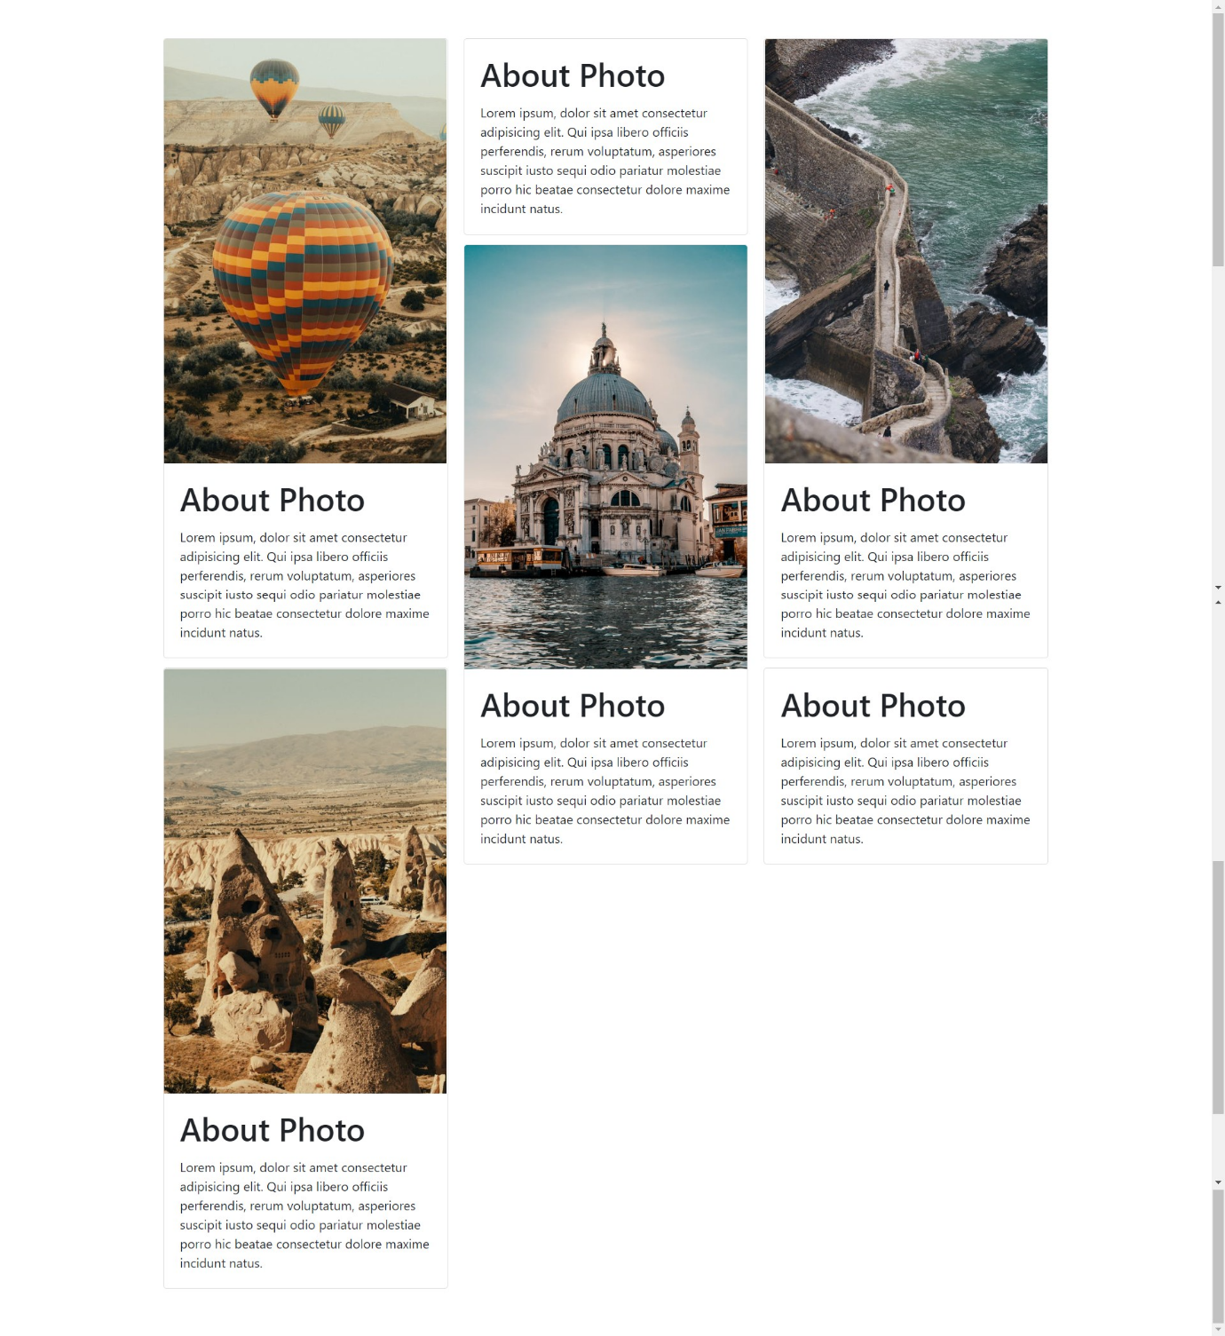

15. media

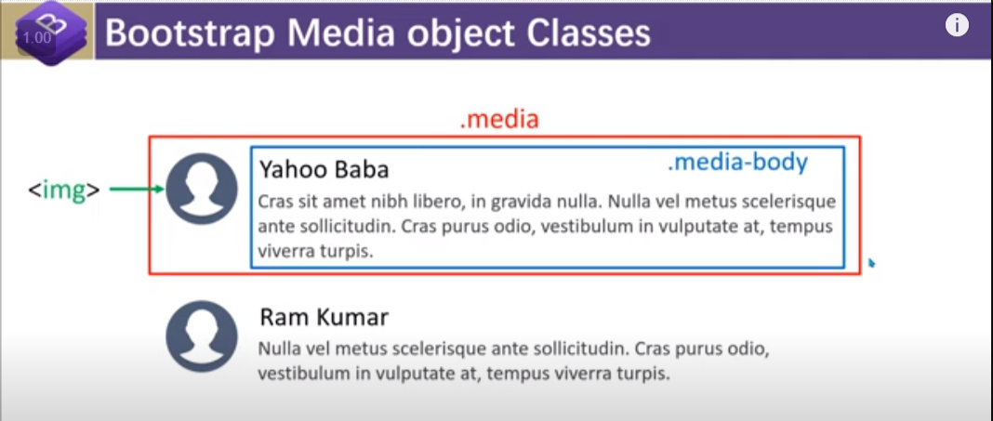

i) 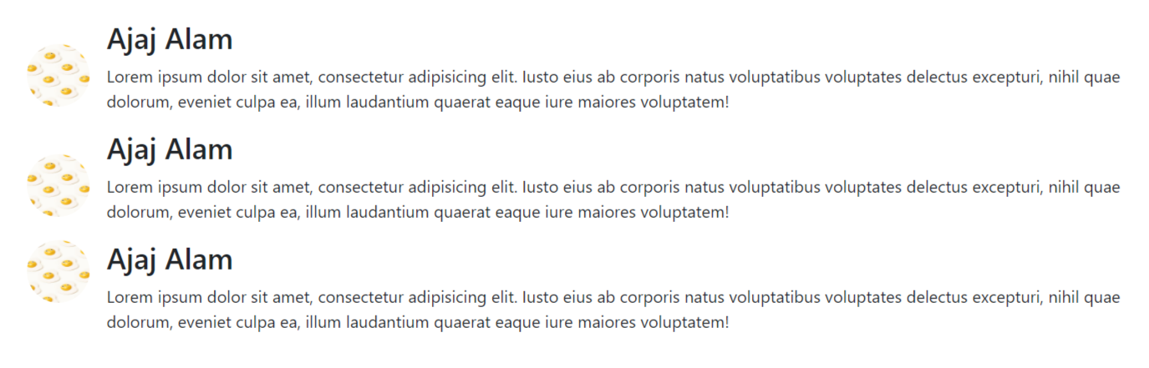

code :

<div class="container">

        <div class="row py-5">

            <div class="col">

                <div class="media">

                    <img src="https://images.unsplash.com/photo-1631931413024-38ed4229d10d?ixlib=rb-1.2.1&ixid=MnwxMjA3fDB8MHxzZWFyY2h8MTh8fHJhbmRvbXxlbnwwfHwwfHw%3D&auto=format&fit=crop&w=500&q=60" height="60px" width="60px" class="rounded-circle mr-3 align-self-center">

                    <div class="media-body">

                        <h3>Ajaj Alam</h3>

                        <p>Lorem ipsum dolor sit amet, consectetur adipisicing elit. Iusto eius ab corporis natus voluptatibus voluptates delectus excepturi, nihil quae dolorum, eveniet culpa ea, illum laudantium quaerat eaque iure maiores voluptatem!</p>

                    </div>

                </div>

                <div class="media">

                    <img src="https://images.unsplash.com/photo-1631931413024-38ed4229d10d?ixlib=rb-1.2.1&ixid=MnwxMjA3fDB8MHxzZWFyY2h8MTh8fHJhbmRvbXxlbnwwfHwwfHw%3D&auto=format&fit=crop&w=500&q=60" height="60px" width="60px" class="rounded-circle mr-3 align-self-center">

                    <div class="media-body">

                        <h3>Ajaj Alam</h3>

                        <p>Lorem ipsum dolor sit amet, consectetur adipisicing elit. Iusto eius ab corporis natus voluptatibus voluptates delectus excepturi, nihil quae dolorum, eveniet culpa ea, illum laudantium quaerat eaque iure maiores voluptatem!</p>

                    </div>

                </div>

                <div class="media">

                    <img src="https://images.unsplash.com/photo-1631931413024-38ed4229d10d?ixlib=rb-1.2.1&ixid=MnwxMjA3fDB8MHxzZWFyY2h8MTh8fHJhbmRvbXxlbnwwfHwwfHw%3D&auto=format&fit=crop&w=500&q=60" height="60px" width="60px" class="rounded-circle mr-3 ">

                    <div class="media-body">

                        <h3>Ajaj Alam</h3>

                        <p>Lorem ipsum dolor sit amet, consectetur adipisicing elit. Iusto eius ab corporis natus voluptatibus voluptates delectus excepturi, nihil quae dolorum, eveniet culpa ea, illum laudantium quaerat eaque iure maiores voluptatem!</p>

                    </div>

                </div>

        </div>

    </div>

1. We can also specify the position of img :

By using class in image : align-self-start (to align at the top ) , align-self-center (to align them between ) , align-self-bottom ( to align at the bottom )

iii) we can also make media layout like this :



<div class="media-body">

                        <h3>Ajaj Alam</h3>

                        <p>Lorem ipsum dolor sit amet, consectetur adipisicing elit. Iusto eius ab corporis natus

                            voluptatibus voluptates delectus excepturi, nihil quae dolorum, eveniet culpa ea, illum

                            laudantium quaerat eaque iure maiores voluptatem!</p>

                    </div>

                    <img src="https://images.unsplash.com/photo-1631931413024-38ed4229d10d?ixlib=rb-1.2.1&ixid=MnwxMjA3fDB8MHxzZWFyY2h8MTh8fHJhbmRvbXxlbnwwfHwwfHw%3D&auto=format&fit=crop&w=500&q=60"

                        height="60px" width="60px" class="rounded-circle ml-3 align-self-center">

                </div>

iv) To make a reply :

note : we need to make another media and put it in the media body of the comment in which we want to reply

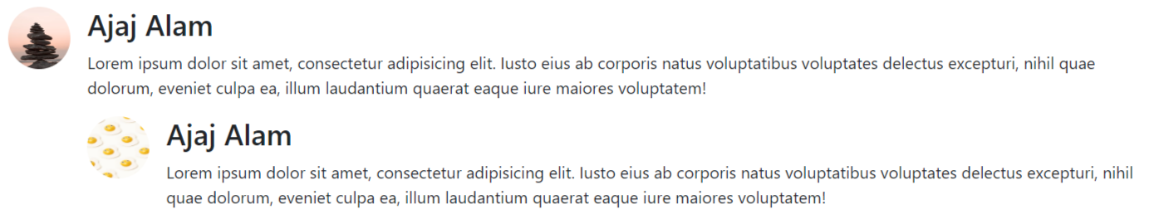

 <div class="media">

                    <img src="https://images.unsplash.com/photo-1502230831726-fe5549140034?ixlib=rb-1.2.1&ixid=MnwxMjA3fDB8MHxwaG90by1wYWdlfHx8fGVufDB8fHx8&auto=format&fit=crop&w=387&q=80"

                        height="60px" width="60px" class="rounded-circle mr-3 align-self-start">

                    <div class="media-body">

                        <h3>Ajaj Alam</h3>

                        <p>Lorem ipsum dolor sit amet, consectetur adipisicing elit. Iusto eius ab corporis natus

                            voluptatibus voluptates delectus excepturi, nihil quae dolorum, eveniet culpa ea, illum

                            laudantium quaerat eaque iure maiores voluptatem!</p>

                            <div class="media">

                                <img src="https://images.unsplash.com/photo-1631931413024-38ed4229d10d?ixlib=rb-1.2.1&ixid=MnwxMjA3fDB8MHxzZWFyY2h8MTh8fHJhbmRvbXxlbnwwfHwwfHw%3D&auto=format&fit=crop&w=500&q=60"

                                    height="60px" width="60px" class="rounded-circle mr-3 ">

                                <div class="media-body">

                                    <h3>Ajaj Alam</h3>

                                    <p>Lorem ipsum dolor sit amet, consectetur adipisicing elit. Iusto eius ab corporis natus

                                        voluptatibus voluptates delectus excepturi, nihil quae dolorum, eveniet culpa ea, illum

                                        laudantium quaerat eaque iure maiores voluptatem!</p>

                                </div>

                            </div>

                    </div>

16.Badge

I

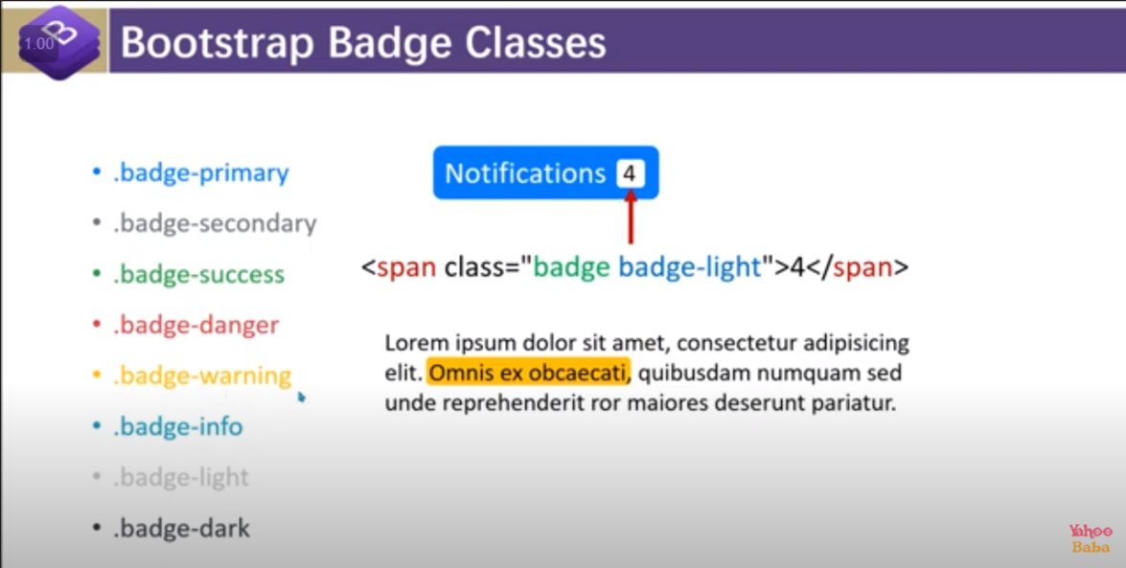

i) we can give badge color by : using class=”badge-pill”

ii) we can use badge in anchor tag :

<a href="" class="badge badge-primary">Read More</a>



iii) we can increase the badge size by giving padding .

visit link :

<https://getbootstrap.com/docs/5.0/components/badge/>

17.Progress

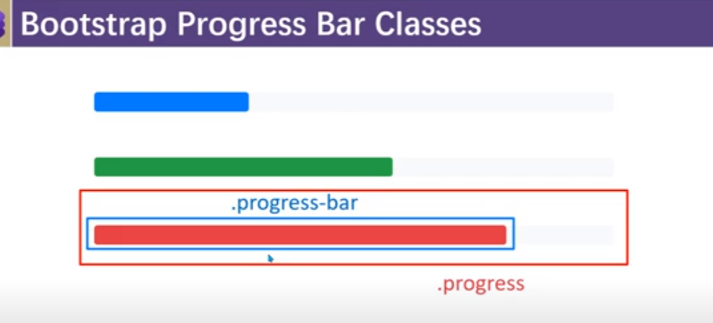

i) To show progress bar it is mandatory to give width and background colour.



<div class="container mt-5">

        <div class="progress mb-4">

            <div class="progress-bar bg-danger w-25">25%</div>

        </div>

        <div class="progress mb-4">

            <div class="progress-bar bg-success w-75">75%</div>

        </div>

        <div class="progress mb-4">

            <div class="progress-bar bg-info w-50">50%</div>

        </div>

    </div>

ii)To get stripped progress bar :class=”progress-bar-stripped”



<div class="progress mb-4">

            <div class="progress-bar progress-bar-striped bg-info w-50">50%</div>

        </div>

iii) To animate the stripped progress bar:

use class=”progress-bar-animate”

 <div class="progress mb-4">

            <div class="progress-bar progress-bar-striped progress-bar-animated bg-info w-50">50%</div>

        </div>

18.Spinner : it is in bootstrap 5

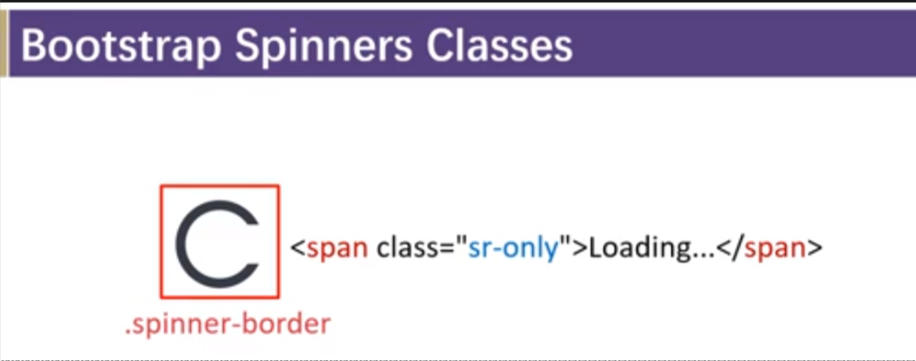

i)  <div class="spinner-border "></div>

ii) we can change the colour of spinner by :

<div class="spinner-border text-danger"></div>

1. we can also increase and decrease the size of spinner

by bootstrap

we can use class =”spinner-border-sm”

by-manually-

note : remember to give similar width and height

<div class="spinner-border text-danger" style="width: 100px; height:100px"></div>

iv) we can also have other form of spinner : for that we need to use spinner-grow instead of spinner-border

<div class="spinner-grow text-danger" style="width: 100px; height:100px"></div>

v)we can use spinner with the button:



<button class="btn btn-primary">

            <span class="spinner-border spinner-border-sm text-light"></span>

            Loading...</button>

19.jumbotron : it is used to highlight some thing

i)

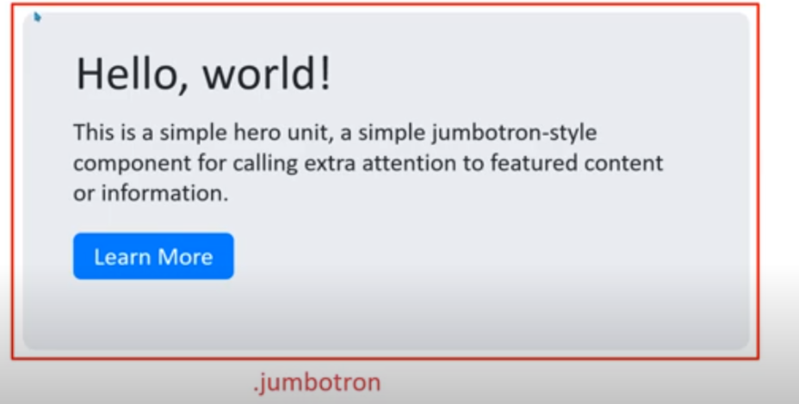

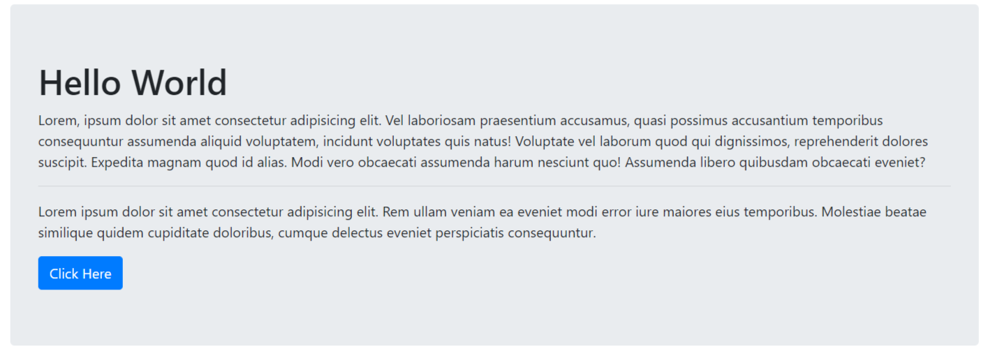

<div class="jumbotron ">

            <h1>Hello World</h1>

            <p>Lorem, ipsum dolor sit amet consectetur adipisicing elit. Vel laboriosam praesentium accusamus, quasi possimus accusantium temporibus consequuntur assumenda aliquid voluptatem, incidunt voluptates quis natus! Voluptate vel laborum quod qui dignissimos, reprehenderit dolores suscipit. Expedita magnam quod id alias. Modi vero obcaecati assumenda harum nesciunt quo! Assumenda libero quibusdam obcaecati eveniet?</p><hr>

            <p>Lorem ipsum dolor sit amet consectetur adipisicing elit. Rem ullam veniam ea eveniet modi error iure maiores eius temporibus. Molestiae beatae similique quidem cupiditate doloribus, cumque delectus eveniet perspiciatis consequuntur.</p>

            <button class="btn btn-primary">Click Here</button>

        </div>

ii) to give full width : use class=”jumbotron jumbotron-fluid”

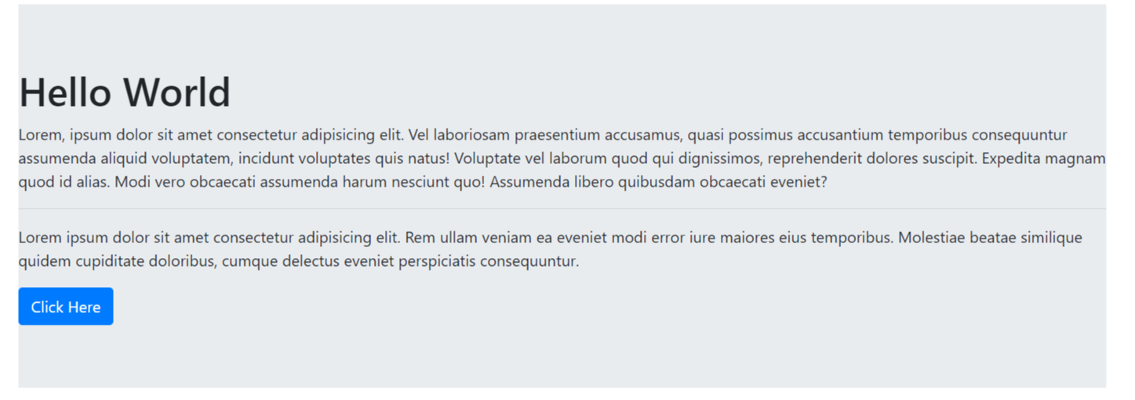

 <div class="jumbotron jumbotron-fluid">

            <h1>Hello World</h1>

            <p>Lorem, ipsum dolor sit amet consectetur adipisicing elit. Vel laboriosam praesentium accusamus, quasi possimus accusantium temporibus consequuntur assumenda aliquid voluptatem, incidunt voluptates quis natus! Voluptate vel laborum quod qui dignissimos, reprehenderit dolores suscipit. Expedita magnam quod id alias. Modi vero obcaecati assumenda harum nesciunt quo! Assumenda libero quibusdam obcaecati eveniet?</p><hr>

            <p>Lorem ipsum dolor sit amet consectetur adipisicing elit. Rem ullam veniam ea eveniet modi error iure maiores eius temporibus. Molestiae beatae similique quidem cupiditate doloribus, cumque delectus eveniet perspiciatis consequuntur.</p>

            <button class="btn btn-primary">Click Here</button>

        </div>

iii) we can also our own background-colour and text-colour

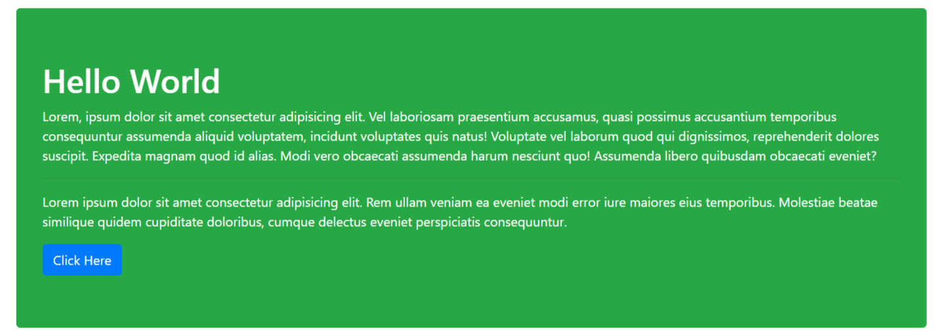

<div class="jumbotron bg-success text-white">

            <h1>Hello World</h1>

            <p>Lorem, ipsum dolor sit amet consectetur adipisicing elit. Vel laboriosam praesentium accusamus, quasi possimus accusantium temporibus consequuntur assumenda aliquid voluptatem, incidunt voluptates quis natus! Voluptate vel laborum quod qui dignissimos, reprehenderit dolores suscipit. Expedita magnam quod id alias. Modi vero obcaecati assumenda harum nesciunt quo! Assumenda libero quibusdam obcaecati eveniet?</p><hr>

            <p>Lorem ipsum dolor sit amet consectetur adipisicing elit. Rem ullam veniam ea eveniet modi error iure maiores eius temporibus. Molestiae beatae similique quidem cupiditate doloribus, cumque delectus eveniet perspiciatis consequuntur.</p>

            <button class="btn btn-primary">Click Here</button>

        </div>

20. genral class :

1. fade : it is used to provide animation

2. show : it is used to show the active content

5.hide : completely hide the content remove the content from dom

3. active : active the content

4. hidden : compent will be going to visible but no action will be performed

JavaScript Class of bootstrap :

1.Tool Tip plugin:

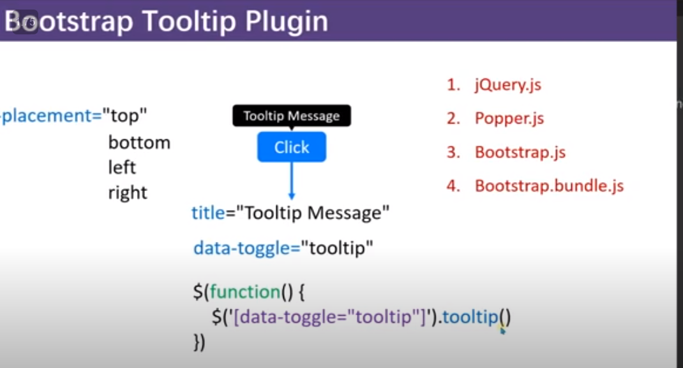

Note : above : it will be data-pacement=””

i)

head syntax :

<link rel="stylesheet" href="bootstrap.min.css">

    <script src="https://code.jquery.com/jquery-3.4.1.slim.min.js"></script>

    <script src="https://cdn.jsdelivr.net/npm/popper.js@1.16.0/dist/umd/popper.min.js"></script>

  <script src="https://cdn.jsdelivr.net/npm/bootstrap@4.4.1/dist/js/bootstrap.min.js"></script>

    <script>

        $(document).ready(*function*(){

            $('[data-toggle="tooltip"]').tooltip();

        })

    </script>

Body syntax :

<button class="btn btn-primary m-5" title="message at the top" placement="top" data-toggle="tooltip">Click Me</button>

ii) using html in title :

head:

 <script src="https://code.jquery.com/jquery-3.4.1.slim.min.js"></script>

    <script src="https://cdn.jsdelivr.net/npm/popper.js@1.16.0/dist/umd/popper.min.js"></script>

  <script src="https://cdn.jsdelivr.net/npm/bootstrap@4.4.1/dist/js/bootstrap.min.js"></script>

    <script>

        $(document).ready(*function*(){

            $('[data-toggle="tooltip"]').tooltip(

                {

                    html:true

                }

            );

        })

    </script>

Body:

<button class="btn btn-primary mt-5 ml-5" data-placement="left" title="<h1>Hello<br>Ajaj!</h1>" data-toggle="tooltip">click Me</button>

iii) Tool tip changes we can do :

<script>

        $(document).ready(*function*(){

            $('[data-toggle="tooltip"]').tooltip(

                {

                    html:true,  // enable to write the html content

                    animation:true ,        // remove the smothenss

                    delay:{show:"100",hide:"100"},    // specify delay and hide time in mili second

                    placement:"left",                // through this we can specify the placement

                    title:'<h6>Hello<br>Ajaj!</h6>',   // through this we can give the title

                    trigger:'hover',   // there is another value: focus it will work with the form , by default it has : hover value   // throgh this we can specify the event

                    offset:80  // through this we can change the position of title : +value will take it to down or right -value will take it to up and left

                }

            );

        })

    </script>

iv) tool tip method :

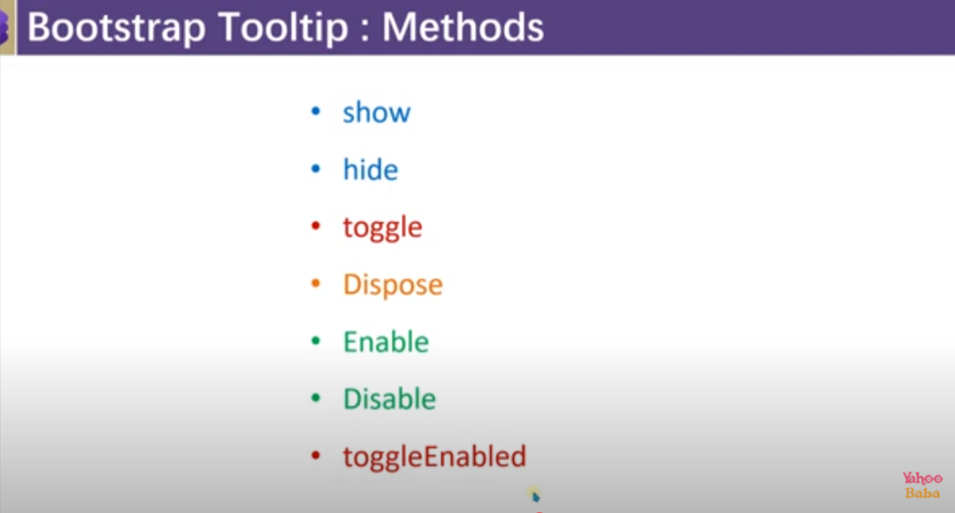

🡪dispose : it will going to permanently delete the tooltip

🡪disable : it will going to disable the tooltip it will not going to delete it permanently .

🡪toggledEnabled : it will going to work as toggle for enable and disable

  <script>

        $(document).ready(*function*(){

            $('[data-toggle="tooltip"]').tooltip(

                {

                    html:true,

                    placement:"left",

                    title:'<h6>Hello<br>Ajaj!</h6>',

                }

            );

            $('#Toggle-btn').click(*function*(){

                $('[data-toggle="tooltip"]').tooltip('toggle');

            })

        })

    </script>

</head>

<body>

    <button class="btn btn-primary mt-5 ml-5" data-toggle="tooltip">click Me</button><br>

    <button class="btn btn-outline-success ml-5 mt-5" id="Toggle-btn">Toggle</button>

</body>

v) Tool tip event :

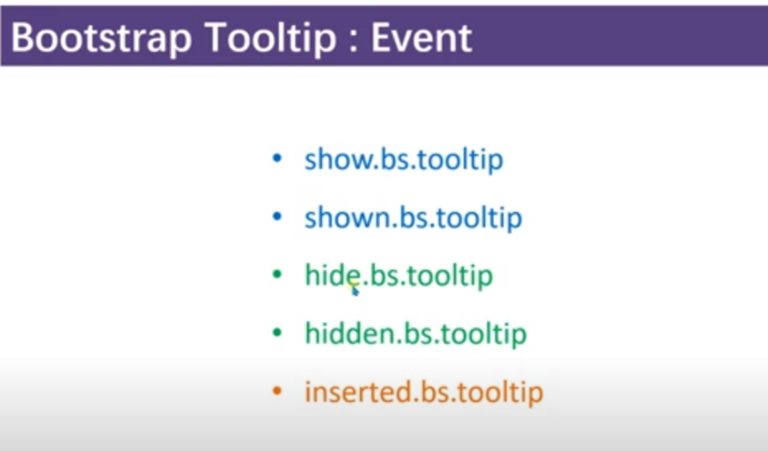

Bs= bootstrap

🡪show.bs.tooltip : it will going to trigger event wirtten in it before the tooltip show

🡪shown.bs.tooltip : it will going to trigger event written in it after the tooltip show

🡪 hide.bs.tooltip : : it will going to trigger event written in it before the tooltip hide

🡪hidden.bs.tooltip : it will going to trigger event written in it after the tooltip show

🡪inserted.bs.tooltip : it will going to call between show and showen

Code :

<script>

        $(document).ready(*function*(){

            $('#tooltip-event').tooltip(

                {

                    html:true,

                    placement:"left",

                    title:'<h6>Hello<br>Ajaj!</h6>',

                    trigger:'click'

                }

            );

            $('#tooltip-event').on({

                'show.bs.tooltip' : *function*(){

                    alert('show has been called');

                },

                'shown.bs.tooltip':*function*(){

                    alert('shown have been called!');

                },

                'inserted.bs.tooltip':*function*(){

                    alert('inserted have been callled!');

                },

                'hide.bs.tooltip':*function*(){

                    alert('hide have been called');

                },

                'hidden.bs.tooltip':*function*(){

                    alert('hidden have been called');

                },

            })

        })

    </script>

Body code :

<button class="btn btn-primary mt-5 ml-5" id="tooltip-event">click Me</button><br>

ii) Popover :

i)

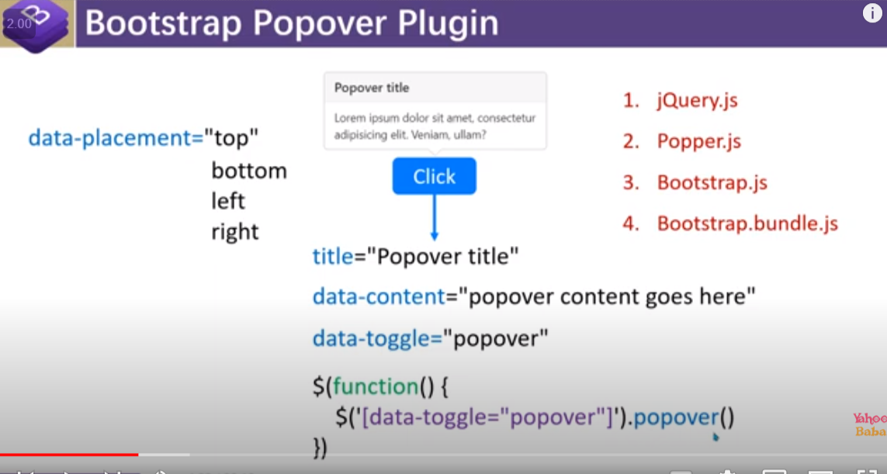

Head code:

<link rel="stylesheet" href="bootstrap.min.css">

    <script src="https://code.jquery.com/jquery-3.4.1.slim.min.js"></script>

    <script src="https://cdn.jsdelivr.net/npm/popper.js@1.16.0/dist/umd/popper.min.js"></script>

  <script src="https://cdn.jsdelivr.net/npm/bootstrap@4.4.1/dist/js/bootstrap.min.js"></script>

    <script>

       $(document).ready(*function*(){

        $('[data-toggle="popover"]').popover();

       })

    </script>

Body-code :

<button class="btn btn-primary mt-5 ml-5" title="popover" data-placement="right" data-content="Hello Ajaj Alam. Thanks for clicking here !" data-toggle="popover">Click Me</button>

ii) passing html in data-content :

<script>

       $(document).ready(*function*(){

        $('[data-toggle="popover"]').popover({

            html:true,

        });

       })

    </script>

<button class="btn btn-primary mt-5 ml-5" title="popover" data-placement="right" data-content="<h3>Hello Ajaj Alam. Thanks for clicking here !</h3>" data-toggle="popover">Click Me</button>

iii) Things that we can manipulate through popover :

 $(document).ready(*function*(){

        $('[data-toggle="popover"]').popover({

            html:true,

            animation:true,

            delay:{hide:"100",show:"100"},

            title:"Popover!",

            content:"<h3>Hello Ajaj Alam. Thanks for clicking here !</h3>",

            placement:'right',

            trigger:"hover",

            offset:100

        });

iv)popover method :



v)popover event :



🡺Diffrence between tooltip plugins and popover plugins

Tooltip plugins :

i) in tooltip plogins the background colour wil be black and we can not show tittle .

ii) by default it called on hover

popover plugins :

i) Through this we can show title and background grey.

ii) by default it trigger on click .

when to use which :

when we have to show small message the we can use tooltip and if we have to show large message with the till then we can use popover .

3.Alert classes and plugins

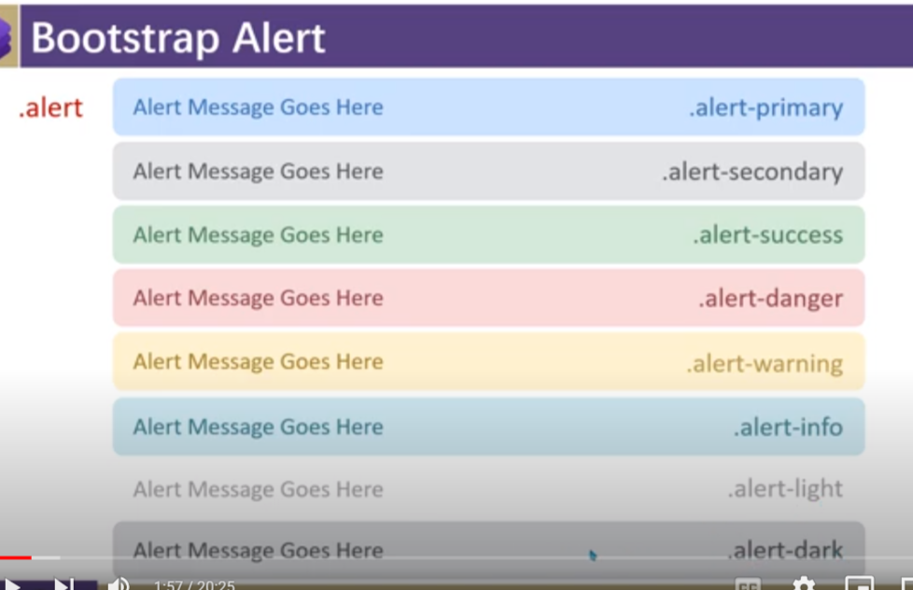

i)

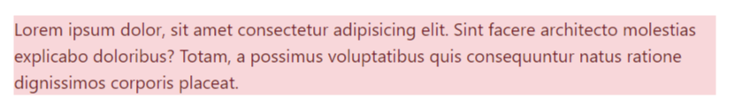

 <div class="container py-5">

        <div class="row justify-content-center">

            <div class="col-7">

                <div class="alter alert-danger">

                    <p>Lorem ipsum dolor, sit amet consectetur adipisicing elit. Sint facere architecto molestias explicabo doloribus? Totam, a possimus voluptatibus quis consequuntur natus ratione dignissimos corporis placeat.</p>

                </div>

            </div>

        </div>

    </div>

ii)Adding-link by using class=”alert link”

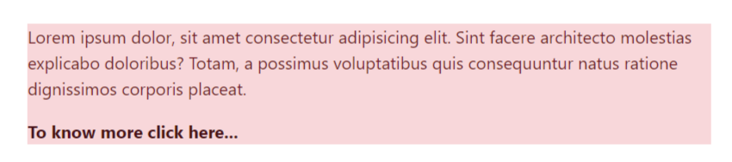

<div class="container py-5">

        <div class="row justify-content-center">

            <div class="col-7">

                <div class="alter alert-danger">

                    <p>Lorem ipsum dolor, sit amet consectetur adipisicing elit. Sint facere architecto molestias explicabo doloribus? Totam, a possimus voluptatibus quis consequuntur natus ratione dignissimos corporis placeat.</p>

                    <a href="" class="alert-link">To know more click here...</a>

                </div>

            </div>

        </div>

    </div>

iii)Adding heading by using class=”alert-heading”

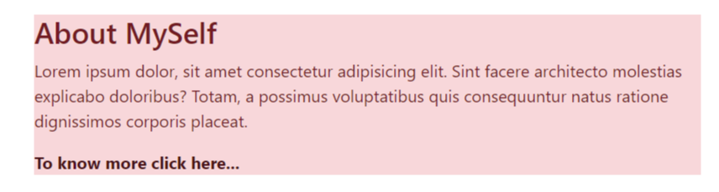

<div class="container py-5">

        <div class="row justify-content-center">

            <div class="col-7">

                <div class="alter alert-danger">

                    <h3 class="alert-heading">About MySelf</h3>

                    <p>Lorem ipsum dolor, sit amet consectetur adipisicing elit. Sint facere architecto molestias explicabo doloribus? Totam, a possimus voluptatibus quis consequuntur natus ratione dignissimos corporis placeat.</p>

                    <a href="" class="alert-link">To know more click here...</a>

                </div>

            </div>

        </div>

    </div>

iv) alert dismiss :

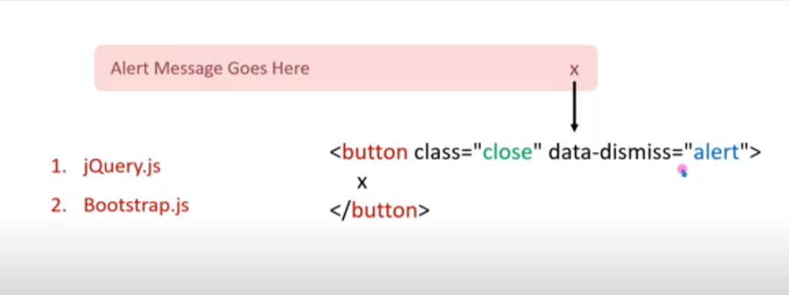

Note : we can get x sign form html entities web site

Code : &times

 <div class="container py-5">

        <div class="row no-gutters">

            <div class="col">

                <div class="alert alert-danger">Lorem ipsum dolor sit amet, consectetur adipisicing elit <button class="close" data-dismiss="alert"><span>&times;</span></button>

                </div>

            </div>

        </div>

v) alert method

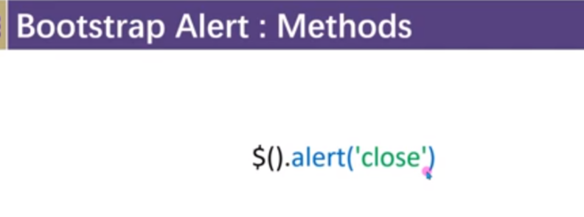

Using this we can trigger any alert :

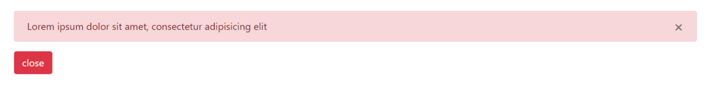

Code :

<script>

    $(document).ready(*function*(){

        $('#btn-close').click(*function*(){

            $('[data-dismiss="alert"]').alert('close');

        })

    })

</script>

</head>

<body>

    <div class="container py-5">

        <div class="row no-gutters">

            <div class="col">

                <div class="alert alert-danger">Lorem ipsum dolor sit amet, consectetur adipisicing elit <button class="close" data-dismiss="alert"><span>&times;</span></button>

                </div>

            </div>

        </div>

        <div class="row">

            <div class="col">

                <button class="btn btn-danger" id="btn-close">close</button>

            </div>

        </div>

    </div>

vi) alert event :

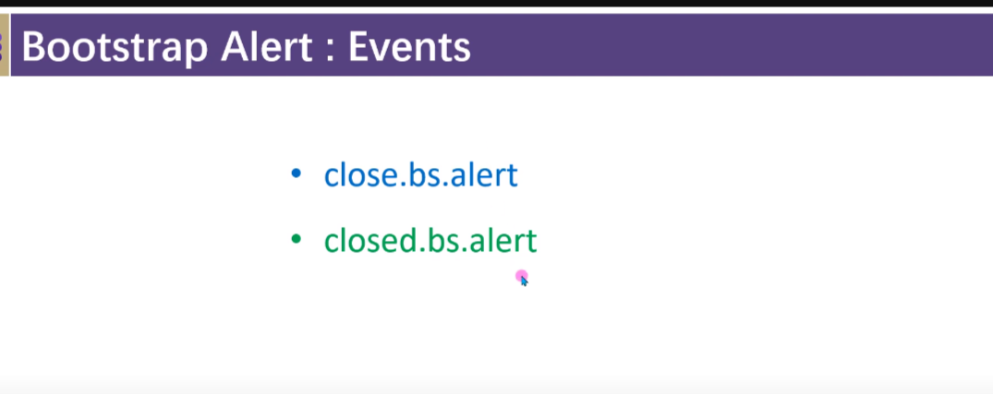

4.Modal :

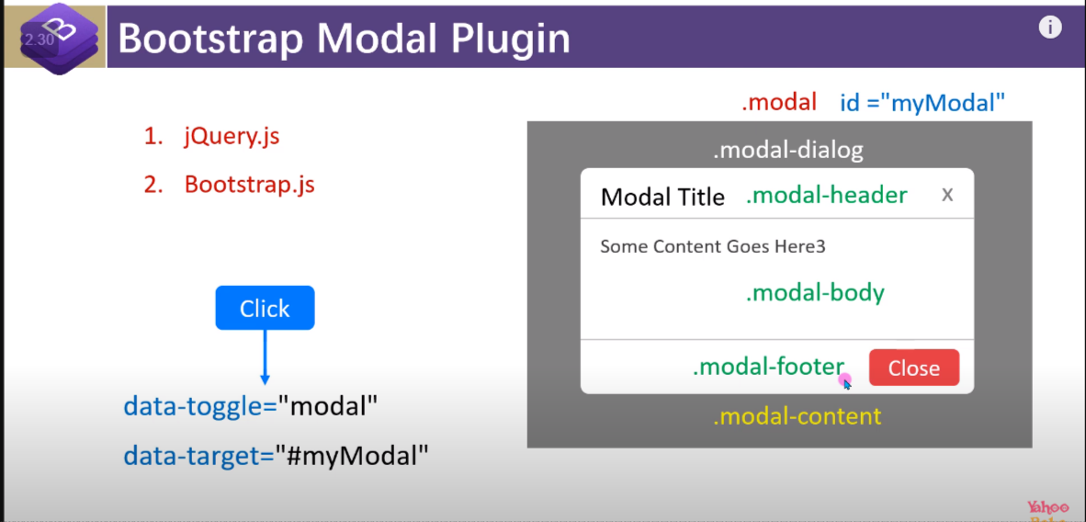

i)

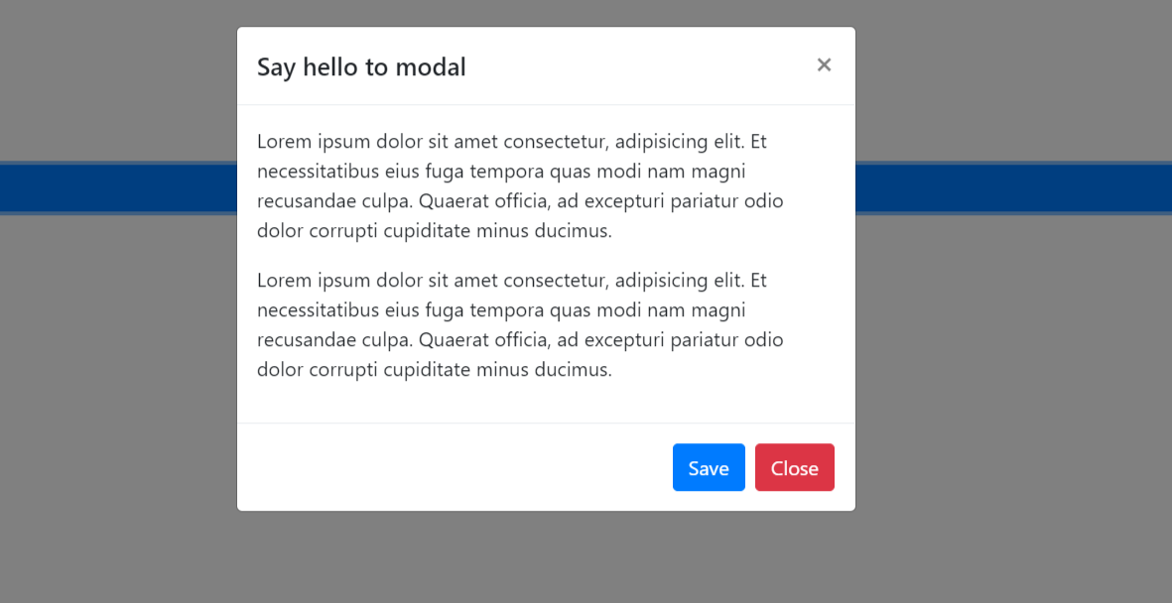

<div class="container" style="height:50vh;">

        <div class="row  h-100 align-items-center">

            <div class="col  h-25">

                <button class="btn btn-primary btn-block" data-toggle="modal" data-target="#modal">Click Me</button>

            </div>

            <div class="modal" id="modal">

                <div class="modal-dialog">

                    <div class="modal-content">

                        <div class="modal-header">

                            <h5 class="modal-title">Say hello to modal</h5>

                            <button class="close" data-dismiss="modal">

                                <span>&times;</span>

                            </button>

                        </div>

                        <div class="modal-body">

                            <p>Lorem ipsum dolor sit amet consectetur, adipisicing elit. Et necessitatibus eius fuga

                                tempora quas modi nam magni recusandae culpa. Quaerat officia, ad excepturi pariatur

                                odio dolor corrupti cupiditate minus ducimus.</p>

                            <p>Lorem ipsum dolor sit amet consectetur, adipisicing elit. Et necessitatibus eius fuga

                                tempora quas modi nam magni recusandae culpa. Quaerat officia, ad excepturi pariatur

                                odio dolor corrupti cupiditate minus ducimus.</p>

                        </div>

                        <div class="modal-footer">

                            <button class="btn btn-primary " >Save</button>

                            <button class="btn btn-danger " data-dismiss="modal">Close</button>

                        </div>

                    </div>

                </div>

            </div>

        </div>

    </div>

ii) To add animation : add class=”fade” with class=”modal”

<div class="modal fade" id="modal">

iii) if we want ki mdal box screen ke kisi part ke click karne par close na ho and only close ho when we click on close btn or X :

for that we need to add attributes at class=”modal” data-backdrop=”static”

 <div class="modal fade" id="modal" data-backdrop="static">

iv) To centered modal dialog box:

use class=”modal-dialog-centered” with the class=”modal-dialog”

<div class="modal-dialog modal-dialog-centered">



v) if we have large content in modal-dialog to add scroll in the modal :

use class=”modal-dialog-scrollable” with class=”modal-dialog”

note : it is bootstrap 5 property

vi)we can make layout inside the modal-body :

using container , row , col

vii) we can set the width of modal-dilaog : by adding class=”modal-sm” with class=”modal-dialog “

note : The width will be responsive

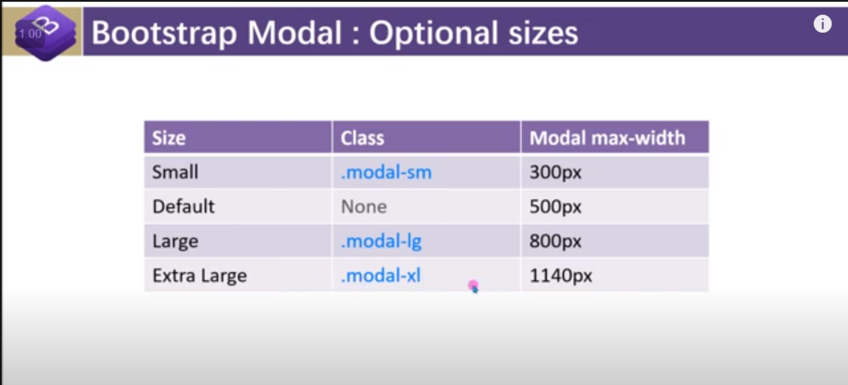

viii) To close modal with the escap key of the keyboard :

use attributes : tabindex=”-1” along the class=”modal”

 <div class="modal fade" id="modal"  tabindex="-1">

2.Modal method

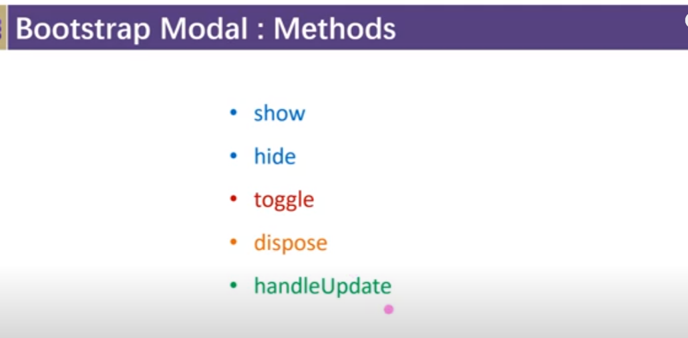

🡪 handelUpdate : is used to deal with the dynamic data .

Suppose : we have suddenly large content in the modal-dialog to handel that we use handelUpdate

3. modal event

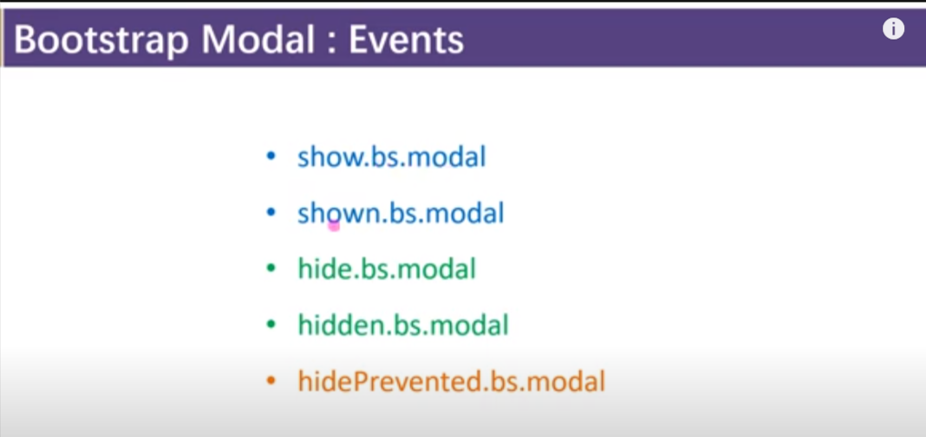

🡪hidden prevented: is used when user want to close the modal by clicking on the screen but we have used data-backdrop=”static” on that course we can use hidePrevented.bs.modal

Note : it triggers as soon as we want to close but it doesn’t happening .

5.Collapse plugin

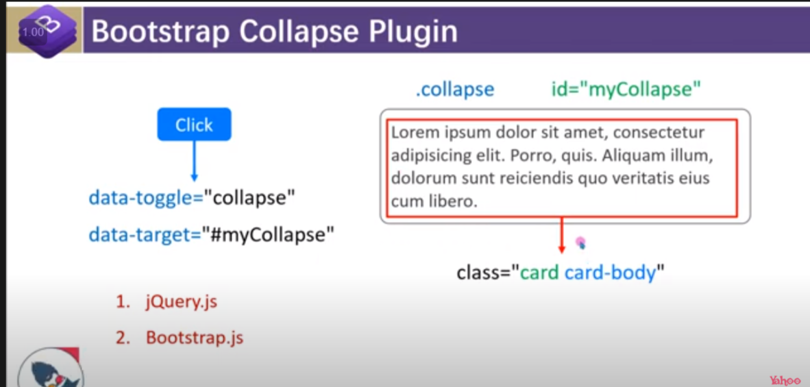

i) 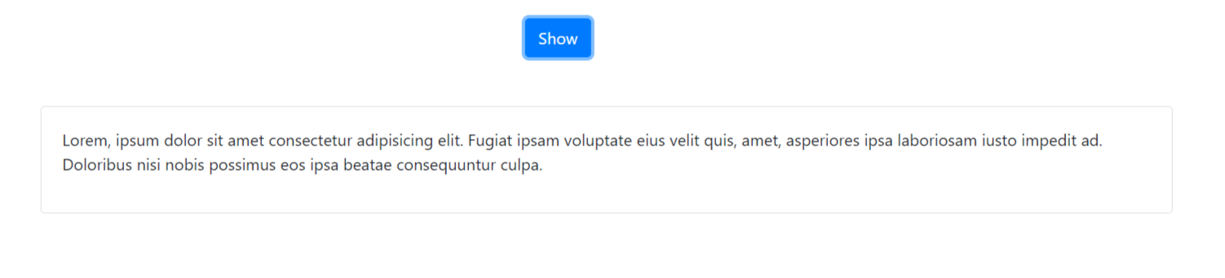

<div class="container">

        <div class="row  mt-4 justify-content-center">

            <div class="col-2 ">

                <button class="btn btn-primary" data-toggle="collapse" data-target="#collapse-item">Show</button>

            </div>

        </div>

        <div class="collapse mt-5" id="collapse-item">

            <div class="card card-body">

                <p>Lorem, ipsum dolor sit amet consectetur adipisicing elit. Fugiat ipsam voluptate eius velit quis,

                    amet, asperiores ipsa laboriosam iusto impedit ad. Doloribus nisi nobis possimus eos ipsa beatae

                    consequuntur culpa.</p>

            </div>

        </div>

    </div>

# 🡺Accordion

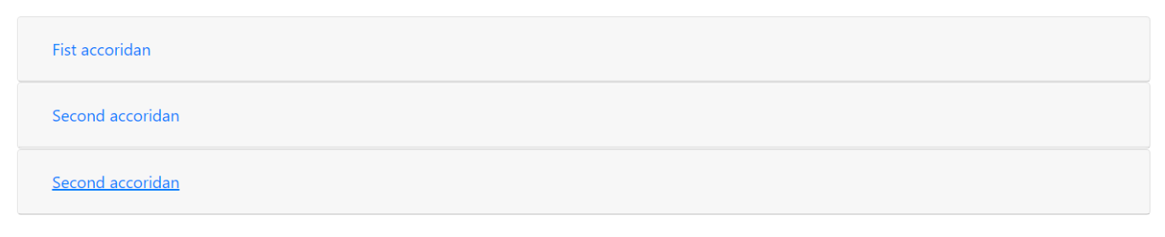

<div class="container">

        <div class="row  mt-4 ">

            <div class="col">

                <div class="Accordion" id="accordionExample">

                    <div class="card">

                        <div class="card-header">

                            <button class="btn btn-link text-left btn-block" data-toggle="collapse"

                                data-target="#collapse1">Fist accoridan</button>

                        </div>

                        <div class="collapse" id="collapse1" data-parent="#accordionExample">

                            <div class="card-body">

                                <p>Lorem ipsum dolor sit amet consectetur adipisicing elit. Corrupti optio cupiditate

                                    beatae quam tempora vel, aut accusantium dignissimos reprehenderit! Excepturi at

                                    alias eveniet beatae, ipsam praesentium enim minus? Facere, praesentium.</p>

                            </div>

                        </div>

                    </div>

                    <div class="card">

                        <div class="card-header">

                            <button class="btn btn-link text-left btn-block" data-toggle="collapse"

                                data-target="#collapse2">Second accoridan</button>

                        </div>

                        <div class="collapse" id="collapse2" data-parent="#accordionExample">

                            <div class="card-body">

                                <p>Lorem ipsum dolor sit amet consectetur adipisicing elit. Corrupti optio cupiditate

                                    beatae quam tempora vel, aut accusantium dignissimos reprehenderit! Excepturi at

                                    alias eveniet beatae, ipsam praesentium enim minus? Facere, praesentium.</p>

                            </div>

                        </div>

                    </div>

                    <div class="card">

                        <div class="card-header">

                            <button class="btn btn-link text-left btn-block" data-toggle="collapse"

                                data-target="#collapse3">Second accoridan</button>

                        </div>

                        <div class="collapse" id="collapse3" data-parent="#accordionExample">

                            <div class="card-body">

                                <p>Lorem ipsum dolor sit amet consectetur adipisicing elit. Corrupti optio cupiditate

                                    beatae quam tempora vel, aut accusantium dignissimos reprehenderit! Excepturi at

                                    alias eveniet beatae, ipsam praesentium enim minus? Facere, praesentium.</p>

                            </div>

                        </div>

                    </div>

                </div>

            </div>

        </div>

    </div>

ii)if we want on of the accordian to show automatically :

use class=”show” in class=”collapse”

<div class="collapse show" id="collapse1" data-parent="#accordionExample">

iii) we can also set accordion view dynamically by using class=”collapsed”

<button class="btn btn-link text-left btn-block collapsed" data-toggle="collapse"

                                data-target="#collapse1">Fist accoridan</button>

video link:

<https://www.youtube.com/watch?v=N7YQamb37VE&list=PL0b6OzIxLPbz1cgxiH5KCBsyQij1HsPtG&index=49>

time :20 onward

iii)collapse method :

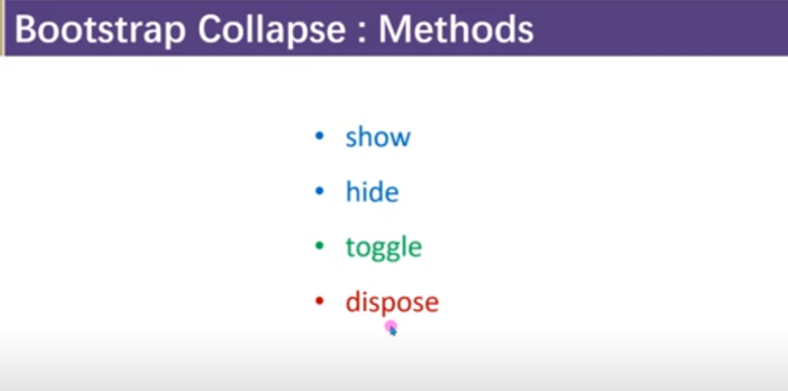

iv)collapse event

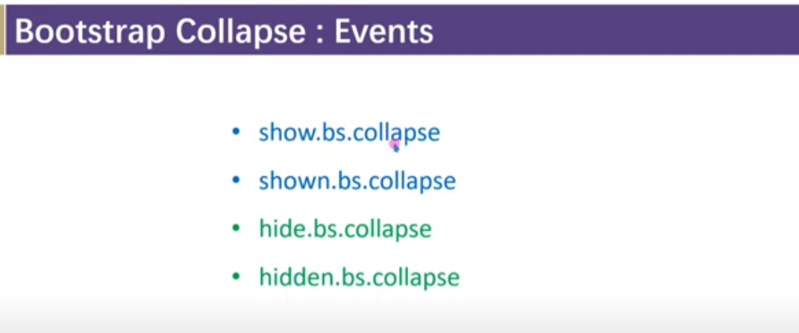

6.Tab plugin

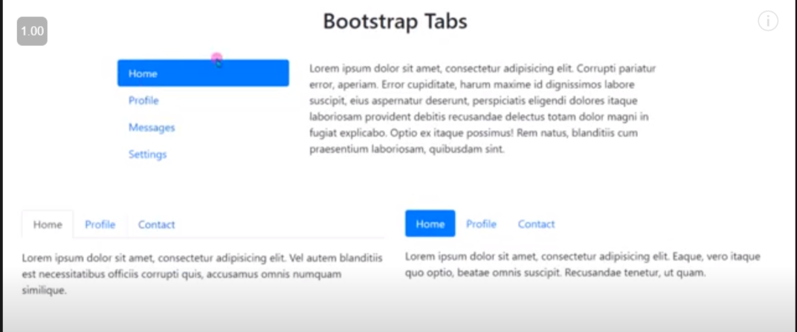

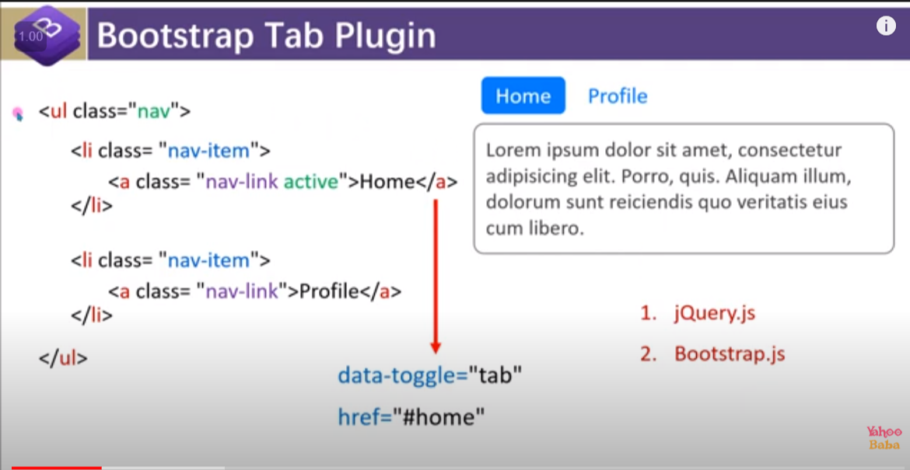

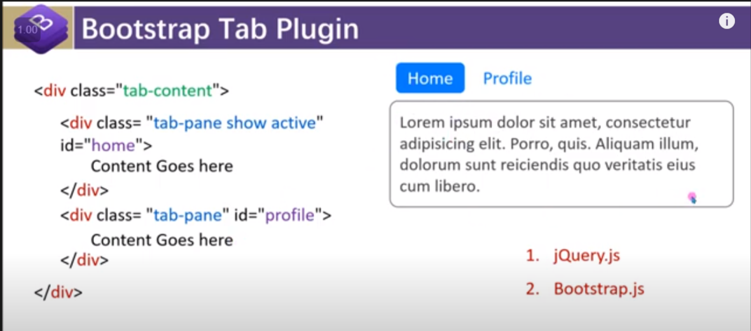

i)

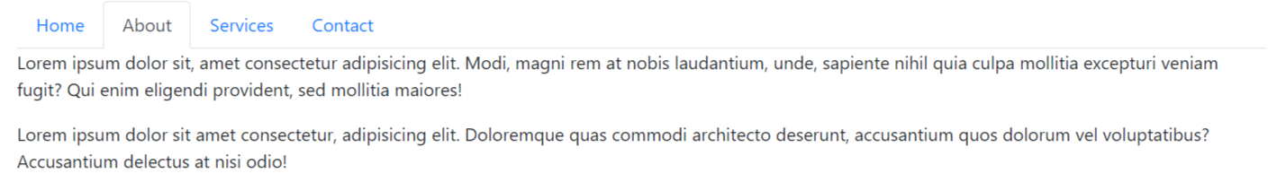

<div class="container">

        <div class="row  mt-4 ">

            <div class="col">

                <ul class="nav nav-tabs">

                    <li class="nav-item "><a href="#home" class="nav-link active" data-toggle="tab">Home</a></li>

                    <li class="nav-item"><a href="#about" class="nav-link" data-toggle="tab">About</a></li>

                    <li class="nav-item"><a href="#services" class="nav-link" data-toggle="tab">Services</a></li>

                    <li class="nav-item"><a href="#contact" class="nav-link" data-toggle="tab">Contact</a></li>

                </ul>

            </div>

        </div>

        <div class="row">

            <div class="col">

                <div class="tab-content">

                    <div class="tab-pane fade show active" id="home">

                        <p>Lorem ipsum dolor sit, amet consectetur adipisicing elit. Modi, magni rem at nobis laudantium,

                            unde, sapiente nihil quia culpa mollitia excepturi veniam fugit? Qui enim eligendi provident,

                            sed mollitia maiores!</p>

                    </div>

                    <div class="tab-pane fade" id="about">

                        <p>Lorem ipsum dolor sit, amet consectetur adipisicing elit. Modi, magni rem at nobis laudantium,

                            unde, sapiente nihil quia culpa mollitia excepturi veniam fugit? Qui enim eligendi provident,

                            sed mollitia maiores!</p>

                            <p>Lorem ipsum dolor sit amet consectetur, adipisicing elit. Doloremque quas commodi architecto deserunt, accusantium quos dolorum vel voluptatibus? Accusantium delectus at nisi odio!</p>

                    </div>

                    <div class="tab-pane fade" id="services">

                        <p>Lorem ipsum dolor sit, amet consectetur adipisicing elit. Modi, magni rem at nobis laudantium,

                            sed mollitia maiores!</p>

                    </div>

                    <div class="tab-pane fade" id="contact">

                        <p>Lorem ipsum dolor sit, amet consectetur adipisicing elit. Modi, magni rem at nobis </p>

                    </div>

                </div>

            </div>

        </div>

    </div>

ii) pill tabs :

to form pill tabs :

1. remove class nav-tabs from tab class and add class nav-pills

2. inseted of data-toggle=”tab” we need to use data-toggle=”pill”

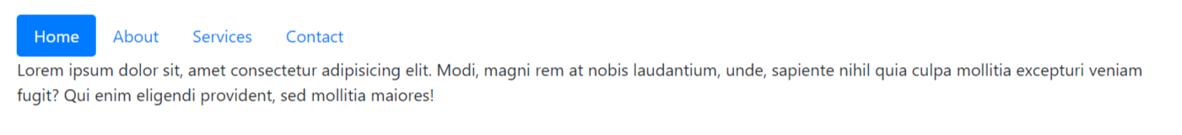

<div class="container">

        <div class="row  mt-4 ">

            <div class="col">

                <ul class="nav nav-pills">

                    <li class="nav-item "><a href="#home" class="nav-link active" data-toggle="pill">Home</a></li>

                    <li class="nav-item"><a href="#about" class="nav-link" data-toggle="pill">About</a></li>

                    <li class="nav-item"><a href="#services" class="nav-link" data-toggle="pill">Services</a></li>

                    <li class="nav-item"><a href="#contact" class="nav-link" data-toggle="pill">Contact</a></li>

                </ul>

            </div>

        </div>

        <div class="row">

            <div class="col">

                <div class="tab-content">

                    <div class="tab-pane fade show active" id="home">

                        <p>Lorem ipsum dolor sit, amet consectetur adipisicing elit. Modi, magni rem at nobis laudantium,

                            unde, sapiente nihil quia culpa mollitia excepturi veniam fugit? Qui enim eligendi provident,

                            sed mollitia maiores!</p>

                    </div>

                    <div class="tab-pane fade" id="about">

                        <p>Lorem ipsum dolor sit, amet consectetur adipisicing elit. Modi, magni rem at nobis laudantium,

                            unde, sapiente nihil quia culpa mollitia excepturi veniam fugit? Qui enim eligendi provident,

                            sed mollitia maiores!</p>

                            <p>Lorem ipsum dolor sit amet consectetur, adipisicing elit. Doloremque quas commodi architecto deserunt, accusantium quos dolorum vel voluptatibus? Accusantium delectus at nisi odio!</p>

                    </div>

                    <div class="tab-pane fade" id="services">

                        <p>Lorem ipsum dolor sit, amet consectetur adipisicing elit. Modi, magni rem at nobis laudantium,

                            sed mollitia maiores!</p>

                    </div>

                    <div class="tab-pane fade" id="contact">

                        <p>Lorem ipsum dolor sit, amet consectetur adipisicing elit. Modi, magni rem at nobis </p>

                    </div>

                </div>

            </div>

        </div>

    </div>

3. tab method :

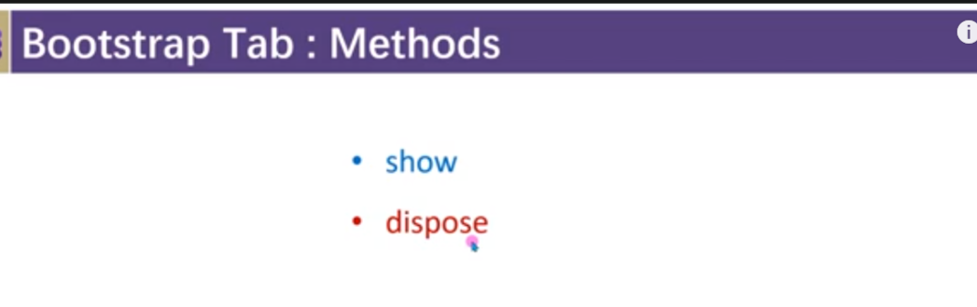

4.event

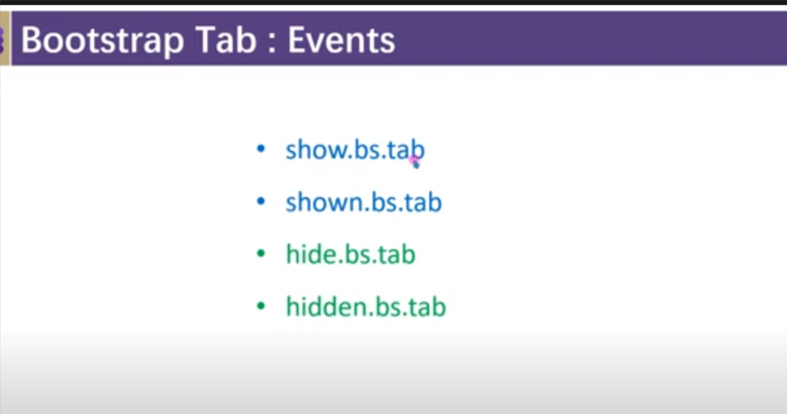

7. Carousel

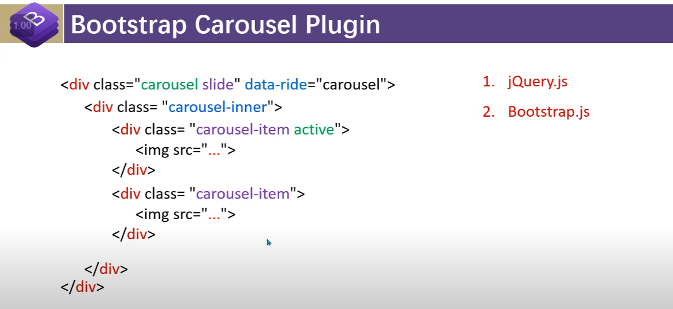

Note :

i) It is important to active at least one image otherwise carousel will not going to work

i)



 <div class="container">

        <div class="row  mt-4">

            <div class="col">

                <div class="carousel slide" data-ride="carousel">

                    <div class="carousel-inner" >

                        <div class="carousel-item active">

                            <img class="d-block w-100 img-fluid" style="height: 60vh;" src="https://images.unsplash.com/photo-1593642532454-e138e28a63f4?ixlib=rb-1.2.1&ixid=MnwxMjA3fDB8MHxwaG90by1wYWdlfHx8fGVufDB8fHx8&auto=format&fit=crop&w=1169&q=80" alt="">

                        </div>

                        <div class="carousel-item">

                            <img class="d-block w-100" style="height: 60vh;" src="https://images.unsplash.com/photo-1593642634402-b0eb5e2eebc9?ixlib=rb-1.2.1&ixid=MnwxMjA3fDB8MHxwaG90by1wYWdlfHx8fGVufDB8fHx8&auto=format&fit=crop&w=1169&q=80" alt="">

                        </div>

                        <div class="carousel-item">

                            <img class="d-block w-100" style="height: 60vh;" src="https://images.unsplash.com/photo-1593642702821-c8da6771f0c6?ixlib=rb-1.2.1&ixid=MnwxMjA3fDB8MHxwaG90by1wYWdlfHx8fGVufDB8fHx8&auto=format&fit=crop&w=1332&q=80" alt="">

                        </div>

                    </div>

                </div>

            </div>

        </div>

    </div>

ii)To add carousel control

🡪add carousel control below and out of carousel-inner class

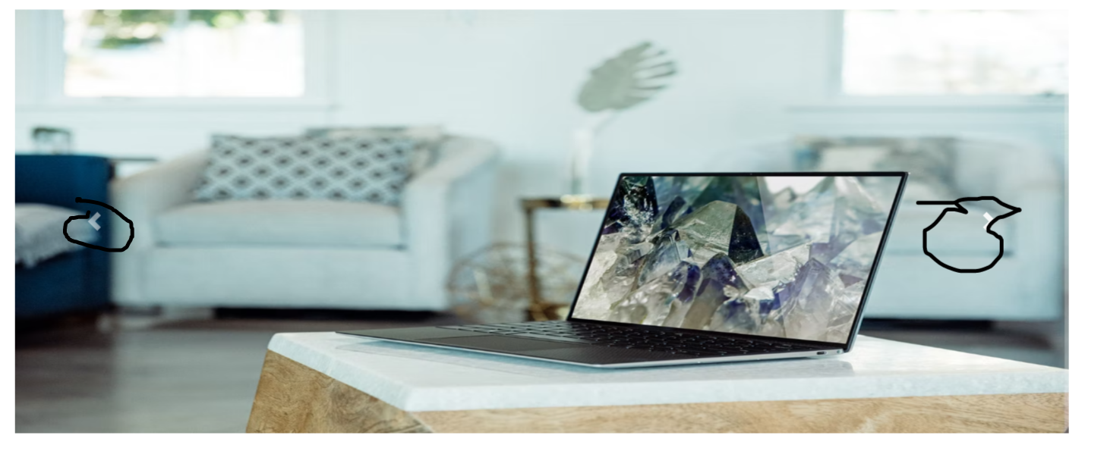

 <div class="container">

        <div class="row  mt-4">

            <div class="col">

                <div class="carousel slide" data-ride="carousel" id="Mycarousel">

                    <div class="carousel-inner" >

                        <div class="carousel-item active">

                            <img class="d-block w-100 img-fluid" style="height: 60vh;" src="https://images.unsplash.com/photo-1593642532454-e138e28a63f4?ixlib=rb-1.2.1&ixid=MnwxMjA3fDB8MHxwaG90by1wYWdlfHx8fGVufDB8fHx8&auto=format&fit=crop&w=1169&q=80" alt="">

                        </div>

                        <div class="carousel-item">

                            <img class="d-block w-100" style="height: 60vh;" src="https://images.unsplash.com/photo-1593642634402-b0eb5e2eebc9?ixlib=rb-1.2.1&ixid=MnwxMjA3fDB8MHxwaG90by1wYWdlfHx8fGVufDB8fHx8&auto=format&fit=crop&w=1169&q=80" alt="">

                        </div>

                        <div class="carousel-item">

                            <img class="d-block w-100" style="height: 60vh;" src="https://images.unsplash.com/photo-1593642702821-c8da6771f0c6?ixlib=rb-1.2.1&ixid=MnwxMjA3fDB8MHxwaG90by1wYWdlfHx8fGVufDB8fHx8&auto=format&fit=crop&w=1332&q=80" alt="">

                        </div>

                    </div>

                    <a href="# Mycarousel " class="carousel-control-prev" data-slide="prev"><span class="carousel-control-prev-icon"></span></a>

                    <a href="# Mycarousel " class="carousel-control-next" data-slide="next"><span class="carousel-control-next-icon"></span></a>

                </div>

            </div>

        </div>

    </div>

iii) Adding carousel-slider :

to add carousel slider : we need to add certain class above carousel-inner within carousel class



Note : during adding carousel slider we need to specify attributes data-slide-to=”0/1/2..”

The no is 0-for 1st image , 1 for 2nd image and so on

Note : do not forget to add class active in the li of active image

<div class="container">

        <div class="row  mt-4">

            <div class="col">

                <div class="carousel slide" data-ride="carousel" id="mycarousel">

                    <ul class="carousel-indicators" >

                        <li data-target="#mycarousel" data-slide-to="0" class="active"></li>

                        <li data-target="#mycarousel" data-slide-to="1" ></li>

                        <li data-target="#mycarousel" data-slide-to="2" ></li>

                    </ul>

                    <div class="carousel-inner" >

                        <div class="carousel-item active">

                            <img class="d-block w-100 img-fluid" style="height: 60vh;" src="https://images.unsplash.com/photo-1593642532454-e138e28a63f4?ixlib=rb-1.2.1&ixid=MnwxMjA3fDB8MHxwaG90by1wYWdlfHx8fGVufDB8fHx8&auto=format&fit=crop&w=1169&q=80" alt="">

                        </div>

                        <div class="carousel-item">

                            <img class="d-block w-100" style="height: 60vh;" src="https://images.unsplash.com/photo-1593642634402-b0eb5e2eebc9?ixlib=rb-1.2.1&ixid=MnwxMjA3fDB8MHxwaG90by1wYWdlfHx8fGVufDB8fHx8&auto=format&fit=crop&w=1169&q=80" alt="">

                        </div>

                        <div class="carousel-item">

                            <img class="d-block w-100" style="height: 60vh;" src="https://images.unsplash.com/photo-1593642702821-c8da6771f0c6?ixlib=rb-1.2.1&ixid=MnwxMjA3fDB8MHxwaG90by1wYWdlfHx8fGVufDB8fHx8&auto=format&fit=crop&w=1332&q=80" alt="">

                        </div>

                    </div>

                    <a href="#mycarousel" class="carousel-control-prev" data-slide="prev"><span class="carousel-control-prev-icon"></span></a>

                    <a href="#mycarousel" class="carousel-control-next" data-slide="next"><span class="carousel-control-next-icon"></span></a>

                </div>

            </div>

        </div>

    </div>

iv) we can add heading or pargraph in the imge by using class=”carousel-caption”

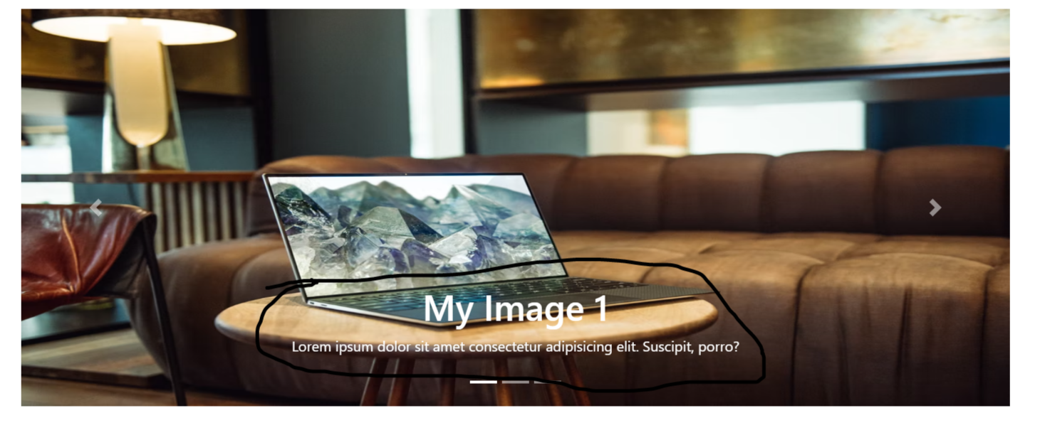

 <div class="carousel-item active">

                            <img class="d-block w-100 img-fluid" style="height: 60vh;" src="https://images.unsplash.com/photo-1593642532454-e138e28a63f4?ixlib=rb-1.2.1&ixid=MnwxMjA3fDB8MHxwaG90by1wYWdlfHx8fGVufDB8fHx8&auto=format&fit=crop&w=1169&q=80" alt="">

                            <div class="carousel-caption">

                                <h1>My Image 1</h1>

                                <p>Lorem ipsum dolor sit amet consectetur adipisicing elit. Suscipit, porro?</p>

                            </div>

                        </div>

v) if we want to add :

fade kind of animation then we need to add class=”carousel-fade”

<div class="carousel slide carousel-fade" data-ride="carousel" id="mycarousel">

v)To change the the timing of slide/fade we can do that by adding attributes :

data-interval=”2000” means 2s in the class=”carousel-item”

<div class="carousel-item active" data-interval="10000">

Note :by default it has 5 sec time

$(document).ready(*function*(){

            $('#mycarousel').carousel({

                interval:'2000',

                wrap:false , // it will going to stop sliding after reaching to the last slide

            });

        })

2. Carousel method :

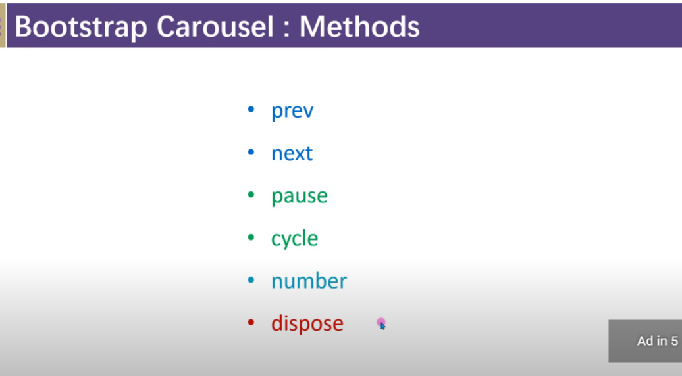

🡪perv: on that carousel will going to go into prev

🡪next: on that carousel will going to go into next

🡪pause: on that moving of carousel will going to stop

🡪cycle : on that pause will going to start

🡪number : on that we can specify the number of moving as given below

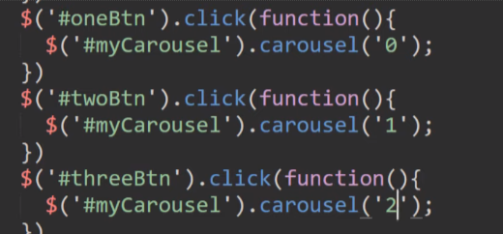

🡪dispose : will delete

3. Event

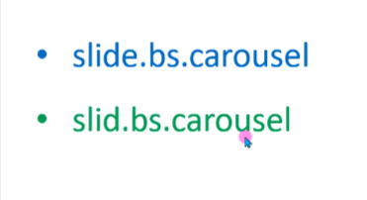

🡪slide.bs.carousel: will going to trigger just before the image changes

🡪slid.bs.carousel : will going to trigger after the image have been changed completely

<script>

        $(document).ready(*function*(){

            $('#mycarousel').on({

                'slide.bs.carousel':*function*(){

                    alert('slide have been called');

                },

                'slid.bs.carousel':*function*(){

                    alert('slid have been called');

                }

            })

        })

    </script>

8. Toast Plugin it is bootstrap 5 property

It is used to show notification

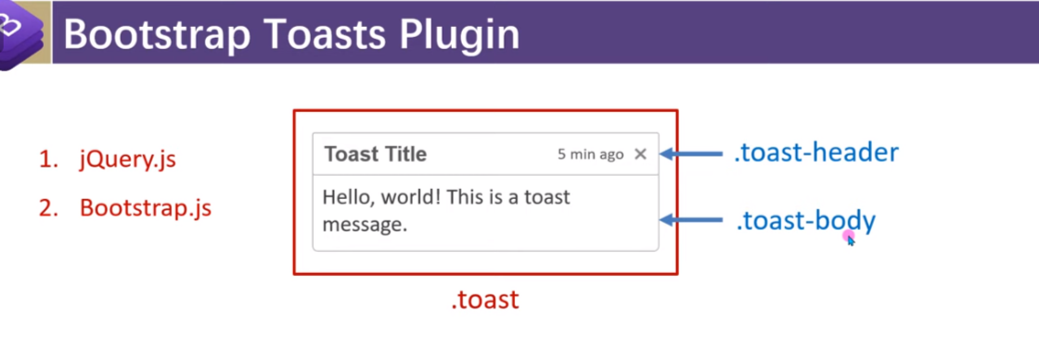

🡺script code :

 <script>

        $(document).ready(*function*(){

            $('.toast').toast();

        })

    </script>

Body code :

<div class="container">

        <div class="row  mt-4">

            <div class="col">

                <div class="toast show">

                    <div class="toast-header " id="mytoast">

                        <b>Say hello to toast</b>

                        <button class="close ml-auto" data-dismiss="toast"><span>&times;</span></button>

                    </div>

                    <div class="toast-body">

                        <p>Lorem ipsum dolor sit amet consectetur adipisicing elit. Excepturi recusandae aut quae consequuntur cumque nam consequatur officia voluptate a facere quisquam esse quidem, iusto voluptatem dolor non inventore praesentium fugit.</p>

                        <button class="btn btn-primary" data-dismiss="toast">Close</button>

                    </div>

                </div>

            </div>

        </div>

Note : use class=”show “ with toast to show the notification by default

2.toast method



3. toast event

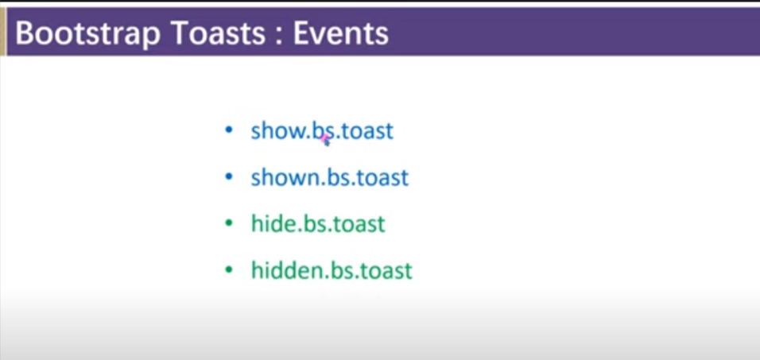

🡺 use of plugin with the bootstrap 5

Note : in boot strap5 we do not need to use jquery cnd for plugin

ii) we can do all work by using bootstrap javascript cdn link

A) Way of customizing :

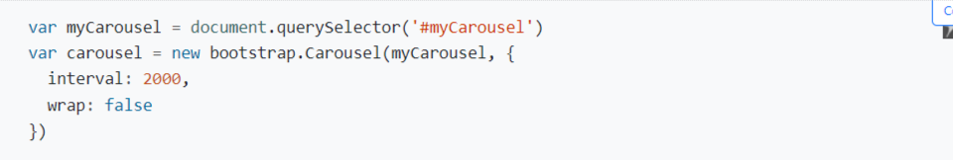

Note : after bootstrap first letter of name of plugin will be capital .

B) way of calling method :

Carousel.show().

🡺BOOTSTRAP UTLITY API :

Step 1 : instal sas live server

Step 2 : in terminal run command : npm init 🡪 to create a node package

Step 3 : install bootstrap by : npm i bootstrap

Step 4 : create sass file in it create style.scss

Step5 : in style.scss file

Import : from node_module file->bootstrap->scss->then

@import '../node_modules/bootstrap/scss/functions';

@import '../node_modules/bootstrap/scss/variables';

@import '../node_modules/bootstrap/scss/maps';

@import '../node_modules/bootstrap/scss/utilities';

searching :

i) to search any thing in the ustlities.scss : in serach box that can be get by shortcut : ctrl + f into in write any thing you want to search in inverted couma eg : “width”

ii)to search in .min.css file : search anything with : eg : .width

To make changes in utilities :

@import '../node_modules/bootstrap/scss/functions';

@import '../node_modules/bootstrap/scss/variables';

@import '../node_modules/bootstrap/scss/maps';

@import '../node_modules/bootstrap/scss/utilities';

$utilities:(

    "width": (

*property*: *width*,

*class*:*w*,

*values*: (

*25*: 25%,

*50*: 50%,

*75*: 75%,

*100*: 100%,

*auto*: auto,

*30*:30% //adding a new width

        )

      ),

);

@import '../node_modules/bootstrap/scss/bootstrap.scss';

Note : using above method we can create our own class and property :

ii) for taking any string as key as put that into double quote

iii) for number we can directly use no .

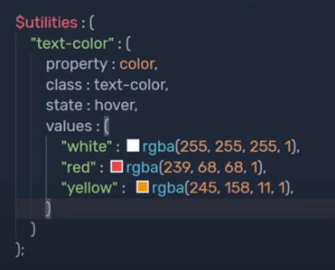

By using it we can create our hover as well using :

State:hover

For calling it in html : class=”text-color-red-hover”

🡺 if we want to generate responsive class for every things that I write:

Use : responsive:true,

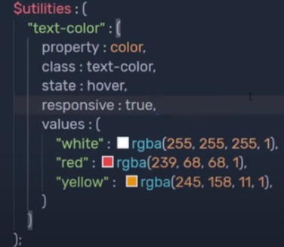

If I am using state and responsive it will going to create seprate class for each one . eg ->

It will going to create class=”text-color-sm-white” or class=”text-color-white-hover”

link :

<https://www.youtube.com/watch?v=4k3AiwXrfig&t=864s>

Adding something to the variable :

Here :

$theme-colors : is original variable and $custom-them-colors is created variable

Link :

<https://www.youtube.com/watch?v=nCX3QVl_PiI>

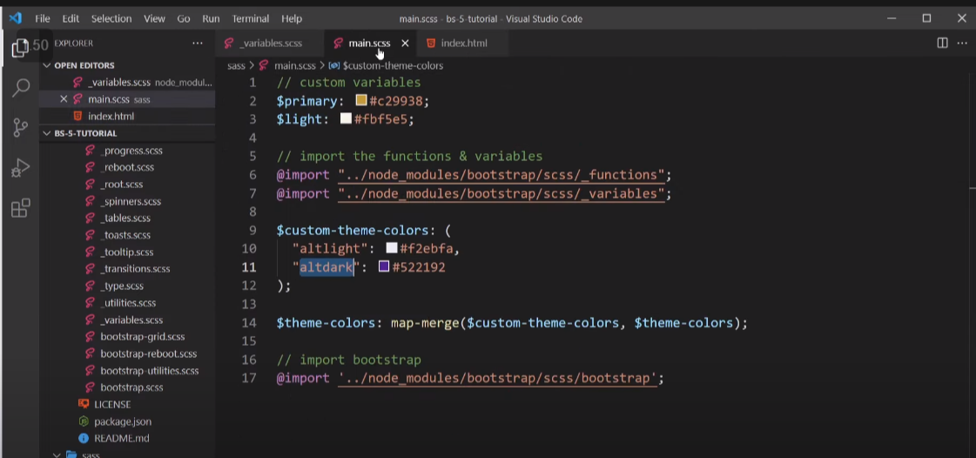

🡺 We can create utilites for image :

